IDG Product Adoption
ODI

Release 2013.1

ODI Custom Elements

Procedures for adding additional values to standard contracts

Release 1.0

Adding to the Contract 1
Formatting the XML 1
Retrieval of custom elements 2

Adding to the Contract

Formatting the XML

The ODI contracts have been created to allow the provider to add additional elements that are necessary for select situations. This can be accomplished by adding subsequent elements with their associated values within the <Custom> element. The structure can be as simple as one element or as complex as required to represent large amounts of data.

Depending on the provider, collecting the information may be a separate process from creating the XML or CSV extract files for ODI to process.

Example: Location of <Custom> element for Deposit Account information.
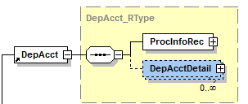

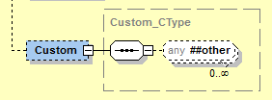

The XML must be formatted in the following manner.

<Custom xmlns:custom = “[Custom Namespace]”>
<NewElement>Value</NewElement>
</Custom>

- A Namespace must be provided as an attribute on the actual <Custom> element when it contains additional custom elements. The brackets, [ ], have to be removed but the double quotes have to remain.

- Use Pascal Casing when naming new custom elements.
  - Correct: CustomerName
  - Incorrect: customername
- Elements of Date/Time type are normally formatted with a ‘Dt’ Suffix – NewDateDt
- Aggregate elements are prefixed with MTD or YTD – YTDCounter, MTDNumber

There is no limitation to the complexity of the contents of the <Custom> element as long as it is valid XML.

Retrieval of custom elements

ODI will process and format data in two primary methods. The first is to insert the data into a SQL database for JHA products to access directly. The second is file based output for 3rd party (non-JHA) consumers. These output files can be either in XML or CSV format.

XML
Parsing custom from XML output files will follow the same process for the standard elements since they are in the same format and the entire file has to be processed as raw XML.

SQL
Parsing the custom from SQL will be different as individual columns will not exist for any custom elements. The entire contents of the <Custom> element will be stored a string in the ‘Custom’ column in SQL.

CSV
As it is for SQL, the entire per record contents of the <Custom> element will be inserted between the CSV field separators.

SQL example of <Custom> output:
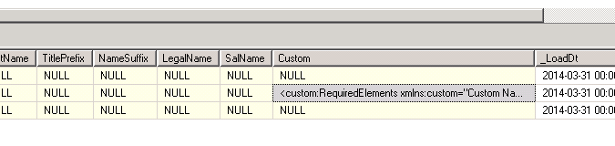

Information
Additional information can be requested from the IDG Product Adoption group by email IDGAdoption@jackhenry.com

