Provider Behaviors Guidelines

Integration Development Group
Product Adoption

Provider Service Deployment Guidelines 2
Authentication/Authorization – JX 2
Authentication/Authorization – Calling Product 2
Authentication / Authorization – End User 2
Provider Service Deployment Path 3
jXchange Header Behavior 4
Request Structure 4
Institution Routing Identification Behavior 5
Backwards Compatibility 5
Error/Fault Behaviors 6
Types of Error Categories 6
Error / Fault Message Array Elements 6
Error Response Structures 7
HdrFault (HdrFault_MType) 7
MsgRecInfoArray (MsgRecInfoArray_AType) 10
Typical Flow for Fault Handling 11
jXchange Service Provider Error Codes 12
Enumerated Elements 13
Closed Enumerated Elements 13
Open Enumerated Elements 13
Concurrency Models 14
Concurrency EA Guidelines 14
Addition Service Guidelines 15
Modification Service Guidelines 15
Inquiry Service Guidelines 16
Search Service Guidelines 16
Search Record Request / Response Behavior 17
Wildcard Search 17
Misc Information 18
Authentication User Credentials 18
Custom Elements 18
Documented Choice Statements 18
Extending and EA XSD Contract 19
Forced Elements 19
JHANull Attribute 19
MemoPostInc 20
MaskVal Attribute 20
Rstr Behavior 20
X_Filter Behavior 21
Resources 22

Provider Service Deployment Guidelines
To ensure consistency among all of our Enterprise provider groups the following guidelines should be taken into consideration when planning out your service deployment. You will be asked to complete a Provider Information Form during your project. This is necessary for JX to understand your deployment environment as well as how to communicate to your service.

Authentication/Authorization – JX

jXchange Service Gateway will always send credentials that have been established for communicating to your service in the SOAP Header of an incoming request. These credentials represent the Service Gateway itself. They do not represent the calling end Product or User. The JX credentials can be sent as a Security Assertion in Username/Password or JX can also support hitting a federated endpoint and passing a SAML Token in the message. You will need to decide what binding you will be using to determine how this will be communicated.

Authentication/Authorization – Calling Product

JX already authenticates an end products credentials against ADFS upon receipt of a message and authorizes them to communicate to your service based on the JX configuration.
If your product needs to do additional authorization based on the end consumer product, the credentials that a product provides to JX can be forwarded automatically and injected into the <AuthenProdCred/> element of the message. The automatic injection would be provided in the form of a SAML token. If you cannot support receiving a full SAML token, the end product can be instructed to insert their credentials in the form of a <wsse: Security/> assertion. They can provide their userID and Password or simply the user ID.

Authentication / Authorization – End User

If your product needs to do additional authorization based on the end user of the consumer product, the consumer can present the captured user information within the <AuthenUsrCred/> element. These credentials would need to be in the form of a <wsse:Security/> assertion instead of a full SAML token. This keeps an end consumer product from having to access a FI’s ADFS store to obtain a token.

Provider Service Deployment Path

What will be the path to which your service will be deployed? The suggested method is not to include any type of versioning in the path itself. This keeps anyone from having to make additional configuration changes any time there is a version change of the end provider service.

The suggested deployment template to use would be:

<server>\<product name>\2008\<container>.svc

<Container>

Once you have identified the messages that you will be supporting, you should be able to locate what container the message XSD/WSDL belongs to.

For Example:

If you are supporting the TrnAdd and the CustInq operation. Those operations are grouped into the TransactionMaster and CustomerMaster groups by EA.

Any messages that fall under that grouping should ideally be deployed to an endpoints such as:

<server>\<product name>\2008\Transaction.svc
<server>\<product name>\2008\Customer.svc

It is possible to group all of your supported operations under a single deployment endpoint but ideally it is recommended to follow the “container” structure to keep consistency across all providers.

jXchange Header Behavior
- Tracking Utilization
- Lives in Request and Response Message
- Specific Behavior

Request Structure
Some elements are linked to the EA SharePoint – Architectural Guidelines page where more detailed information can be found concerning their definition and use.

XSD Element Path | Required/Optional/Conditional | Comment
jXchangeHdr.JXVer | O | jXchange will return the current version deployed regardless of the value in the request header
jXchangeHdr.AuditUserId | R | This is the User Id which the consumer would like written to the audit as performing the requested service. It will vary but could be down to the user id. It will not be used to authenticate however, just audit.
jXchangeHdr.AuditWsId | R | This is the Workstation Id which the consumer would like written to the audit as performing the requested service
jXchangeHdr.ConsumerName | O | The name of the consumer that is consuming the service
jXchangeHdr.ConsumerProd | O | The name of the product which is consuming the service (Business Product Name)
jXchangeHdr.jXLogTrackingId | O | jXchange could create Id when not submitted by Consumer
jXchangeHdr.InstRtId | C | The identification of the entity of submitted message. A financial institution will utilize the routing transit or ABA nine (9) digit number assigned to financial institutions for the purpose of routing as assigned by the American Bankers Association. Any leading zeros must be provided for a complete routing and transit number. A non-financial institution entity will use a mutually agreed upon identification that must contain at least one non-integer character. When a record is directed to a specific Financial Institution within a holding company, the institution routing identification is specific Financial Institution routing identification and not the holding company identification
jXchangeHdr.InstEnv | O | An identification provided by the consumer that defines the environment in which the institution is operating. Production (PROD) is the default value
jXchangeHdr.BusCorrelId | O | The correlation identification as related to business functions and activities
jXchangeHdr.WorkFlowCorelId | O | The correlation identification as related to workflow functions and activities
jXchangeHdr.ValidConsmProd | O | Unique Identifier for a Consumer. Used for JX auditing and reporting purposes
jXchangeHdr.ValidConsmName | O | Unique Identifier for a Consumer. Used for JX auditing and reporting purposes

Responses should echo back the information provided in the jXchange Header with the Consumer request.

Institution Routing Identification Behavior
- The Service Provider will need to map to the submitted Institution Routing number <InstRtId> element if their application maintains a different institution identifier
- The Institution Routing Number <InstRtId> can be the nine (9) digit assigned by the American Bankers Association (ABA).
  - All leading zeros must be included to be a complete routing and transit number
- The absence of the Institution Environment <InstEnv> element will equate to “PROD” = Production Environment.
  - It will be the responsibility of the sender to send the appropriate data to identify the environment if necessary

Backwards Compatibility
Backward compatibility is a relationship between two components, rather than being an attribute of just one of them. More generally, a new component is said to be backward compatible if it provides all of the functionality of the old component. Backward compatibility is the special case of compatibility in which the new component has a direct historical ancestral relationship with the old component.
jXchange maintains Backwards Compatibility with the user of Version Tags
- EA Sharepoint Information regarding Version Tags
Examples of both Backwards and Non-Backwards Changes

- Backward Changes
  - Adding new optional elements or optional attributes
  - Changing attributes cardinality from mandatory to optional
  - Adding a term to an enumerated list

- Non-Backward Changes
  - Changing an attribute cardinality from optional to mandatory
  - Adding a mandatory element
  - Changing an attribute or element tag name

Error/Fault Behaviors
JXchange, error handling has been designed into the messaging structure and involves notification through use of codes, categories and descriptions, as well as options for error overrides for non-fatal errors.
Additional information from EA can be found HERE.

In the process of moving information back and forth between a Consumer and a Service Provider, it is occasionally necessary to provide notification of errors arising in messaging protocol and submitted element values. In jXchange, error handling has been designed into the messaging structure and involves notification through use of codes, categories, descriptions, and options for error overrides for non-fatal errors.

Types of Error Categories
- Warning: Successful transmission of requested response transmission, but information must be returned to the customer describing under what condition the successful response was able to be created.

- Error: Failure condition that cannot be overridden and must be corrected before processing can be completed.

- Fault: Failure condition that can be overridden.

- Override: Specific warning notifying the customer that the fault has been overridden.

- FaultLookup: Fault where the element that is causing the fault can be sent to a service for a listing of the possible values.

In the Error Message Response, the Service Provider is required to use error elements listed in the XSD for use with jXchange. jXchange, by contract, is not required to translate Service Provider elements or values.

Error / Fault Message Array Elements

Error notification, like that caused by flawed element values being submitted, is returned within a message's complex structure. Nested within the FaultRecInfoArray as well as the MsgRecInfoArray is the fault message complex (FaultMsgRec / MsgRec). The FaultMsgRec / MsgRec complexes contain the following simple elements for description of the error or fault:

- ErrCode: Error Code (Required)

- ErrCat: Error Category (Required)

- ErrDesc: Error Description (Required)

- ErrElem: Error Element (Optional) – This element would contain the X path to the element in question. It is optional but highly recommended to help jXchange Service Consumers to properly identify what item in the request is problematic.

- ErrElemVal: Error Element Value (Optional) – This element would contain the actual value that was submitted in the element. It is optional but highly recommended to help jXchange Service Consumers to properly identify what item in the request is problematic.

- ErrLoc: Error Location (Optional) – This element would contain information regarding the location the error took place. For example Silverlake services provide the actual business service that was processing the request at the time the error was encountered. It is optional but highly recommended to help jXchange Service Consumers to properly identify and report the problematic item to a JHA support group.

Error Response Structures

HdrFault (HdrFault_MType)

The HdrFault response is to be utilized when it is necessary for a jXchange Service Consumer to perform an action in order to send a successful request. This action could either be to correct the submitted request with appropriate data or to send in an Override in order for the jXchange Service Provider to successfully process the request.

Appropriate Error Categories:

- Error
- Fault
- FaultLookup

The HdrFault consists of the following:

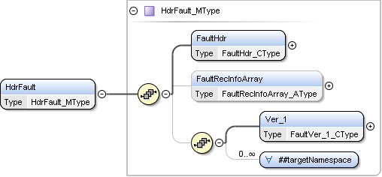

- FaultHdr (FaultHdr_CType)
  - This should mirror the information that was passed into the Service Provider by the Service Consumer within the jXchangeHdr complex

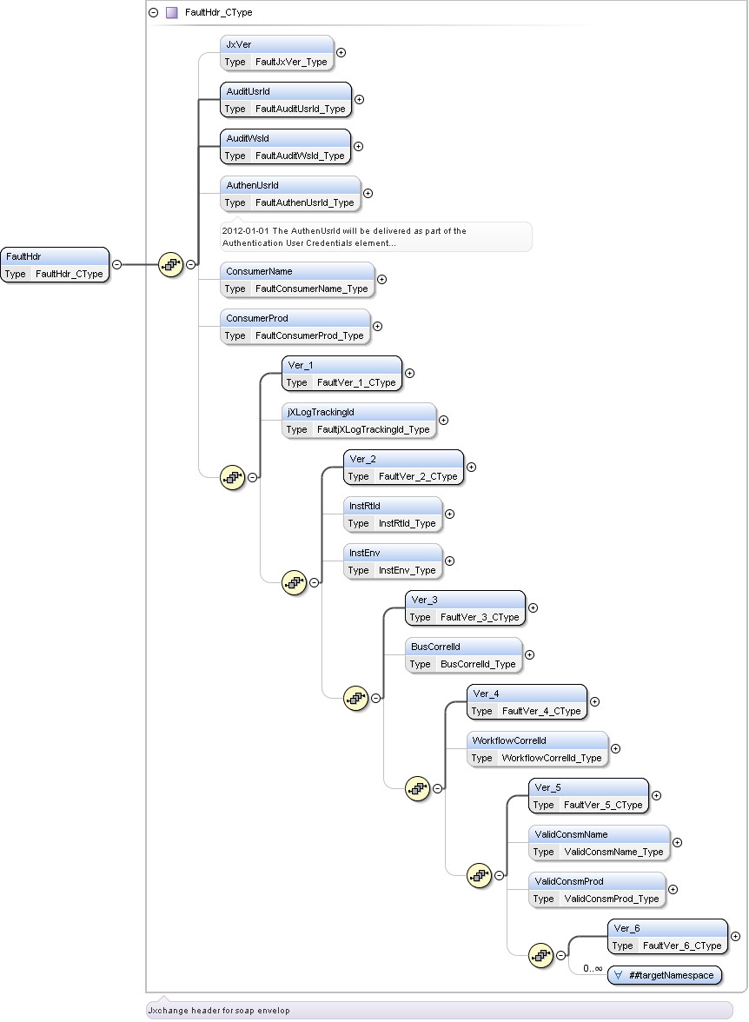

- FaultRecInfoArray (FaultRecInfoArray_AType)

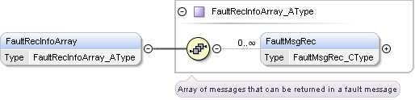

- FaultMsgRec (FaultMsgRec_CType)

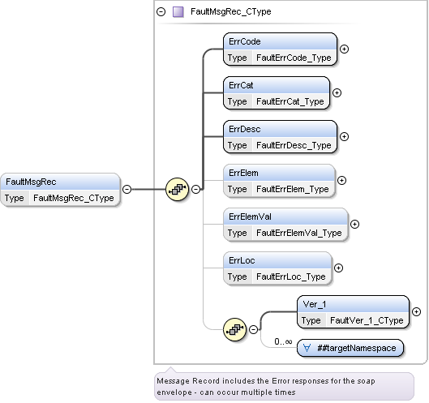

MsgRecInfoArray (MsgRecInfoArray_AType)

Within each jXchange Service Gateway response message is the MsgRecInfoArray structure. This is found as part of the MsgRsHdr Complex. This Array should be utililzed to send informational data to the jXchange Service Consumer. These items would not require any action on the Consumer’s part and should not interfere with the successful processing of the Service Consumer’s request.

Appropriate Error Categories
- Override
- Warning

MsgRsHdr (MsgRsHdr_CType)

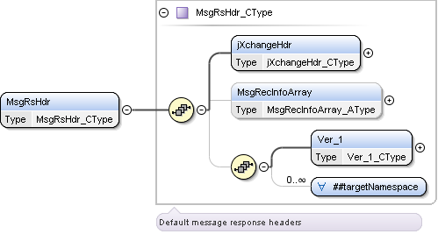

MsgRecInfoArray (MsgRecInfoArray_AType)

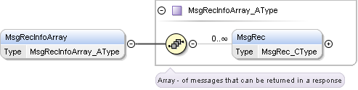

MsgRec (MsgRec_CType)

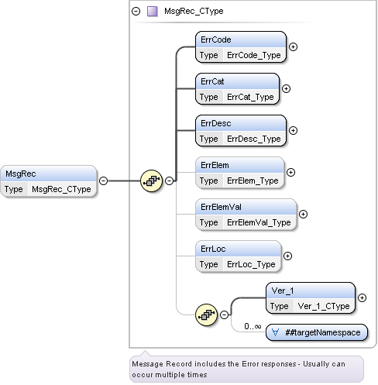

Typical Flow for Fault Handling

In a standard message flow involving errors with an ErrCat value of Fault responses, the message flow begins with a standard request message from the Third Party Consumer to the Jack Henry bank's Service Provider.

The error condition is created by an element of the request message containing an incomplete or invalid value, which prevents the Service Provider from completing the requested action.
In response, the Service Provider returns an error message to the consumer with a code, category, and description corresponding to the severity of the error fault.

Once an error message has been returned to the consumer, the consumer can return an override request to the Service Provider. The override request is identical to the primary request for service, in addition to an ErrOvrRd element containing the error codes that the consumer requests the Service Provider to overlook. The error codes listed for override must contain only fault values that can be overridden. Error values only result in a fatal error being issued for the second request with override.

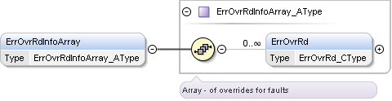

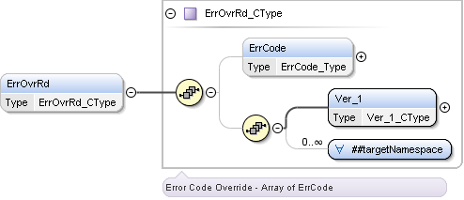

If the second request is issued with an override value that is allowed to be overridden, the Service provider accepts the second request, ignores the error condition designated in the primary response, and honors the service request.

The response would include the MsgRecInfoArray with the details of the fault but with the Error Category of “Override” to indicate the fault was overridden and allowed to process.

jXchange Service Provider Error Codes

jXchange does not normally dictate to a Service Provider group an appropriate range for defining your error codes. Some items to be taken into consideration for the ease of research are the following:

- If possible keep the defined error code range outside that of typical system error codes as overlapping codes can cause confusion.

- If possible keep the defined error code range outside that of the typical jXchange error codes as overlapping codes can cause confusion.

  - Normally IDG product error codes are found within the 1000 – 5999 range.

Overlapping error codes are acceptable as long as enough pertinent information is provided in the related error elements to uniquely identify the source of the error/fault.

Parallel vs. Serial Error Message Handling
- Serial – a Service Provider will issue an error response message when it has discovered the first error in a request.
- Parallel – The Service Provider can continue to process a request message after detecting a fault capable of being overridden in an attempt to identify all possible errors before returning an error message to the Consumer
- Parallel Error Message Handling is the most efficient method and is suggested as the preferred error handling system for Service Providers.

Enumerated Elements
These are elements that have a pre-defined set of data values. The XSD contracts define enumerated elements by data type Closed Enumerated or Open Enumerated. The EAG defined types adopt the string primitive data type.
Here is the link to the EA Sharepoint Entry: What are Enumerated Elements

Closed Enumerated Elements
- Contract defined with a definite set of values
  - Service Provider must convert the element to canonical values to their applications stored/understood value
  - Example, element that conveys whether a job is part time position. Element name, <PartTimePos> has canonical values of ~true~ or ~false~. The application would convert true = Yes(Y) and false = No(N)

Open Enumerated Elements
- A definite set of values but not represented in contracts
  - The enumerated values offered differ from installation to installation often times referred to a parameter values
  - Service Provider conveys these canonical values by means of web service call – Service Dictionary Search (SvcDictSrch)
- Click the link for more information on the Service Dictionary Search Service

Concurrency Models
- The application and database must work in concert to provide the appropriate level of data integrity and performance while minimizing user rework to address conflicts and deadlocks.
- Optimistic, Pessimistic and Chaos refer to three different types of concurrency concepts and the safeguards an application will take based on the likelihood of concurrent updates and how much rework is acceptable
  - Optimistic concurrency control is used when it is unlikely that different users will update the same data
  - Pessimistic concurrency control is used when it is likely that the same data will be updated by different users
  - Chaos concurrency control is used in situations when concurrent updates are not possible or “last in wins” is acceptable.

Concurrency EA Guidelines
EA Sharpoint: What are Concurrency Models
- Adoptions of the Optimistic Concurrency model for modification services
  - The activity intention element will exist on all inquiry operations that support a modification mate
- The Activity Intention element allows the consumer to convey to the service provider their intention for the data returned in the response.
  - The Activity Intention element <ActIntent> supports three canonical values:
    - Read Only (ReadOnly) – this is the default
    - Update (Upd)
    - Delete (Dlt)
- The service provider will echo back the Activity Intention element in the response.
  - The service provider will return an Activity Intention Key when the consumer submits the Activity Intention element canonical values of Update or Delete.
  - The service provider must return a unique Activity Intention Key <ActIntentKey> for each item that is returned when the response includes an array of elements.
  - The consumer should cache the Activity Intention Key so it can be submitted in a subsequent modification request.
- The Service provider will return a fault when the provider’s saved data does not match the intended updated data when the consumer’s modification request with Activity Intention Key <ActIntentKey> is submitted on the modification request.

Addition Service Guidelines
EA Sharepoint Link: What contracts qualify as an Addition (Add) Service

- The named EA XSD contract will be suffixed with ~Add~
- The business function will convey to the service provider to create an entry/record in the service provider’s data base for the supported business service
- The service provider would return the added entry/records keys in the response if applicable
- The majority of the child node elements will be decorated with the JHANull attribute
- Generally, the request message will have a complex object that is required but all the elements inside the complex object are optional. This should convey that at least one of the elements inside the object is required
- A consumer may send a Service Dictionary Search (SvcDictSrch) message for all addition services to obtain the service provider’s element default values. This will assist the consumer in their validation process for elements without having to deliver the XML payload and receiving an error that an element is required by the service provider even though the XSD contract references the element as optional
- The EA XSD addition contracts make use of re-used complex objects. Thereby, often many of the child nodes (elements) encapsulated by a parent node (complex) are optional from an XSD contract perspective. However; service providers will have minimum requirements as to the required elements which will be conveyed to the consumer by means of message fault(s).

Modification Service Guidelines
Reference to EA Sharepoint Link: What contracts qualify as a Modification (Mod) Service

- The named EA XSD contract will be suffixed with ~Mod~;
- The business function will convey to the service provider to update an entry/record in the service provider’s data base for the supported business service;
- The service provider would return the RsStat element as success in the response if the operations request was successful otherwise, a fault is returned;
- The service provider should return a fault when any of the modified elements are invalid on the request and will never return a partial success response;
- The child node elements will be decorated with the JHANull attribute. The behavioral aspect of the attribute is addressed elsewhere in this document;
- The request message will have required element(s) representative of the keys as related to the specific business service;
- The request message will contain a delete element <Dlt> that permits a consumer to submit the key(s) with a Delete=true without a complex object to convey a delete request to the Service Provider. However; the service provider reserves the right to either mark the record for deletion or perform a data base delete request.

Inquiry Service Guidelines
Reference to EA Sharepoint Link: What contracts qualify as an Inquiry (Inq) Service

- The named EA XSD contract will be suffixed with ~Inq~
- The request message will have required key(s) however; the key(s) may be presented in the request as a documented choice statement
- The service provider will return a fault when an invalid key(s) is submitted on the request
- The service provider would return the elements as related to the requested key in the response
- Some of the child or parent node elements could be decorated with the Restriction ~Rstr~ attribute
- The response message may be a multi-occurrence object depending upon the business activity of the inquiry message
- The request message may contain the Include Extended Element array that may require the consumer to submit a list of “x_” named objects to be returned in the response
  - A request made with a valid key but does not include any of the “x_” named objects could be returned a response with no complex objects.
- The RsStat element is NOT included in the response because successful response package is an implied <RsStat>Success</RsStat> element value

Search Service Guidelines
Reference to EA Sharepoint Link: What contracts qualify as a Search (Srch) Service

- The names EA XSD contract will be suffixed with ~Srch~
- The request message may have required key(s) however; the key(s) may be presented in the request as a documented choice statement
- The request message could have a number of elements that can serve as filters that allows a consumer to reduce the response set being returned
- The request filters will be echoed back at the root response message
- Some of the child or parent node elements could be decorated with the Restriction ~Rstr~ attribute. The behavioral aspect of the attribute is addressed elsewhere in this document.
- The response message will always be a multi-occurrence object
- The request message may contain the Include Extended Element array that allows a consumer to include a list of “x_” named objects to be included with the default response set.
- The search message has a specific message header that differs from other message headers to allow the service providers to provide a pseudo state in a stateless message environment.
  - EA Sharepoint Link on Search Service Header: Why do Search Messages have a different header
- The RsStat element is NOT included int the response because successful response package is an implied element value
- A request made with a valid key, if applicable, but due to filters submitted in the request returned a zero set of response does not constitute a fault. The service provider will provide a warning to convey that no records matched the consumer’s search criteria
- The response set is typically a limited element response set but could return some key(s) that allows a consumer to capture to make an inquiry message service call if applicable for the search business activity

Search Record Request / Response Behavior
EA Sharepoint Link on Search Service Header: Why do Search Messages have a different header

There are elements that pertain strictly to search operations that are used to control the records and the number of those records that are returned to the user.
- Cursor (Request) – Tells the provider at which record to begin returning the results
- MaxRec (Request) – Tells the provider the maximum number of records to return in the response
- SentRec (Response) – Tells the consumer how many records were returned; may or may not be equal to the maximum number requested
- MoreRec(Response) – Tells the user if there are more records available than what was returned
- Cursor (Response) – Tells the user which record (as a number) would be next to be returned
- TotRec(Response) – Tells the user the total number of records that exist in the file that meet the criteria of the request; is not returned if Cursor was included with the request
- An example can be found at the above EA link.

Wildcard Search
Reference to EA Sharepoint Link: How do contracts convey wildcard searches

- A wildcard search allows a consumer to get a response set that is dynamic based on a message request elements
- Many search filter elements need to provide a consumer a means to search for the matches
- This can be referred to as a wildcard search because the consumer does not have enough information to do an exact match search
- These types of searches can be based on partial data value
- The consumer needs to convey to the service provider as to the type of partial search such as but not limited to:
  - Exact Match
  - Contains within
  - Starts With
  - Ends With
- A service provider cannot require exact case matches
  - For example, if a consumer submits a last name data value of ~mcgrath~ then the service provider should respond back with any data values that match regardless of case which could include but not limited to ~McGrath~, ~Mcgrath~, ~mcgrath~, ~MCGRATH~ or any combination of case difference thereafter

Misc Information

Authentication User Credentials
- Authentication of end user credentials in the form of a WS Security Element that contains a single SAML V2.0 assertion
http://docs.oasis-open.org/security/saml/v2.0/saml-core-2.0-os.pdf

Custom Elements
The EA XSD contracts wildcard schema is provided by means of a custom complex. The custom complex (Custom_CType) provides a mean for institution specific data as an extension point for custom variations of the XSD common dictionary. The ##other namespace property is leveraged as this allows all elements which are from namespace other than targetNamespace.
EA Sharepoint Link: Can a consumer deliver Custom Element(s)

Documented Choice Statements
Reference to EA Sharepoint Link: Usage of Choice Statements

- EA does not make usage of xsd:choice statements because:
  - Some programming languages do not provide an explicit mapping from xsd:choice whenever a code generator encounters xsd:choice in a type definition, it could map that type to a less than friendly API
  - XSD does not permit versioning within the choice statement which creates a challenge to maintain forward compatibility.
- EA makes use of documented choice statements.
  - The XSD syntax in itself does not convey a specific behavior but the comments provided via either XML comments or annotations does convey this behavior
  - The disadvantage to this method is that it requires a developer to read the XSD in order to understand behavior rather than allowing a code generator toolkit to understand based on XSD syntax

Extending and EA XSD Contract
EA XSD contracts sometimes have to be extended to allow for messaging components that can be exposed within the Jack Henry enterprise but not to Third Party Consumers. There are two categories of XSD extension contracts; (1) Me to Me and (2) Us to Us. The Me to Me category are for XSD extensions when the consumer and the service provider are the same application. The Us to Us category are for XSD extensions when there are requirements within the enterprise applications specifically for ease of implementation but not to be exposed to Third Party applications.
EA SharePoint Link: How can a service provider extend an EA XSD contract

Forced Elements
The vast majority of EA XSD message elements are optional because messages often are supported by multiple service providers. This can be the cause of some ambiguity on the part of the message receiver (consumer) when an element, understood by the service provider, but not returned in the message because the element is optional.
EA SharePoint Link: What is the guidance for Forced Elements

JHANull Attribute
Reference EA Link: What is the purpose of the JHANull attribute

- An object is null whether it doesn’t exist or the element is assigned to “xsi:nil=true”
  - This becomes a problem because most implementation of web services are deserialized on input and serialized on output
  - Any other approach is discouraged as the complexity of implementation becomes more difficult
- Clients that are using .Net or probably any tool kit will not be able to take advantage of this implementation in the jXchange framework
  - They will not have control over an element creation during serialization using the existing tools.

MemoPostInc
- Element included in an AcctHistSrch message that determines the behavior searching history search for memo posted items. The default value will be Excl (Exclude). Canonical Values are:
  - Excl
  - Only
- If the MemoPostInc element has the value of “Only”, XSLT is used to transform the AcctHistSrch request to a MemoPostSrch request and then is sent to the provider. XSLT is used to transform the provider’s MemoPostSrchResponse to an AcctHistSrchResponse.
- If the MemoPostInc element has the value of “Excl”, it is just passed through.

MaskVal Attribute
The service provider will always include the clear text of the element value however; may optionally include the service provider’s masked value of the clear text. This will allow the consumer to switch from a masked value to a clear text value with requiring an additional service call.
Example: <TaxId MaskVal="882-89-7818">882897818</TaxId>

Rstr Behavior
The attribute Restrictions <Rstr> references the element of the same name and is a closed enumerator with the following canonical values:
- NoAccess = Access is denied. This attribute value may exist at the parent node as well as the element node.
- NoAccessPart = Access is denied as a default for all of the nodes related to the parent node and any of the related nodes could override the accessibility setting at the parent node. This attribute value can only exist at a parent node.
- ReadWrite = Full read and write access to any of the nodes. This is the default value.
- ReadWritePart = Full read and write access for all the nodes related to the parent node and any of the related nodes could override the accessibility setting at the parent node. This attribute value can only exist at a parent node.
- ReadOnly = Read only to any of the nodes.
- ReadOnlyPart = Read only as a default for all of the nodes related to the parent node and any of the related nodes could override the accessibility setting at the parent node. This attribute value can only exist at a parent node.
- Hid = Hide all of the nodes.
The canonical values that are prefixed with Part (Partial) will convey to the consumer that overrides can exist for any of the proceeding nodes. Therefore, these canonical values can never exist at an element node.
The elements in the XML body are decorated with an attribute that conveys restrictions for an element. However, the data pertaining to the element is delivered when the service provider needs to convey to the consumer that the data element should be masked. For example, the current balance with restrictions could appear as <CurBal Rstr = “NoAccess”>1000.00</Curbal>.

X_Filter Behavior
To limit the size of responses containing automatically generated response elements, jXchange is designed to automatically return priority preferred elements from any given message pair and retain the non-preferred and less used premium complex elements until they have been specifically requested

- Operations containing the premium x_prefix complexes in the response elements, request elements (IncXtendElemArray and XtendElem) are included in the Request message structure to call for any or all premium complexes. The request elements, if needed, must contain the name of one or more premium complexes

- A Service Provider may adopt the option to return all object and allow the Service Gateway to filter out the complexes not requested.

Resources
- Enterprise Architect Group Sharepoint
  - https://jackhenry.sharepoint.com/sites/EAG/default.aspx
- Corporate Wiki – Enterprise Architect Group
  - https://jhatoday.jackhenry.com/sites/wiki/Wiki%20Pages/EAG%20Architectural%20Guidelines.aspx
- Corporate Wiki – jXchange
  - https://jhatoday.jackhenry.com/sites/wiki/Wiki%20Pages/jXchange.aspx#article_15
- IDG Developer Portal
  - https://idg.jhahosted.com/
    - Here you can find the following:
      - Current GA XSD/WSDL packages (Downloads)
      - Current GA EBO/Client packages (Downloads)
      - Current Documentation for supported JX Messages (Resources->Message Briefs)

