Service Gateway - Supporting large images using MTOM

With Synergy as the provider

MTOM

MTOM stands for Message Transmission Optimization Mechanism. MTOM should be used when sending large images to Synergy through Service Gateway using operation DocImgAdd. It should also be used when retrieving large images using DocImgSrch. Synergy supports images up to 50 mb. To allow for the additional overhead in the message that accompanies the image itself, the changed values are bumped from 3.125 mb to 55 mb.

Requirements

Client
They have to use the MTOM binding in their own configuration file at the operational level only
  - Only use MTOM for large images
    - We need to define all messages that pass base64 data
    - Here is a blurb from MSDN:
Still, as with Base64, MTOM also comes with some necessary overhead for the MIME format, so that advantages of using MTOM are only seen when the size of a binary data element exceeds about 1 KB
  - All other operations should NOT use MTOM
  - https://hostname/jXchange/2008/ServiceGateway/ServiceGateway.svc/basicHttpMtom

Environment
Before any changes are made - it has to be determined if the incoming lines from the consumer to Service Gateway can handle the large image payload.

Below are the changes necessary for Jxchange Service Gateway in the web.config file and in the JMC.

Web.config
Current binding size | 3276800
New binding size | 57671680

The JMC settings are for the provider bindings only. The client bindings have to be changed in the web.config file using the Service Configuration Editor.

The current values are most likely 3276800 and would need to be changed to 57671680. The sendTimeout attribute should be updated as well.

NOTE: | Beginning with Jxchange release 2014.0 and above, some bindings will be prefixed with ‘custom’. This change was made to accommodate transaction logging enhancements.

Change the values in the httpsTransport section for customBasicHttpBinding_MTOM
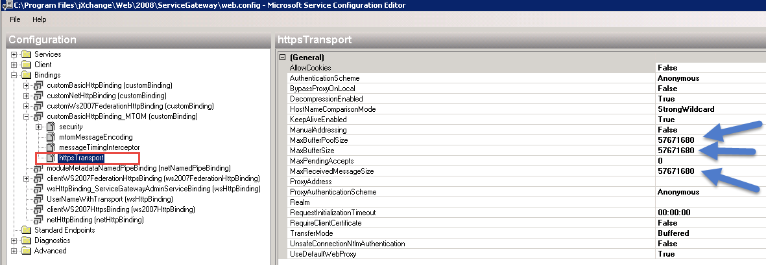

Select the customBasicHttpBinding_MTOM top node and change the SendTimeout value to 10:00

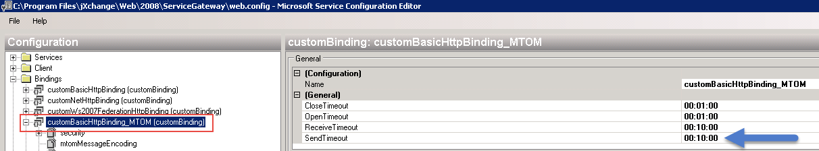

Save the web.config file
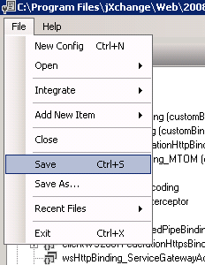

Web.config File after the change
<binding name="customBasicHttpBinding_MTOM" sendTimeout="00:10:00">
<security authenticationMode="UserNameOverTransport"/>
<mtomMessageEncoding messageVersion="Soap11">
<readerQuotas maxStringContentLength="1048576" maxNameTableCharCount="1048576"/>
</mtomMessageEncoding>
<messageTimingInterceptor/>
<httpsTransport maxBufferPoolSize="57671680" maxReceivedMessageSize="57671680" requestInitializationTimeout="00:00:00" maxBufferSize="57671680"/>
</binding>
*Note the addition of the sendTimeout attribute.

JMC

Synergy’s provider binding is clientWSHttpsBinding so that is the binding that needs to be updated for this scenario.

*Note the reader quotas are updated to 31457280.

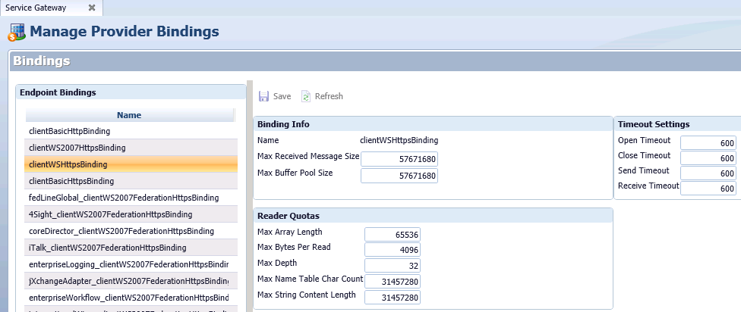

IIS Configuration

Besides the known changes with the Service Gateway bindings and the provider bindings, we also must change the Service Gateway IIS Application’s Request Filtering – maxAllowedContentLength.

How to edit the request filtering feature settings and request limits
- Open Internet Information Services (IIS) Manager:
  - If you are using Windows Server 2012 or Windows Server 2012 R2:
    - On the taskbar, click Server Manager, click Tools, and then click Internet Information Services (IIS) Manager.
  - If you are using Windows Server 2008 or Windows Server 2008 R2:
    - On the taskbar, click Start, point to Administrative Tools, and then click Internet Information Services (IIS) Manager.
- In the Connections pane, go to the Service Gateway application.
- In the Home pane, double-click Request Filtering.
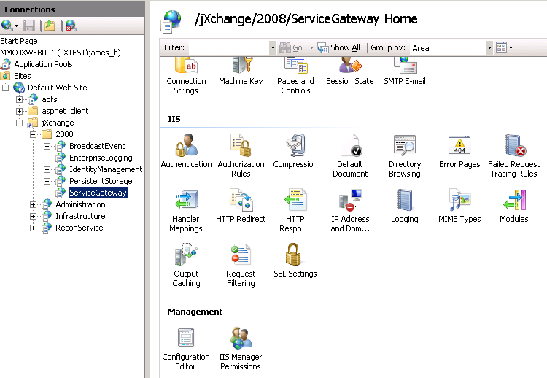

- Click Edit Feature Settings... in the Actions pane on the right side of the screen.
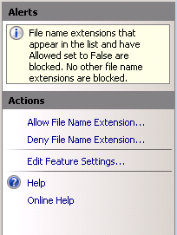

- Change the Maximum allowed content length to the desired maximum size

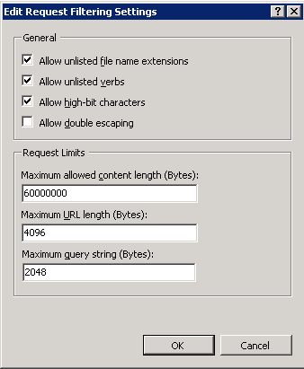

Article References about MTOM encoding

http://msdn.microsoft.com/en-us/library/aa395209(v=vs.110).aspx

http://help.adobe.com/en_US/livecycle/9.0/programLC/help/index.htm?content=000239.html

http://www.crosschecknet.com/intro_to_mtom.php

