
jXchange™ Release 2017
Teller Services
Last Updated: March 29, 2018


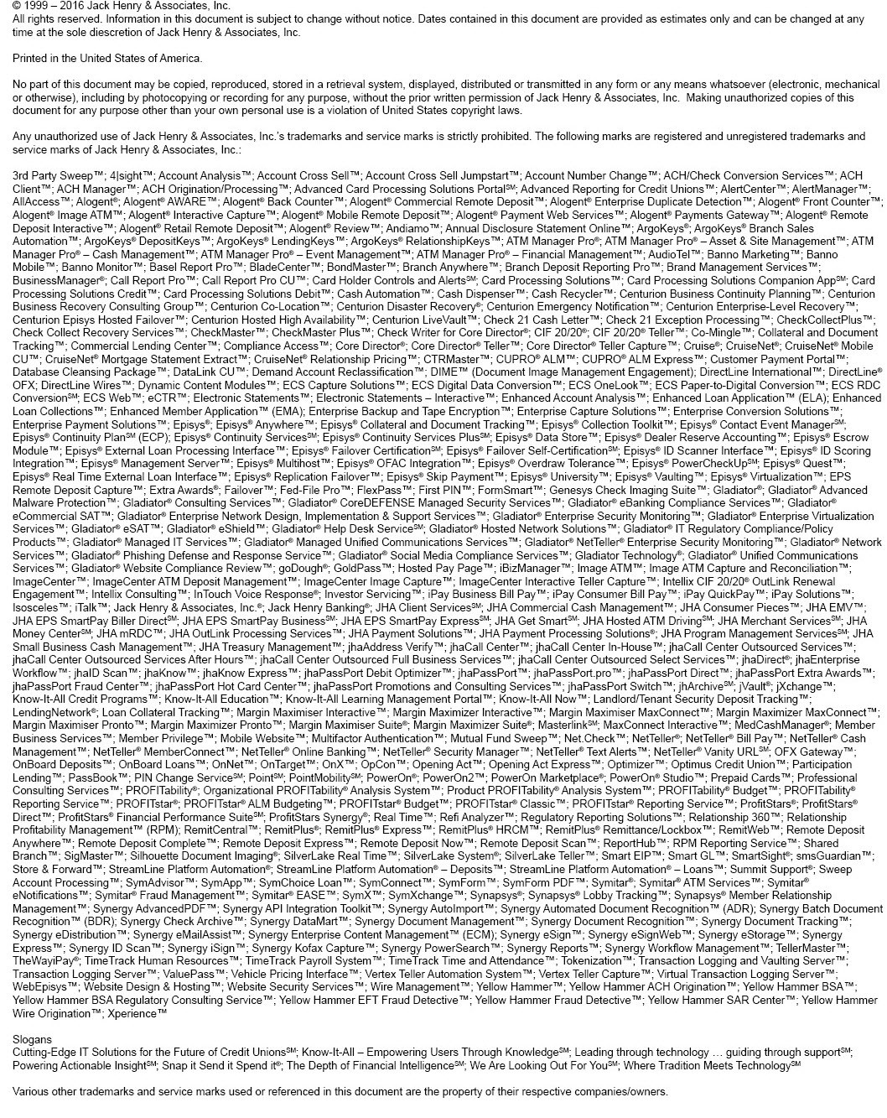

Contents
Teller Services 12
WSDL Name 12
XML Schema File Name 12
Teller Services Updates 12
Teller Services Consumer Use Cases 12
Authentication Use Case 12
Transaction Use Case 13
Settlement Use Case 14
Line of Credit Advance Use Case 14
Transfer Use Case 14
Cash Recycling Use Case 14
Coin Deposit Use Case 15
Additional comments 15
MsgRqHdr/MsgRsHdr 15
MsgRqHdr/MsgRsHdr Behavior 15
MsgRqHdr/MsgRsHdr Business Case 15
MsgRqHdr_CType 16
MsgRsHdr_CType 20
Possible Error Codes: 23
SrchMsgRqHdr/SrchMsgRsHdr 23
SrchMsgRqHdr/SrchMsgRsHdr Behavior 23
SrchMsgRqHdr/SrchMsgRsHdr Business Case 23
SrchMsgRqHdr_CType 24
jXchangeHdr_CType 26
SrchMsgRsHdr_CType 28
Possible Error Codes: 31
MsgRecInfoArray 32
MsgRecInfoArray Behavior 32
Teller Service Response with Error Business Case 32
MsgRecInfoArray_AType 32
Teller Services Error Codes 34
Teller Specific Error Codes 34
iAdapter Error Codes 38
Custom_CType 42
Custom_CType Behavior 42
Teller Transaction Search 42
Message Flow 43
Primary Request 43
Primary Response 43
Teller Transaction Search Behavior 43
Teller Transaction Search Business Case 43
TellerTrnSrchRq_MType 45
TellerDrwIdArray_AType 47
TellerTrnSrchRs_MType 48
TellerDrwIdArray_AType 50
TellerTrnSrchRecArray_AType 51
Rmk_AType 53
Possible Error Codes: 53
Teller Transaction Inquiry 54
Message Flow 54
Primary Request 54
Primary Response 54
Teller Transaction Inquiry Behavior 54
Teller Transaction Inquiry Business Case 55
TellerTrnInqRq_MType 56
TellerTrnInqRs_MType 57
TellerTrnInfoRec_CType 58
TellerTrnInfo_CType 59
TellerTrnDetArray_AType 60
TellerTrnDet_CType 61
Rmk_AType 62
TellerDrwComptArray_AType 62
TellerDrwComptRec_CType 63
CashCntDet_CType 63
CashMachArray_AType 64
CashMachTrnDet_CType 64
Possible Error Codes: 65
Teller Transaction Add 65
Message Flow 65
Primary Request 66
Primary Response 66
Teller Transaction Add Behavior 66
Teller Transaction Add Business Case 67
TellerTrnAddRq_MType 68
TellerTrn_CType 69
TellerTrnInfo_CType 69
TellerTrnDetArray_AType 71
TellerTrnDet_CType 71
Rmk_AType 72
TellerDrwComptArray_AType 72
TellerDrwComptRec_CType 73
CashCntDet_CType 73
CashMachArray_AType 74
CashMachTrnDet_CType 74
ErrOvrRdInfoArray_AType 75
ErrOvrRd_CType 75
TellerTrnAddRs_MType 75
Possible Error Codes: 76
Teller Transaction Modification 77
Message Flow 77
Primary Request 77
Primary Response 77
Teller Transaction Modification Behavior 77
Teller Transaction Modification Business Case 78
TellerTrnModRq_MType 79
TellerTrn_CType 80
TellerTrnInfo_CType 80
TellerTrnDetArray_AType 82
TellerTrnDet_CType 82
Rmk_AType 83
TellerDrwComptArray_AType 83
TellerDrwComptRec_CType 84
CashCntDet_CType 84
CashMachArray_AType 85
CashMachTrnDet_CType 85
ErrOvrRdInfoArray_AType 86
ErrOvrRd_CType 86
TellerTrnModRs_MType 87
Possible Error Codes: 87
Teller Drawer Search 88
Message Flow 88
Primary Request 88
Primary Response 88
Teller Drawer Search Behavior 88
Teller Drawer Search Business Case 89
TellerDrwSrchRq_MType 91
IncXtendElemArray_AType 92
IncXtendElemInfo_CType 92
TellerDrwSrchRs_MType 93
TellerDrwSrchRecArray_AType 94
CashMachInfo_CType 95
CashMachIPInfoArray_AType 96
TrnsitnInfo_CType 97
TellerDrwComptArray_AType 99
CashCntDet_CType 100
Possible Error Codes: 100
Teller Drawer Mod 101
Message Flow 101
Primary Request 101
Primary Response 101
Teller Drawer Mod Behavior 101
Teller Drawer Mod ClaimModInfo Business Case 102
Teller Drawer Mod RlsModInfo Business Case 103
Teller Drawer Mod TrnsitnModInfo Business Case 103
Teller Drawer Mod BalModInfo Business Case 104
TellerDrwModRq_MType 104
ClaimModInfo_CType 105
RlsModInfo_CType 106
TrnsitnModInfo_CType 107
BalModInfo_CType 108
TellerDrwComptArray_AType 109
CashCntDet_CType 109
ModRmkArray_AType 110
TellerDrwModRs_MType 111
Possible Error Codes: 111
Teller Drawer Transition Search 112
Message Flow 112
Primary Request 112
Primary Response 112
Teller Drawer Transition Search Behavior 112
Teller Drawer Transition Search Business Case 112
TellerDrwTrnsitnSrchRq_MType 114
TellerDrwTrnsitnSrchRs_MType 114
TrnsitnSrchArray_AType 115
Possible Error Codes: 117
Teller Non Customer Add 118
Message Flow 118
Primary Request 118
Primary Response 118
Teller Non Customer Add Behavior 118
Teller Non Customer Add Business Case 119
TellerNonCustAddRq_MType 121
PersonName_CType 123
X_PersonName_CType 124
Addr_CType 125
FreeFormAddrArray_AType 127
AddrLineInfo_CType 128
IdVerifyArray_AType 128
IdVerifyQueryArray_AType 129
PhoneArray_AType 130
EmailArray_AType 132
TellerNonCustAddRs_MType 132
Possible Error Codes: 133
Teller Non Customer Modification 133
Message Flow 133
Primary Request 133
Primary Response 133
Teller Non Customer Modification Behavior 133
Teller Non Customer Modification Business Case 135
TellerNonCustModRq_MType 137
ErrOvrRdInfoArray_AType 138
ErrOvrRd_CType 138
PersonName_CType 140
X_PersonName_CType 141
Addr_CType 142
FreeFormAddrArray_AType 144
AddrLineInfo_CType 145
IdVerifyArray_AType 145
IdVerifyQueryArray_AType 146
PhoneArray_AType 147
EmailArray_AType 149
ModRmkArray_AType 149
TellerNonCustModRs_MType 150
Possible Error Codes: 150
Teller Customer Search 151
Message Flow 151
Primary Request 151
Primary Response 151
Teller Drawer Transition Search Behavior 152
Teller Customer Search Business Case 152
TellerCustSrchRq_MType 153
TellerCustSrchRs_MType 155
TellerCustSrchRecArray_AType 156
Possible Error Codes: 157
Teller Non Customer Inquiry 158
Message Flow 158
Primary Request 158
Primary Response 158
Teller Non Customer Inquiry Behavior 158
Teller Non Customer Inquiry Business Case 159
TellerNonCustInqSrchRq_MType 161
IncXtendElemArray_AType 162
TellerNonCustInqRs_MType 162
TellerNonCustInqRec_CType 163
TellerNonCustDetail_CType 164
PersonName_CType 166
X_PersonName_CType 167
Addr_CType 168
FreeFormAddrArray_AType 170
AddrLineInfo_CType 170
IdVerifyArray_AType 171
IdVerifyQueryArray_AType 172
PhoneArray_AType 173
EmailArray_AType 174
Possible Error Codes: 174
Teller Currency Transaction Add 175
Message Flow 175
Primary Request 175
Primary Response 175
Teller Currency Transaction Add Behavior 175
Teller Currency Transaction Add Business Case 175
TellerCurrTrnAddRq_MType 177
CurrTrnInfo_CType 178
CurrTrnAcctArray_AType 178
CurrTrnAcctDetail_CType 179
CurrTrnCustArray_AType 180
IdVerifyArray_AType 181
IdVerifyQueryArray_AType 182
IdVerifyQueryInfo_CType 182
ErrOvrRdInfoArray_AType 183
ErrOvrRd_CType 183
TellerCurrTrnAddRs_MType 183
Possible Error Codes: 184
Teller Currency Transaction Search 185
Message Flow 185
Primary Request 185
Primary Response 185
Teller Currency Transaction Search Behavior 185
SrchType_Type 186
Teller Currency Transaction Search Business Case 187
TellerCurrTrnSrchRq_MType 189
TellerCurrTrnSrchRs_MType 192
TellerCurrTrnSrchRecArray_AType 194
TellerCurrTrnSrchRec_CType 194
CustName_CType 195
X_PersonName_CType 196
Possible Error Codes: 197
Teller Currency Transaction Modification 198
Message Flow 198
Primary Request 198
Primary Response 198
Teller Currency Transaction Modification Behavior 198
Teller Currency Transaction Modification Business Case 199
TellerCurrTrnModRq_MType 201
ErrOvrRdInfoArray_AType 202
ErrOvrRd_CType 202
CurrTrnInfo_CType 203
CurrTrnAcctArray_AType 203
CurrTrnAcctDetail_CType 203
CurrTrnCustArray_AType 204
IdVerifyArray_AType 206
IdVerifyQueryArray_AType 207
IdVerifyQueryInfo_CType 207
ModRmkArray_AType 208
TellerCurrTrnModRq_MType 208
Possible Error Codes: 208
Teller Currency Transaction Inquiry 209
Message Flow 209
Primary Request 209
Primary Response 209
Teller Currency Transaction Inquiry Behavior 209
Teller Currency Transaction Inquiry Business Case 210
TellerCurrTrnInqRq_MType 212
IncXtendElemArray_AType 213
TellerCurrTrnInqRs_MType 213
CurrTrnInqRec_CType 214
CurrTrnInfo_CType 214
CurrTrnAcctArray_AType 215
CurrTrnAcctDetail_CType 215
CurrTrnCustArray_AType 216
IdVerifyArray_AType 217
IdVerifyQueryArray_AType 218
IdVerifyQueryInfo_CType 218
TellerTrnRcptArray_AType 219
Possible Error Codes: 220
Teller XXXXXX Service Template 220
Message Flow 221
Primary Request 221
Primary Response 221
Teller XXXXXXXX Behavior 221
Teller XXXXXXXXX Business Case 221
XXXXXXXXXRq_MType 221
XXXXXXXX_CType 222
XXXXXXXXX_AType 223
XXXXXXXXX_CType 223
XXXXXXXXRs_MType 223
XXXXXXXX_CType 224
XXXXXXXXX_AType 224
XXXXXXXXX_CType 224
Possible Error Codes: 225

Teller Services
jXchange maintains messaging services for Teller transaction add/modification/search/inquiry, Teller Currency Transaction Reporting (CTR) add/modification/search/inquiry, Teller drawer modification/search/transition search, Teller customer and non-customer search, Teller non-customer add/modification/inquiry, and service dictionary search.
WSDL Name
TPG_Teller
XML Schema File Name
TPG_TellerMaster

Teller Services Updates
This topic explains the updates to this service.

Teller Services Consumer Use Cases

Authentication Use Case

Description
Teller Sign-On - A means for the consumer to be able to sign onto the branch platform before serving customers.

Operation(s)
For full integration with Teller, multiple operation calls are required to initiate a session. This is also considered the login process.

Teller Operation | Description
SvcDictSrch | Returns Information related the institution and Teller parameters, such as:
  Description
  Core Institution Information
  Provider user available options
  Branch numbers to select
  Teller holiday calendar – ensures transactions are assigned to a processing day.
  Valid Processing Days - Separate calendar from core for Teller application processing
  User IDs and their Roles and authority
TellerDrwSrch | Bring back list of drawers which can be used, related cash machines, drawer status, tied Compartments and their denomination counts, and last drawer transition (Cash In/Out and Current Cash)
TellerDrwTrnsitnSrch | Will return Drawer Transition (Cash In/Out and Current or Ending Cash) for selected date range
TellerDrwMod – Claim Teller Drawer | Drawer is locked so other users cannot access

To logout of the session, the following operations must be called.

Teller Operation | Description
TellerDrawerMod – Drawer Transition Mod, Drawer Balance Mod, and Release Teller Drawer | Updates cash in/out and current cash; updates compartment cash totals; Releases the drawer for potential use by another session/teller

Transaction Use Case

Description
Transaction Processing - As a consumer I want to be able to cash both on us and transit checks, as well as make deposits to and withdrawals from customer accounts. We need to track changes to cash inventory in the machine within Teller so that Branch Cash can be balanced and maintained in the Teller system. We also need to track cash for reporting based on Currency Transaction Reporting (CTR) parameters.

Operation(s)
Below are the currently identified operation calls that make up the Teller Transaction Process

Teller Operation | Description
SvcDictSrch | Returns Information related the institution and Vertex parameters, such as:
  Description
  Core Institution Information
  Provider user available options
  Branch numbers to select
  Teller holiday calendar – ensures transactions are assigned to a processing day.
  Valid Processing Days - Separate calendar from core for Teller application processing
  Currency Transaction Reporting (CTR) Parameters
  MIL and Cashier’s Check Parameters
  RegCC Hold Parameters
  User IDs and their Roles and authority
  Transaction Parameters and valid Transaction Codes and setup
TellerTrnSrch | To allow for view of transaction journal/previous transactions – search transactions by multiple criteria – returns unique ID for each transaction
TellerTrnInq | Use unique ID returned from TellerTrnSrch to view full details of a transaction
TellerTrnAdd | Creates transaction in Teller (allows inventory/branch cash/transaction data to be managed in Teller system)
TrnAdd (Core service) | Creates Memo-Post in Core
Any time there is a requirement for a Beneficiary and Transactor (persons) to be identified for Currency Transaction Report (CTR) cash reporting:
TellerCustSrch | Person Search (Search current customer and non-customer databases – if customer CIF is returned use CustInq…otherwise use PersonInq to get non-customer information)
TellerNonCustInq | Person Inquiry-non-customer (using results from person search get detailed information about a single non-customer)
CustInq (Core service) | Customer Inquiry (using search results from person search get detailed information about a single customer)
TellerNonCustAdd | Person Add (if person being searched for does not exist, this allows a new non-customer to be added to the database)
TellerNonCustMod | Person Modification (if information returned in the Inquiry needs to be updated…i.e.: address, phone, email, etc…is outdated and needs to be modified)
TellerCurrTrnSrch | Currency Transaction Search (To determine other cash transactions identified for the person on the same processing date) – to determine aggregate total for the day and also to determine unique ID to pass in TellerCurrTrnInq
TellerCurrTrnInq | Will return all information related to a currency transaction-must pass unique ID returned in search
TellerCurrTrnAdd | Creates currency transaction reporting information in Teller
To delete transactions:
TellerTrnMod | Delete Only
TellerCurrTrnMod | Delete Only

Special Considerations:
If no cash involved – It’s possible to use the existing core operations XferAdd or TrnAdd. As a reference, if a customer was at the teller line it would be a Teller based transaction. If customer called into a Call Center, it would most likely be a core based transaction. If total transaction count is a requirement (instead of only total cash levels) then the Teller Transaction Process operations should always be used.

Settlement Use Case

Description
End of Day Balancing - As a consumer I want to track the terminal’s cash like a “Virtual Cash drawer”, and at the end of day perform balancing on a specific terminal.

Operation(s)
Teller Transaction Process – This will create the cash adjustment.

Line of Credit Advance Use Case

Description
As a consumer - I want the ability to advance a line of credit. Advance can be deposited into your savings, checking or money market accounts or taken in cash.

Operation(s)
Teller Transaction Process

Transfer Use Case

Description
As a consumer - I want the ability to transfer from DDA accounts to make a payment on a line of credit, HELOC or loan account with the option to apply to regular or principle payment.

Operation(s)
Could use Core operations (XferAdd, TrnAdd) but if paying with Cash, then would have to use the Teller Transaction Process

Cash Recycling Use Case

Description
As a consumer - I want the ability offer Cash Recycling

Operation(s)
Hardware requirement offered by Consumer/Vendor. Teller rails would be used for proper settlement. If going to Teller, then use the Teller Transaction Process

Coin Deposit Use Case

Description
As a consumer - I want the ability to accept Coin Deposit tied to DDA account

Operation(s)
Consumer/Vendor hardware requirement. The Teller Transaction Process would be used for updating totals or to make a deposit.

Additional comments
Consumers will still need to create X9.37 files for POD for item processing to capture images.

MsgRqHdr/MsgRsHdr
MsgRqHdr/MsgRsHdr is a required element for all jXchange search and inquiry services.

MsgRqHdr/MsgRsHdr Behavior
The Teller Transaction Search provides consumers with a listing of transaction items from Teller, based upon search filters provided, such as cash deposits, check deposits, cash withdrawals and cash checks.

MsgRqHdr/MsgRsHdr Business Case
The consumer is attempting to perform any Teller Search or Inquiry functions in this business case.
The Third Party Consumer sends the MsgRqHdr_CType as part of any Teller Search or Inquiry message with the following values:
Complex Element | Simple Element | Example Value
MsgRqHdr
jXchangeHdr | JxVer | 2016.0.08
 | AuditUsrId | USER1234
 | AuditWsId | COMPUTERNAME1234
 | AuthenUsrId | USER1234
 | ConsumerName | JHA
 | ConsumerProd | VERTEX
 | jXLogTrackingId | c5b49f3f-3d35-4f78-ba94-334146f729fe
 | InstRtId | 123456789
 | InstEnv | PROD
 | BusCorrelId | 127f9790-7083-4bb0-8e17-4b8aec686904
 | WorkflowCorrelId | n/a
 | ValidConsmName | JHA
 | ValidConsmProd | VERTEX
AuthenUsrCred | wsse:Security | (SAML credentials)
AuthenProdCred | wsse:Security | (SAML credentials)

The Service Provider returns MsgRsHdr_CType with the following values:
Complex Element | Simple Element | Example Value
MsgRsHdr
jXchangeHdr | JxVer | 2016.0.08
 | AuditUsrId | USER1234
 | AuditWsId | COMPUTERNAME1234
 | AuthenUsrId | USER1234
 | ConsumerName | JHA
 | ConsumerProd | VERTEX
 | jXLogTrackingId | c5b49f3f-3d35-4f78-ba94-334146f729fe
 | InstRtId | 123456789
 | InstEnv | PROD
 | BusCorrelId | 127f9790-7083-4bb0-8e17-4b8aec686904
 | WorkflowCorrelId | n/a
 | ValidConsmName | JHA
 | ValidConsmProd | VERTEX

MsgRqHdr_CType
MsgRqHdr_CType is a complex CType element. This is the default message request header.
Contains:
AuthenUsrCred_CType
jXchangeHdr_CType
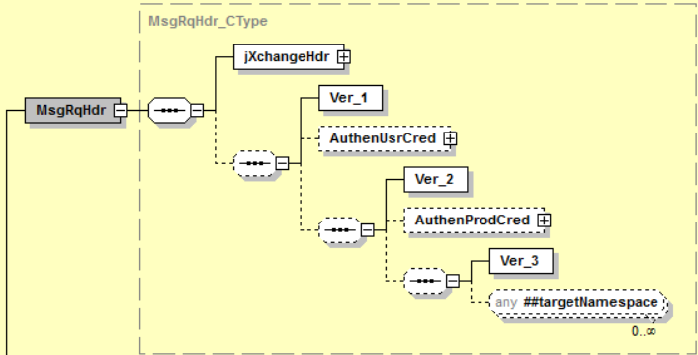

Simple Elements
The following simple elements are contained within this complex.
AuthenProdCred
Authentication of the Consumer Product Credentials in the form of a WS Security element that contains a single SAML V2.0 Assertion.

AuthenUsrCred_CType
AuthenUsrCred_CType is a complex CType element. This element represents authentication of the enduser credentials in the form of a WS Security element that contains a single SAML V2.0 Assertion.
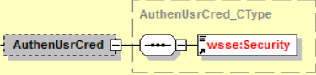

Simple Elements
The following simple elements are contained within this complex.
Security
Defines the wsse:Security SOAP header element.
jXchangeHdr_CType
jXchangeHdr_CType is a complex CType element.
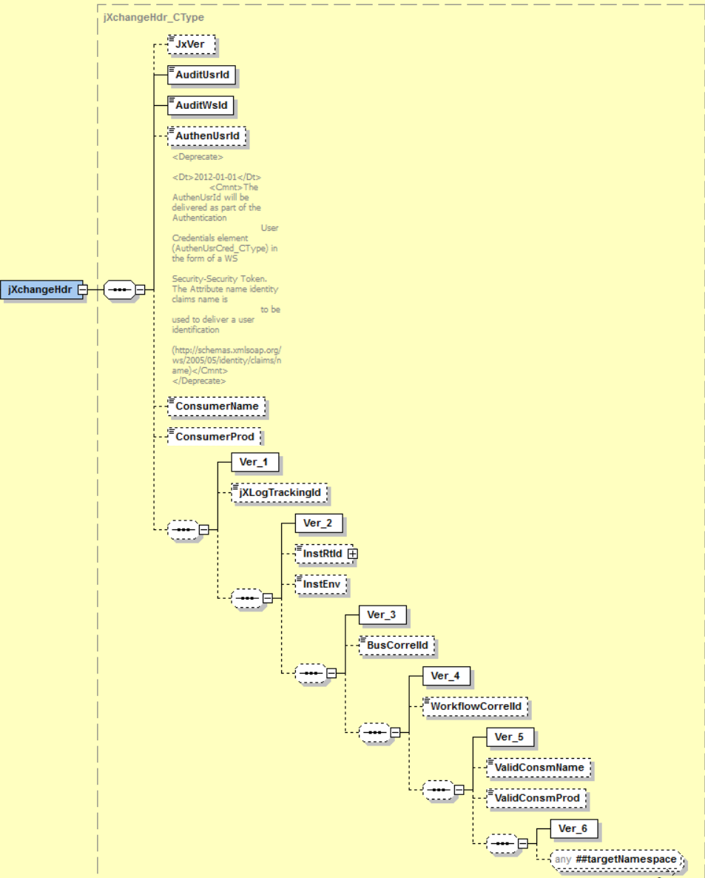

Simple Elements
The following simple elements are contained within this complex.
AuditUsrId
The user ID that the consumer would like written in the audit as performing the requested service. It varies, but it could be the same as the user ID. It is not used to authenticate. It is used to audit the Soap Header Fault. This element is Required. The User Id sent in this element will have to be configured within the JHA Teller System.
AuditWsId
The workstation ID that the consumer would like written in the audit as performing the requested service for the Soap Header Fault. It varies, but it could be the same as the user ID. This element is Required. The Workstation Id sent in this element will have to be configured within the JHA Teller System.
AuthenUsrId
The user ID which the consumer would like the service provider to authenticate with for the Soap Header Fault. It is a user ID that the provider understands.
This element deprecates in accordance with XSD contract tenets. Effective date: 2017–01–01. The new complex element for user authentication credentials was added to both the Search Message Request Header SrchMsgRqHdr_CType and the Message Request Header MsgRqHdr_CType. AuthenUsrId is ignored by the service providers when the authentication user credentials AuthenUsrCred_CType package is delivered. The expectation is that the password credentials and the user name token are provided in the authentication user credential complex element in accordance with the standards established by WS-Security.
BusCorrelId
The correlation identification as related to business functions and activities.
ConsumerName
The name of the service consumer (business name) for the Soap Header Fault.
ConsumerProd
The name of the product which is consuming the service (business product name) for the Soap Header Fault.
InstEnv
An identification provided by the consumer that defines the environment in which the institution is operating. Canonical values are:
Prod
InstRtId
The identification of the entity of the submitted message. A financial institution entity uses the routing transit or nine-digit number assigned to financial institutions for routing as assigned by the American Bankers Association. Any leading zeros must be provided for a complete routing and transit number. A non-financial institution entity should use a mutually agreed upon identification that must contain at least one non-integer character.
The element is required in all message requests.
jXLogTrackingId
An identification provided by jXchange to be able to trace the request and response of a message from the third-party gateway, internal gateway, and service provider for the Soap Header Fault.
JxVer
Contains the version jXchange is running for the Soap Header Fault.
ValidConsmName
The consumer name that can be validated by enterprise governance. The canonical values are managed in a consumer/product enterprise table.
ValidConsmProd
The consumer product name that can be validated by enterprise governance. The canonical values are managed in a consumer/product enterprise table.
WorkflowCorrelId
The correlation identification as related to workflow functions and activities.

MsgRsHdr_CType
MsgRsHdr_CType is a complex CType element. This is the default message response header.
Contains:
jXchangeHdr_CType
MsgRecInfoArray_AType
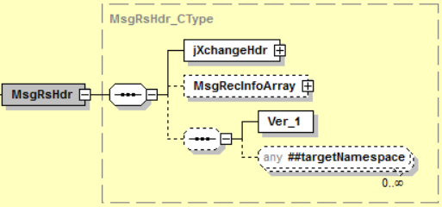
jXchangeHdr_CType
jXchangeHdr_CType is a complex CType element.

Simple Elements
The following simple elements are contained within this complex.
AuditUsrId
The user ID that the consumer would like written in the audit as performing the requested service. It varies, but it could be the same as the user ID. It is not used to authenticate. It is used to audit the Soap Header Fault. This element is Required. The User Id sent in this element will have to be configured within the JHA Teller System.
AuditWsId
The workstation ID that the consumer would like written in the audit as performing the requested service for the Soap Header Fault. It varies, but it could be the same as the user ID. This element is Required. The Workstation Id sent in this element will have to be configured within the JHA Teller System.
AuthenUsrId
The user ID which the consumer would like the service provider to authenticate with for the Soap Header Fault. It is a user ID that the provider understands.
This element deprecates in accordance with XSD contract tenets. Effective date: 2017–01–01. The new complex element for user authentication credentials was added to both the Search Message Request Header SrchMsgRqHdr_CType and the Message Request Header MsgRqHdr_CType. AuthenUsrId is ignored by the service providers when the authentication user credentials AuthenUsrCred_CType package is delivered. The expectation is that the password credentials and the user name token are provided in the authentication user credential complex element in accordance with the standards established by WS-Security.
BusCorrelId
The correlation identification as related to business functions and activities.
ConsumerName
The name of the service consumer (business name) for the Soap Header Fault.
ConsumerProd
The name of the product which is consuming the service (business product name) for the Soap Header Fault.
InstEnv
An identification provided by the consumer that defines the environment in which the institution is operating. Canonical values are:
Prod
InstRtId
The identification of the entity of the submitted message. A financial institution entity uses the routing transit or nine-digit number assigned to financial institutions for routing as assigned by the American Bankers Association. Any leading zeros must be provided for a complete routing and transit number. A non-financial institution entity should use a mutually agreed upon identification that must contain at least one non-integer character.
The element is required in all message requests.
jXLogTrackingId
An identification provided by jXchange to be able to trace the request and response of a message from the third-party gateway, internal gateway, and service provider for the Soap Header Fault.
JxVer
Contains the version jXchange is running for the Soap Header Fault.
ValidConsmName
The consumer name that can be validated by enterprise governance. The canonical values are managed in a consumer/product enterprise table.
ValidConsmProd
The consumer product name that can be validated by enterprise governance. The canonical values are managed in a consumer/product enterprise table.
WorkflowCorrelId
The correlation identification as related to workflow functions and activities.

Possible Error Codes:
1020, 1022, 1051, 1052, 1053, 9040, 9999, 2002, 2003, 2009, 2015, 2016, 2017, 2018, 2021, 2031, 2401, 2505, 2700

SrchMsgRqHdr/SrchMsgRsHdr
SrchMsgRqHdr/SrchMsgRsHdr is a required element for all jXchange search and inquiry services.

SrchMsgRqHdr/SrchMsgRsHdr Behavior
The Teller Transaction Search provides consumers with a listing of transaction items from Teller, based upon search filters provided, such as cash deposits, check deposits, cash withdrawals and cash checks.

SrchMsgRqHdr/SrchMsgRsHdr Business Case
The consumer is attempting to perform any Teller Search or Inquiry functions in this business case.
The Third Party Consumer sends the SrchMsgRqHdr_CType as part of any Teller Search or Inquiry message with the following values:
Complex Element | Simple Element | Example Value
SrchMsgRqHdr
jXchangeHdr | JxVer | 2016.0.08
 | AuditUsrId | USER1234
 | AuditWsId | COMPUTERNAME1234
 | AuthenUsrId | USER1234
 | ConsumerName | JHA
 | ConsumerProd | VERTEX
 | jXLogTrackingId | c5b49f3f-3d35-4f78-ba94-334146f729fe
 | InstRtId | 123456789
 | InstEnv | PROD
 | BusCorrelId | 127f9790-7083-4bb0-8e17-4b8aec686904
 | WorkflowCorrelId | n/a
 | ValidConsmName | JHA
 | ValidConsmProd | VERTEX
 | MaxRec | 500
 | Cursor | 0
AuthenUsrCred | wsse:Security | (SAML credentials)
AuthenProdCred | wsse:Security | (SAML credentials)

The Service Provider returns SrchMsgRsHdr_CType with the following values:
Complex Element | Simple Element | Example Value
SrchMsgRsHdr
jXchangeHdr | JxVer | 2016.0.08
 | AuditUsrId | USER1234
 | AuditWsId | COMPUTERNAME1234
 | AuthenUsrId | USER1234
 | ConsumerName | JHA
 | ConsumerProd | VERTEX
 | jXLogTrackingId | c5b49f3f-3d35-4f78-ba94-334146f729fe
 | InstRtId | 123456789
 | InstEnv | PROD
 | BusCorrelId | 127f9790-7083-4bb0-8e17-4b8aec686904
 | WorkflowCorrelId
 | ValidConsmName | JHA
 | ValidConsmProd | VERTEX
 | SentRec | 1
 | MoreRec | false
 | Cursor | 0
 | TotRec | 1

SrchMsgRqHdr_CType
SrchMsgRqHdr_CType is a complex CType element. This is a standard request message header.
Contains:
jXchangeHdr_CType
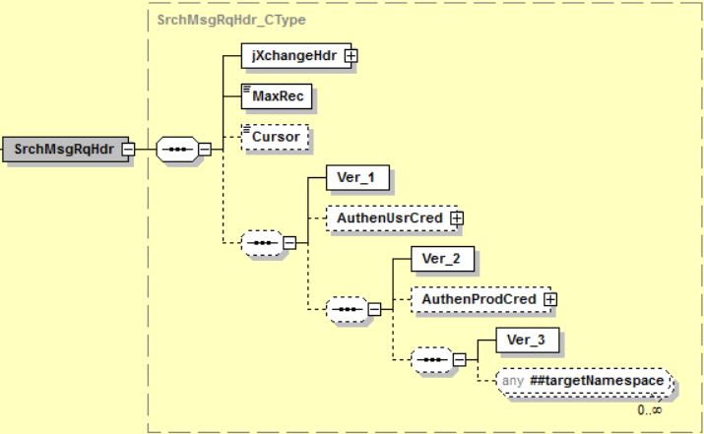

Simple Elements
The following simple elements are contained within this complex.
Cursor
The state information that allows the next call to understand where it left off when returning multiple records and allowing a subsequent call to retrieve more records.
MaxRec
The maximum number of records when multiple records are returned. This element is Required.
AuthenProdCred
Authentication of the Consumer Product Credentials in the form of a WS Security element that contains a single SAML V2.0 Assertion.

AuthenUsrCred_CType
AuthenUsrCred_CType is a complex CType element. This element represents authentication of the enduser credentials in the form of a WS Security element that contains a single SAML V2.0 Assertion.

Simple Elements
The following simple elements are contained within this complex.
Security
Defines the wsse:Security SOAP header element.

jXchangeHdr_CType
jXchangeHdr_CType is a complex CType element.

Simple Elements
The following simple elements are contained within this complex.
AuditUsrId
The user ID that the consumer would like written in the audit as performing the requested service. It varies, but it could be the same as the user ID. It is not used to authenticate. It is used to audit the Soap Header Fault. This element is Required. The User Id sent in this element will have to be configured within the JHA Teller System.
AuditWsId
The workstation ID that the consumer would like written in the audit as performing the requested service for the Soap Header Fault. It varies, but it could be the same as the user ID. This element is Required. The Workstation Id sent in this element will have to be configured within the JHA Teller System.
AuthenUsrId
The user ID which the consumer would like the service provider to authenticate with for the Soap Header Fault. It is a user ID that the provider understands.
This element deprecates in accordance with XSD contract tenets. Effective date: 2017–01–01. The new complex element for user authentication credentials was added to both the Search Message Request Header SrchMsgRqHdr_CType and the Message Request Header MsgRqHdr_CType. AuthenUsrId is ignored by the service providers when the authentication user credentials AuthenUsrCred_CType package is delivered. The expectation is that the password credentials and the user name token are provided in the authentication user credential complex element in accordance with the standards established by WS-Security.
BusCorrelId
The correlation identification as related to business functions and activities.
ConsumerName
The name of the service consumer (business name) for the Soap Header Fault.
ConsumerProd
The name of the product which is consuming the service (business product name) for the Soap Header Fault.
InstEnv
An identification provided by the consumer that defines the environment in which the institution is operating. Canonical values are:
Prod
InstRtId
The identification of the entity of the submitted message. A financial institution entity uses the routing transit or nine-digit number assigned to financial institutions for routing as assigned by the American Bankers Association. Any leading zeros must be provided for a complete routing and transit number. A non-financial institution entity should use a mutually agreed upon identification that must contain at least one non-integer character. The element is required in all message requests.
jXLogTrackingId
An identification provided by jXchange to be able to trace the request and response of a message from the third-party gateway, internal gateway, and service provider for the Soap Header Fault.
JxVer
Contains the version jXchange is running for the Soap Header Fault.
ValidConsmName
The consumer name that can be validated by enterprise governance. The canonical values are managed in a consumer/product enterprise table.
ValidConsmProd
The consumer product name that can be validated by enterprise governance. The canonical values are managed in a consumer/product enterprise table.
WorkflowCorrelId
The correlation identification as related to workflow functions and activities.

SrchMsgRsHdr_CType
SrchMsgRsHdr_CType is a complex CType element. It searches specific message response headers.
Contains:
jXchangeHdr_CType
MsgRecInfoArray_AType
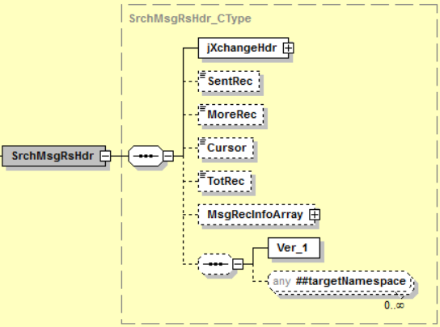

Simple Elements
The following simple elements are contained within this complex.
Cursor
The state information that allows the next call to understand where it left off when returning multiple records and allowing a subsequent call to retrieve more records.
MoreRec
Indicates if there are more records that could be returned. Canonical values are:
false
true
SentRec
The number of records sent in the response.
TotRec
Indicates the total records the request selected, which could be larger than MaxRec.

jXchangeHdr_CType
jXchangeHdr_CType is a complex CType element.

Simple Elements
The following simple elements are contained within this complex.
AuditUsrId
The user ID that the consumer would like written in the audit as performing the requested service. It varies, but it could be the same as the user ID. It is not used to authenticate. It is used to audit the Soap Header Fault. This element is Required. The User Id sent in this element will have to be configured within the JHA Teller System.
AuditWsId
The workstation ID that the consumer would like written in the audit as performing the requested service for the Soap Header Fault. It varies, but it could be the same as the user ID. This element is Required. The Workstation Id sent in this element will have to be configured within the JHA Teller System.
AuthenUsrId
The user ID which the consumer would like the service provider to authenticate with for the Soap Header Fault. It is a user ID that the provider understands.
This element deprecates in accordance with XSD contract tenets. Effective date: 2017–01–01. The new complex element for user authentication credentials was added to both the Search Message Request Header SrchMsgRqHdr_CType and the Message Request Header MsgRqHdr_CType. AuthenUsrId is ignored by the service providers when the authentication user credentials AuthenUsrCred_CType package is delivered. The expectation is that the password credentials and the user name token are provided in the authentication user credential complex element in accordance with the standards established by WS-Security.
BusCorrelId
The correlation identification as related to business functions and activities.
ConsumerName
The name of the service consumer (business name) for the Soap Header Fault.
ConsumerProd
The name of the product which is consuming the service (business product name) for the Soap Header Fault.
InstEnv
An identification provided by the consumer that defines the environment in which the institution is operating. Canonical values are:
Prod
InstRtId
The identification of the entity of the submitted message. A financial institution entity uses the routing transit or nine-digit number assigned to financial institutions for routing as assigned by the American Bankers Association. Any leading zeros must be provided for a complete routing and transit number. A non-financial institution entity should use a mutually agreed upon identification that must contain at least one non-integer character.
The element is required in all message requests.
jXLogTrackingId
An identification provided by jXchange to be able to trace the request and response of a message from the third-party gateway, internal gateway, and service provider for the Soap Header Fault.
JxVer
Contains the version jXchange is running for the Soap Header Fault.
ValidConsmName
The consumer name that can be validated by enterprise governance. The canonical values are managed in a consumer/product enterprise table.
ValidConsmProd
The consumer product name that can be validated by enterprise governance. The canonical values are managed in a consumer/product enterprise table.
WorkflowCorrelId
The correlation identification as related to workflow functions and activities.

Possible Error Codes:
1020 | Error | The requested business service did not return any data responses or messages.
1022 | Error | Date is not valid.
1051 | Error | Required field.
1052 | Error | Invalid user ID.
1053 | Error | User Id disabled.
9040 | Error | Error opening file.
9999 | Error | Value entered must be greater than zero.
2002 | Error | The audit workstation Id is required.
2003 | Error | The consumer product is required.
2009 | Error | The maximum number of records must be greater than zero.
2015 | Error | An invalid cursor was specified.
2016 | Error | The institution routing identifier is required.
2017 | Error | Invalid value based on data type.
2018 | Error | The institution routing identifier is invalid.
2021 | Error | The audit user Id is required.
2031 | Error | The requested max number of records was greater than the systems configured max.
2401 | Error | The provider name is required.
2505 | Error | Access was denied.
2700 | Error | The business correlation Id is required.

MsgRecInfoArray
MsgRecInfoArray is an array in all jXchange Response services for returning errors to the consumer.

MsgRecInfoArray Behavior
The Teller Transaction Search provides consumers with a listing of transaction items from Teller, based upon search filters provided, such as cash deposits, check deposits, cash withdrawals and cash checks.

Teller Service Response with Error Business Case
The consumer is attempting to perform a Teller Transaction Search business case, and an error is returned.
The Service Provider returns MsgRecInfoArray_AType with the following values:
Complex Element | Simple Element | Example Value
MsgRecInfoArray
MsgRec | ErrCode | 199
 | ErrCat | Error
 | ErrDesc | The processing period must be a valid business date.
 | ErrElem | TSPD
 | ErrElemVal | 12-32-2016
 | ErrLoc | TXTRNADD

MsgRecInfoArray_AType
MsgRecInfoArray_AType is an array AType element. This is an array of messages that can be returned in a response.
Contains:
MsgRec_CType
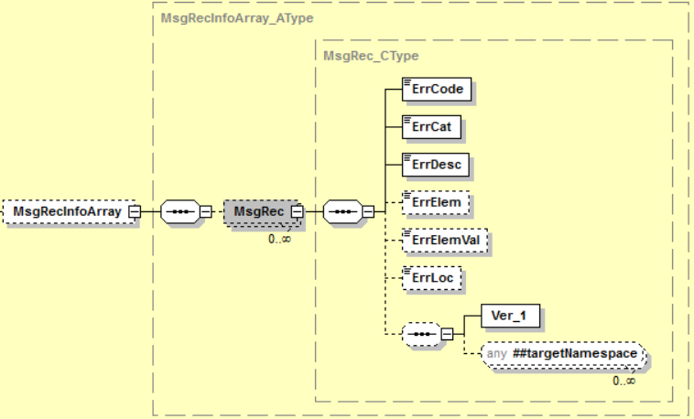

MsgRec_CType
MsgRec_CType is a complex CType element.

Simple Elements
The following simple elements are contained within this complex.
ErrCat
The Soap Header Fault error category. This is a required element.
ErrCode
The Soap Header Fault error code. This is a required element.
ErrDesc
The Soap Header Fault error description. This is a required element.
ErrElem
The Soap Header Fault when an error or fault occurs. This optional element contains the element which is causing the error condition.
ErrElemVal
The Soap Header Fault when an error or fault occurs. This optional element contains the value of the element which is causing the error condition.
ErrLoc
The Soap Header Fault error location. This is typically the program that generated the error condition.

Teller Services Error Codes

Teller Specific Error Codes
1 Error Record not found
2 Error Record already exists
5 Error Cannot allocate files
10 Error Error-Key field(s) specified already exist. Use Different key values.
11 Error Beginning Record cannot be negative
16 Error Cannot open files
48 Error Maximum records must be greater than zero and less than or equal to 4000
49 Warning No Records Match Selection Criteria
100 Error Invalid status - Must be "L=Live or T=Test"
101 Error Unable to write Record to the file
102 Error Invalid OnLine - Must be "1=On or 0=Off"
103 Error Invalid Drawer Type.
104 Error Invalid Drawer Number.
105 Error Valid Values are 'Y' and 'N'.
110 Error Invalid Institution Class.
111 Error Invalid Institution Number.
112 Error Invalid value for offset must be '+ - or blank'
113 Error Invalid Range 0-24.
114 Error Invalid time Entered. Must be entered in military format.
115 Error Invalid maximum days to roll date must be greater than zeros.
116 Error Invalid TimeStamp. Must be in *ISO format. CCYYMMDDHHMMSS
117 Error Routing Number Must be at least Nine Digits Numeric.
118 Error Invalid Branch Number.
119 Error Invalid Cash Machine program.
120 Error Valid Values are 'V' or 'M'.
121 Error Valid Values are (D)ispenser or (R)ecycler.
122 Error Invalid Date. Must be in CCYYMMDD.
123 Error Invalid Display Images Type.
124 Error Invalid Printer Type.
125 Error Invalid Transaction Printer
126 Error Invalid Passbook Printer.
127 Error Invalid Form Printer.
128 Error Invalid Cash Machine Drawer.
129 Error Invalid Mix Name.
131 Error Invalid Printer Name.
132 Error Invalid Cradle Direction. (L)eft of (R)ight or (V)ault.
133 Error Invalid Country Code.
134 Error Invalid Currency Code
135 Error Invalid Round Up/Down value, Values = 'D' or 'U'
136 Error Invalid Compartment.
137 Error Valid Values are 'Y' or 'D' or Blank.
138 Error CTR catagory must be in range from 0 to 9.
139 Error Associated line must be a different line.
140 Error Associated line could not be found.
141 Error Invalid Non-Cash Category.
142 Error Valid Values are 'M','N','D', or 'P'.
143 Error Invalid Host Tran Code Entered.
144 Error Invalid Check Type Entered.
145 Error Invalid Item Capture Type Entered.
146 Error Valid entries are either D=Debit, C=Credit or Blanks.
147 Error Calc Amount must be 1=(+),-1=(-),9=(*CALC),8=(*CALV),or 0=(Blank).
148 Error Memo Amount must be 1=(+),-1=(-),2=(*),or 0=(Blank).
149 Error Cash Amount must be 1=(+),-1=(-),or 0=(Blank).
150 Error Hot-Key already exists.
151 Error Valid Values are (0)External,(1)Internal
152 Error Valid Values are (T)Tradional,(I)Item Capture.
153 Error Invalid prompt for receipt value entered.
154 Error Transaction Type is Not Valid.
155 Error Invalid Context Entered.
156 Error Invalid Hook Entered.
157 Error Invalid Deposit type entered. (Valid Types W/D/I)
158 Error Invalid form application entered.
159 Error Valid Values are (C)redit or (D)ebit.
160 Error Valid Values are (D)Vertex Defined or (U)User Defined.
161 Error Valid Values are Blank,(O)OffLine,(T)Test or (S)Store Forward.
162 Error Valid Values are Blank,(D)Deleted or (P)Pending.
163 Error Workstation not configured in Vertex.
164 Error User is not setup in the Vertex system.
165 Error Invalid Policy entered.
167 Error Valid Values are 'Y' or 'N' or Blank.
168 Error Valid Values are "1=On or 0=Off" or Blank.
169 Error Invalid ID Type entered.
170 Error Invalid Invalid I.D. Issuer entered.
171 Error Invalid Vendor Field Entered.
172 Error Valid person type is I=Individual or O=Organization.
173 Error Library does not exist on system. Enter a Valid Library Name.
174 Error Invalid Month. Must be 1-12.
175 Error Invalid Year. Must be 01-99.
176 Error Series Number is Incorrect.
177 Error Valid Values are (P)Posted, (E)Error or (O)OffLine.
178 Error Relative Period can be (C)=Current or (N)=Next.
179 Error Valid Values are Blank or (D)Deleted.
180 Error Invalid ticket type.
181 Error Valid Values are 'X' or Blank.
182 Error Valid Values are (U)Up or (D)Down.
183 Error Valid Values are (A)By Account or (S)By Service Chg Code.
184 Error Valid Values are (A)Account,(T)Tax ID,(N)Name or (S)Short Name.
185 Error Valid Values are (T)Thumbnail or (D)Detail.
186 Error Valid Values are (N)Disabled,(S)Speed Key or (C)Customer Centric.
187 Error Valid Values are (G)Granted or (R)Rejected.
188 Error Invalid Role.
189 Error Invalid Job List Entry.
190 Error Valid Values are (G)Group Job or (C)Command Line or Blank=Call w/o parms.
191 Error Invalid Menu Name entered.
192 Error Invalid Menu Line Number. Must be 1-34.
193 Error Invalid Menu Option Number.
194 Error Invalid Member type. Must be: CMDL or MENU.
195 Error Invalid Syntax or Bad Command Entered.
196 Error Drawer has already been assigned.
197 Error Claim Drawer Unsucessful.
198 Error This Date has Already been Closed for work.
199 Error The processing period must be a valid business date.
200 Error Processing period is not available.
201 Error Prior Processing Period still Open.
202 Error Invalid Sequence Number.
203 Error Invalid Library List.
204 Error Valid Values are (A)Any or (E)Exact.
205 Error Memo Post Rules = (F)ull,(+)Avail+,(A)Avail,(C)Cash,(!)Cash+ or (N)None.
206 Error Valid Entires are (*OVR) or (*USE) or (*NA) or (*DUAL).
207 Error Valid Values are 'Y' or Blank.
208 Error Valid Values are (E)Edited, (O)OffLine or Blank..
209 Error Valid Values are (Y)Verified, (F)Failed or Blank.
210 Error Printer has not been configured.
211 Error Assign a new set of check numbers.
212 Error Check numbers have not been assigned.
213 Error IMAGE has not been loaded.
214 Error An Image required for this form is not mapped to the printer.
215 Error The CHECK IMAGE does not exist in folder VERTEX.
216 Error Error Voiding Check. (CKDLTT)
217 Error Error Voiding MIL. (CKDLTT)
218 Error (PTTDLT) Error: Transaction has Closed Session.
219 Error (PTTDLT) Error Deleting PTDETL Records.
220 Error (PTTDLT) Error Deleting PTSUM Records.
221 Error (PTTDLT) Error Deleting PTSUMF Records.
222 Error (PTTDLT) Error Reversing PTDWRT Records.
223 Error (PTTDLT) Error Reversing PTDWRF Records.
224 Error (PTTDLT) Error Reversing PTBOS Records.
225 Error Error Writing to the Electronic Journal File.
226 Error (PTTDLT) Error Setting up the Vertex Environment.
227 Error Cannot delete a deleted transaction.
228 Error Error occurred while parsing XML from the request.
229 Error The Person# does not exist in master file.
230 Error Valid Values are 'A','B','C','D','E' or 'F'.
231 Error Invalid Account Relationship Type.
232 Error Valid Values are Blank,(C)Conversion,(V)Vertex,(A)ATM or (S)Store Forward.
233 Error Service Charge Code Required.
234 Warning Invalid Operation for a Test Drawer.
235 Error Valid Values are Blank,(D)*Dsp,(M)*Mand or (N)*NoDsp.
236 Error *NODSP is invalid for Remitter when Mandatory F4 ='Y'.
237 Error Number of Checks must be Greater than Zero.
238 Error Check numbers have not been assigned.
239 Warning **WARNING** Check Number Source is Low.
240 Error Check Type (TC) is Not Valid for Offline Checks.
241 Error Offline Checks cannot Be Generated. No Fields Selected on Check Type.
242 Error Number of Checks Exceed the Series.
243 Error A Check Number in the Series has Previously been Issued.
244 Error That Tax ID Number is already being used.
245 Error That Tax ID and Person Type is already being used.
246 Error Checks cannot Be Printed. See Messages for Details.
247 Error Valid Values are Y=Yes, N=No, T=Test
248 Error Valid Values are P=Production, T=Test
249 Error Valid Valies are N=Nightly, W=Weekly, B=BiWeekly S=Since Last
250 Error Valid Valies are D=Debit, C=Credit, or B=Both
251 Error Invalid Item Capture Type.
800 Warning Some Account Validation Information is not available. Account Servers are Down.
801 Error DataQ is not available. Please Contact Tech Support.
802 Warning Yellowhammer Fraud Detection was not able to analyze data on this transaction.
1,020 Warning The requested business service did not return any data responses or messages.
1,021 Error Numeric data is not valid.
1,022 Error Date is not valid.
1,023 Error The Request file contains no data.
1,024 Warning **WARNING** The requested Transaction was re-numbered,
1,051 Error Required Field.
1,052 Error Invalid User Id.
1,053 Error User Id Disabled.
1,054 Error Invalid Password.
9,040 Error Error opening file
9,999 Error Value entered must be greater than zero.
803 Warning Offline:Check number requested not in offline status. Information not Updated.
1,055 Error Password has expired.
1,056 Error *USE authority to user profile required.
1,025 Warning **WARNING** Requsted Transaction ICXP X937 File has been stored previously.
1,026 Warning **WARNING** Requsted Transaction ICXP CDI File has been stored previously.
1,027 Warning **WARNING** Requsted Transaction JX Tracking ID has been stored previously.
252 Error Invalid prompt for balance value entered.
253 Warning Positive Pay update was Unsuccessful! Check was not recorded.
3,100 Error Proposed addition failed because index combination already exists.
3,101 Error Proposed modification failed because no match was found.
3,102 Error Specified Recipient exists for other publisher.
3,103 Error This field is required and cannot be null.
3,104 Error Newer information is available.
3,105 Error No key specified.
3,106 Error This field is required when Recipient Contact Type is provided.
3,107 Error Consumer Product does not exist for this recipient.
3,108 Error Request contains multiple contact points with the same recipient contact ID.
3,109 Error The alert recipient subscription information array is required.
3,110 Error Must have at least one entry in the alert recipient subscription information arr
3,111 Error The alert recipient subscription information record is required.
3,112 Error The Coordinated Universal Time (UTC) offset is invalid.
3,113 Error The specified alert name not valid for any publisher lib deployed to the institu
3,114 Error The alert send information record is required.
3,115 Error Must have at least one entry in the alert send information record.
3,116 Error Format is invalid
3,117 Error The send alert array is required.
3,118 Error You must have at least one entry in the SndAlrtArray.
3,119 Error Specifying a Consumer Recipient Acct Id requires specifying a Consumer Recipient
3,120 Error The Coordinated Universal Time (UTC) Datetime is invalid.
3,121 Error Specified alert name not valid for the applicable publisher lib for the institute
3,122 Error AlrtInfoRec reqrs initialized SndEvrySub elem or 1 valid record in SndAlrtArray
3,123 Error Must provide either ConsmRecipId and DistGroupId in a single SndAlrtRec.
3,124 Error PubVer not valid for this institution/publisher combination.
3,125 Error Cannot provide both ConsmRecipID and DistGroupId in a single SndAlrtRec
3,126 Error Specified institution has no deployed publisher libraries for the specified publ
3,127 Error When sending to send every subscriber, you may not include recipients in SndAlrt
3,128 Error Out of range (limited to 512 characters).
3,129 Error Must have at least one entry in the RecipOptInInfoRec.
3,130 Error The ConsumerProd specified in the RecipOptInInfoRec is invalid.
3,131 Warning Contact information was duplicated, only one contact was added.
3,132 Warning Contact information already exists.
2,002 Error The audit workstation id is required.
2,003 Error The consumer product is required.
2,005 Error Value does not match defined list of enumerations.
2,008 Error No records match selection criteria
2,009 Error The maximum number of records must be greater than zero.
2,010 Error At a minimum, one search value must be populated with a value.
2,015 Error An invalid cursor was specified.
2,016 Error The institution routing identifier is required.
2,017 Error Invalid value based on data type.
2,018 Error The institution routing identifier is invalid.
2,021 Error The audit user id is required.
2,031 Error The requested max number of records was greater than the system's configured max
2,205 Error The unique identifier is required.
2,401 Error The provider name is required
2,505 Error Access was denied
2,700 Error The business correlation id is required
254 Error Invalid Transaction Receipt ID entered.
255 Error Invalid CTR Transaction ID entered.
256 Error Valid Values are B=Benefactor, T=Transactor.

iAdapter Error Codes
9900102 Error The iAdapter Service did not return a valid response
9900206 Error Error occurred building iAdapter Returned Messages
9900207 Error Error occurred building iAdapter Returned Messages
9900350 Error Unmonitored error occurred with Provider Request Procedure
9900351 Error Requested Name Space not found
9900352 Error Requested Root Element not found in Operation Master File
9900353 Error Requested Version not found
9900400 Error Requested Host Operation not available at this time
9900401 Error Unmonitored error occurred retrieving mapping information
9900450 Error Unmonitored error occurred with the iAdapter Consumer Service
9900451 Error Error occurred parsing the URL
9900455 Error Error occurred building the HTTP Header
9900475 Error Web Service information not found for requested Operation
9900511 Error Unmonitored error occurred building SOAP XML Document
9900560 Error Unknown Error Initiating Web Service
9900565 Error Error Establishing Client Session with Web Server
9900566 Error Error Sending HTTP Header to Web Service
9900567 Error Did Not Recieve HTTP continue from Web Service
9900568 Error Error Sending Request Document to Web Service
9900569 Error Error Recieving Response Document From Web Service
9900570 Error HTTP Error With Request Document
9900575 Error The Web Service did not return valid Messages or Results
9900910 Warning Aggregate Procedure not available for current provider
9900916 Error Error occurred building Provider Messages Response
9900917 Error Error occurred building Provider Fault Response
9901001 Error Unmonitored error occurred in the iAdapter Transformation Service
9901100 Error Requested Instition Id not found
9901101 Error Unmonitored error occurred running iAdapter Transformation Startup
9901115 Error Library List not set for requested Institution Id
9901116 Error Error setting Library List for requested Institution Id
9901130 Error Error initializing the XML ToolKit
9901818 Error Unmonitored error occurred with iAdapter Built-in-Command
9901901 Error Unmonitored error occurred in the Provider Procedure
9901902 Error Unable to activate provider procedure
9901920 Error Attempt to exceed the maximum number of allowed Provider Procedures
9901921 Error Unmonitored error occurred running a Provider Procedure
9901923 Error Error occurred reclaiming Provider Procedure response allocation
9901924 Error Error occurred reclaiming Provider Procedure messages allocation
9901925 Error Unmonitored error occurred reclaiming Provider Procedure allocation
9902100 Error Attempt to exceed maximum number of cached Operations
9902101 Error Unmonitored error occurred caching an Operation
9902105 Error Unmonitored error occurred with caching initial service data
9902120 Error No JXVERSION records found
9902121 Error Attempt to exceed maximum number of JXVERSION records
9902122 Error Error occurred retrieving JXVERSION record information
9902123 Error Unmonitored error occurred building JXVERSION cache
9902130 Error No JXNAMESPC records found
9902131 Error Attempt to exceed maximum number of JXNAMESPC records
9902132 Error Error occurred retrieving JXNAMESPC record information
9902133 Error Unmonitored error occurred building JXNAMESPC cache
9902140 Error No Root Element mapping found
9902141 Error Attempt to exceed maximum number of Root Element Mappings
9902142 Error Error occurred retrieving Root Element Mapping records
9902143 Error Unmonitored error occurred building Root Element cache
9902151 Error Attempt to exceed maximum number of JXMAPPER records
9902152 Error Error occurred retrieving JXMAPPER record information
9902153 Error Unmonitored error occurred building JXMAPPER cache
9902162 Error Error occurred retrieving JXMAST record information
9902163 Error Unmonitored error occurred building JXMAST Operation cache
9902171 Error Attempt to exceed maximum number of JXWEBSERV records per Operation
9902172 Error Error occurred retrieving JXWEBSERV record information
9902173 Error Unmonitored error occurred building JXWEBSERV Operation cache
9902181 Error Attempt to exceed maximum number of JXOPER Application records per Operation
9902182 Error Error occurred retrieving JXOPER record information
9902183 Error Unmonitored error occurred building JXOPER Operation cache
9902191 Error Attempt to exceed maximum number of JXKEYS records per Operation
9902192 Error Error occurred retrieving JXKEYS record information
9902193 Error Unmonitored error occurred building JXKEYS JXXML Operation cache
9902195 Error Attempt to exceed maximum number of JXXML records per Operation per FileKey
9902196 Error Error occurred retrieving JXXML record information
9903101 Error Unmonitored error occurred with XML Document Build procedure
9903111 Error Unmonitored error occurred processing requested Stream File
9903115 Error Error occurred with the requested starting XPath
9903121 Error Unmonitored error occurred processing XML XPath
9903125 Error Error occurred building node array for requested XPath information
9904101 Error Unmonitored error occurred with XML Document Parse procedure
9904105 Error Attempt to exceed maximum Stream File size
9904125 Error Error occurred building node array for requested XPath information
9904214 Error IFS Field Type must contain a valid file name as a Default Value
9907300 Error Error occurred creating the XML Parsing Document from request
9907301 Error Unmonitored error occurred creating XML Parsing Document
9907500 Error Root Element may not be blank creating XML Build Document
9907501 Error Unmonitored error occurred creating XML Build Document
9907505 Error Error occurred creating XML Build Document
9907601 Error Unmonitored error occurred creating XML Soap Document
9907603 Error Unmonitored error occurred merging two XML Documents
9920001 Error Error occurred mapping the element's value
9920011 Error Unmonitored error occurred setting Data Stream Value
9920012 Error Unmonitored error occurred retrieving Data Stream Value
9920013 Error Unmonitored error occurred setting Provider Value
9920014 Error Unmonitored error occurred setting XML Node Value
9920020 Error Required element not sent with request
9920030 Error Error converting Field Value to its mapped Canonical Value
9920031 Error Mapping for Canonical Value not found for required Field Value
9920032 Warning Mapping for Canonical Value not found for optional Field Value
9920035 Error Error translating required Field Value to its Element Tag Name
9920036 Error Tag Name translation not found for required Field Value
9920037 Warning Tag Name translation not found for optional Field Value
9920040 Error The length of the element's value is greater than maximum allowed
9920041 Error Unmonitored error occurred setting Character Value
9920042 Error The number of decimal places is invalid
9920043 Warning The element's value is greater than the provider allows. Element was truncated.
9920045 Error Error with Boolean Type conversion
9920046 Error Error with Boolean Type conversion
9920047 Error The numeric value is greater than maximum allowed
9920048 Error Value cannot be less than zero
9920050 Error Numeric value is invalid
9920051 Error Unmonitored error occurred setting Numeric Value
9920055 Error Date value is invalid
9920056 Error Date value is invalid
9920057 Error Unmonitored error occurred setting Date Data Type
9920065 Error Time value is invalid
9920066 Error Time value is invalid
9920067 Error Unmonitored error occurred setting Time Data Type
9920075 Warning Provider Field contains invalid data and can not be returned
9920076 Error Required Provider Field contains invalid data and can not be returned
9920117 Error Application element is invalid for request
9920118 Error Selection Criteria is invalid for request
9920161 Error Error setting Provider Value
9920201 Error Unknown error retrieving element value from XML document
9920202 Error Unknown error retrieving element value from XML document
9920203 Error Node value exceeded maximum data size
9920210 Error Array has too many elements to map to provider
9920211 Error Unknown error building XML element value
9920215 Error Array's element length is greater than maximum allowed
9920220 Warning Number of Array Elements Found greater than allowed by Provider
9920500 Error The Application/Selection information not available for requested message
9920501 Error Error retrieving Application/Selection Information
9920600 Error Field mapping not found for requested File Key
9920610 Error Error retrieving JXTAGS store for requested file
9920622 Error Error with Field Mappings, Provider Reference File has changed
9920623 Error Unable to locate provider reference file...may be missing or not authorized
9920624 Warning Provider reference file has changed.
9920651 Error Error building XML element
9920994 Warning Element sent with request was ignored
9920995 Error Invalid Element sent with request
9920999 Error Element Value exceeds maximum size
9930001 Error Requested Institution Id not found
9930005 Error An error occurred allocating a record of an opened Service File
9930011 Error An unknown error occurred loading Response Data
9930013 Error An unknown error occurred validing input data
9930014 Error An unknown error occurred setting default values
9930022 Error A Non-Blank value is required for the associated field(s)
9930025 Error The requested operation is not found
9930045 Error An error occurred opening a Service File
9930049 Warning No Records Match Selection Criteria
9930201 Error An error occurred building field list for requested operation
9930210 Error Error occurred parsing Field Key value
9930211 Error Requested Field Key does not exist
9930214 Error Requested Key Field information not valid for request
9930215 Error Record already exists
9930216 Error Error occurred Deleting Record
9930217 Error Error occurred Updating Record
9930218 Error Error occuring Writing Record
9930233 Error Value is not valid for associated field
9930309 Error Error building Port Information for requested institution
9930331 Error User not enrolled with any Provider
9930333 Error Error occurred validating User Profile
9940100 Error Authentication failure. Unable to validate user credentials.
9940110 Warning Not enough information to generate AliasSecretKey
9970501 Error Unable to Set Client Port
9970505 Error Error Building Client Request Data
9970510 Error Error Connecting to Server Job
9970515 Error Error Sending Data to Server Job
9970520 Error Error Recieving Data from Server Job
9970525 Error Error Parsing Response Data from Server Job

Custom_CType
Custom_CType is a complex CType element.

Custom_CType Behavior
This element is optional.
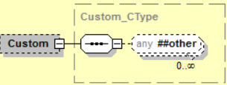

Teller Transaction Search
Teller Transaction Search is a jXchange service designed to allow the consumer to retrieve Teller Transaction information for a specific date or range of dates.

Message Flow
In jXchange, the Teller Transaction Search service uses a typical exchange of MType messages to retrieve Teller Transaction information for a specific date or range of dates from a Service Provider.

Primary Request
The Third Party Consumer forwards the TellerTrnSrchRq_MType message to the Service Provider. The message contains the required element SrchMsgRqHdr_CType. The request also contains several optional simple elements designed to filter the response. The optional element Custom_CType can also be included in the request.

Primary Response
The Service Provider returns the TellerTrnSrchRs_MType message to the Third Party Consumer. The message contains the required element SrchMsgRsHdr_CType. The optional elements TellerTrnSrchRecArray_AType and Custom_CType can also be included in the response.

Teller Transaction Search Behavior
The Teller Transaction Search provides consumers with a listing of transaction items from Teller, based upon search filters provided, such as cash deposits, check deposits, cash withdrawals and cash checks.
The Teller Transaction Search root request message TellerTrnSrchRq_MType contains a documented filter statement where the elements at the root are optional but at least one of the elements are required, Transaction Detail Low Amount <TrnDetLowAmt>, Transaction Detail High Amount <TrnDetHighAmt>, Transaction User Identification <TrnUsrId>, Teller Business Date Start <TellerBusDtStart>, Teller Business Date End <TellerBusDtEnd>, Account Identification <AcctId>, Account Type <AcctType>, Teller Transaction Code <TellerTrnCode>, Cash In Low Amount <CashInLowAmt>, Cash In High Amount <CashInHighAmt>, Cash Out Low Amount <CashOutLowAmt>, Cash Out High Amount <CashOutHighAmt>, Remark <Rmk> and Teller Drawer Identification Array <TellerDrwIdArray>.

The service provider reserves the right to limit the response set.

The Teller Transaction Search root response TellerTrnSrchRq_MType echoes back the request elements along with the Transaction Search Record array TrnSrchRecArray_AType which returns all of the items related to the Transaction Search request documented filters and two additional informational elements, Transaction Date <TrnDt> and Transaction Entry Time <TrnEntryTime>.

Teller Transaction Search Business Case
The consumer is attempting to search Teller Transactions in this business case. When sending this search request, at least one search element will be required.
The Third Party Consumer sends the TellerTrnSrchRq_MType message with the following values:
Complex Element | Simple Element | Example Value
 | TrnDetLowAmt | 0.00
 | TrnDetHighAmt | 999999999.99
 | TrnUsrId | USER123
 | TellerBusStartDt | 2016-12-30
 | TellerBusEndDt | 2017-01-03
 | AcctId | 12345678901
 | AcctType | D
 | TellerTrnCode | 203
 | CashInLowAmt | 0.00
 | CashInHighAmt | 999999999.99
 | CashOutLowAmt | 0.00
 | CashOutHighAmt | 999999999.99
 | Rmk | Check #101
TellerDrwIdArray
TellerDrwIdRec | TellerDrwId | 103

The Service Provider returns TellerTrnSrchRs_MType with the following values:
Complex Element | Simple Element | Example Value
 | TrnDetLowAmt | .00
 | TrnDetHighAmt | 999999999.99
 | TrnUsrId | USER123
 | TellerBusStartDt | 2016-12-30
 | TellerBusEndDt | 2017-01-03
 | AcctId | 12345678901
 | AcctType | D
 | TellerTrnCode | 203
 | CashInLowAmt | .00
 | CashInHighAmt | 999999999.99
 | CashOutLowAmt | .00
 | CashOutHighAmt | 999999999.99
 | Rmk | Check #101
TellerDrwIdArray
TellerDrwIdRec | TellerDrwId | 103
TellerTrnSrchRecArray
TellerTrnSrchRec | TrnRcptID | 0079500001001220151028114226
 | TrnDetAmt | 24.00
 | TrnUsrID | USER1234
 | TellerBusDt | 2017-01-02
 | AcctId | 12345678901
 | AcctType | D
 | TellerTrnCode | 203
 | TrnDt | 2016-12-30
 | TrnEntryTime | 11:01:08.0000000-06:00
 | CashIn | .00
 | CashOut | 24.00
 | TellerDrwId | 103
RmkArray
RmkInfo | Rmk | Check #101

TellerTrnSrchRq_MType
TellerTrnSrchRq_MType is a message MType element.
Contains:
Custom_CType
SrchMsgRqHdr_CType
TellerDrwIdArray_AType
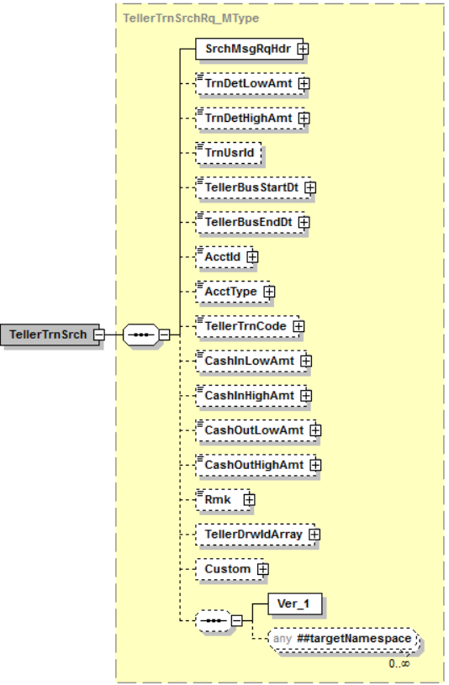

Simple Elements
The following simple elements are contained within this message.
This is a documented filter statement. Any or all of the following can be sent.
TrnDetLowAmt
Transaction Low Dollar amount
Valid values: blank; .00 to 999999999.99
If TrnDetLowAmt is sent without a TrnDetHighAmt, then all transaction amounts equal to or more than the TrnDetLowAmt should be returned.
TrnDetHighAmt
Transaction High Dollar amount
Valid values: blank; .00 to 999999999.99
If TrnDetHighAmt is sent without a TrnDetLowAmt, then all transaction amounts equal to or less than the TrnDetHighAmt should be returned.
TrnUsrId
User ID who performed transaction
Valid Values: blank; 24 character alpha-numeric
TellerBusStartDt
Business (Processing) Start Date
Valid values: blank; Business date in MM-DD-YYYY format
If TellerBusStartDt is sent without a TellerBusEndDt, then all transactions on processing date equal to or greater than the TellerBusStartDt should be returned.
TellerBusEndDt
Business (Processing) End Date
Valid values: blank; Business date in MM-DD-YYYY format
If TellerBusEndDt is sent without a TellerBusStartDt, then all transactions on processing date equal to or less than the TellerBusEndDt should be returned.
AcctId
Account Number
Valid Values: blank; Numeric up to 16 digits
A consumer request with Account Identification <AcctId> and Account Type <AcctType>will return all of the qualified transactions for the requested Account Identification and Account Type. If <AcctId> is sent without <AcctType> all qualified transactions for the requested Account will be returned.

AcctType
Account Type
Valid Values: blank; single character alpha-numeric (i.e.: D-Deposit/Checking; S-Savings; T-Time Deposit; X-Christmas Club; G-GL)
A consumer request with only an Account Type will return all of the qualified transactions for requested Account Type.

TellerTrnCode
Transaction Type Code
Valid Values: blank; 3 digit numeric – must be a valid teller transaction code
CTR
Rmk
Instrument field value (check number or other notes)
Valid Values: blank; 20 character alpha-numeric
The Remark <Rmk> element allow for wild card searches. The Search Type attribute canonical values ~Exact~, ~StartsWith~ and ~Contains~ is supported by the service provider.

TellerDrwIdArray_AType
TellerDrwIdArray_AType is a message AType element.
The Teller Drawer Identification Array <TellerDrwIdArray> includes the Teller Drawer Identification <TellerDrwId>. The Teller Drawer array allows for multiple Teller Drawers to be searched for in one request. This array should be consider an ‘or’ statement, not an ‘and’’ statement that can optionally be used in addition to the other filters.
Contains:
TellerDrwIdRec_CType
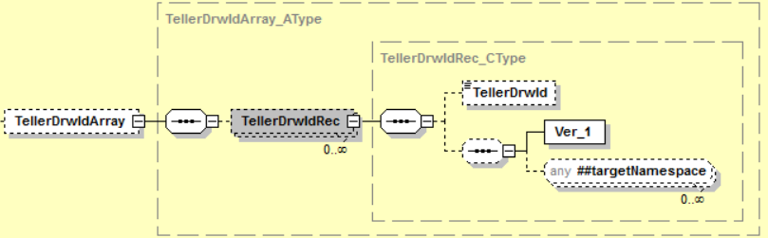

Simple Elements
The following simple elements are contained within this message.
TellerDrwId
Teller Drawer Number
Valid values: blank; 5 digit numeric

TellerTrnSrchRs_MType
TellerTrnSrchRq_MType is a message MType element.
Contains:
Custom_CType
SrchMsgRsHdr_CType
TellerDrwIdArray_AType
TellerTrnSrchRecArray_AType
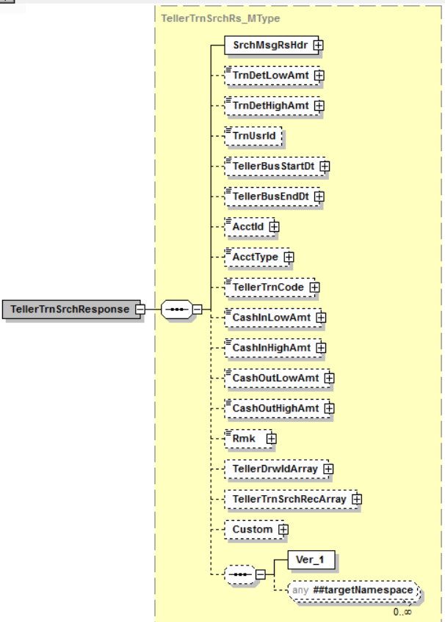

Simple Elements
The following simple elements are contained within this message.
These are an echo back of what was sent in the TellerTrnSrchRq_MType
TrnDetLowAmt
Transaction Low Dollar amount
Valid values: blank; .00 to 999999999.99
TrnDetHighAmt
Transaction High Dollar amount
Valid values: blank; .00 to 999999999.99
TrnUsrId
User ID who performed transaction
Valid Values: blank; 20 character alpha-numeric
TellerBusStartDt
Business (Processing) Start Date
Valid values: blank; Business date in MM-DD-YYYY format
TellerBusEndDt
Business (Processing) End Date
Valid values: blank; Business date in MM-DD-YYYY format
AcctId
Account Number
Valid Values: blank; numeric value up to 16 digits
AcctType
Account Type
Valid Values: blank; single character alpha-numeric (i.e.: D-Deposit/Checking; S-Savings; T-Time Deposit; X-Christmas Club; G-GL)
TellerTrnCode
Transaction Type Code
Valid Values: blank; 3 digit numeric – must be a valid teller transaction code
CashInLowAmt
Cash In Low amount
Valid values: blank; .00 to 999999999.99
CashInHighAmt
Cash In High amount
Valid values: blank; .00 to 999999999.99

CashOutLowAmt
Cash Out Low amount
Valid values: blank; .00 to 999999999.99
CashOutHighAmt
Cash Out High amount
Valid values: blank; .00 to 999999999.99
Rmk
Instrument field value (check number or other notes)
Valid Values: blank; 20 character alpha-numeric

TellerDrwIdArray_AType
TellerDrwIdArray_AType is a message AType element. This is an echo back of what was provided in TellerDrwIdArray in the request.
The Teller Drawer Identification Array <TellerDrwIdArray> includes the Teller Drawer Identification <TellerDrwId>. The Teller Drawer array allows for multiple Teller Drawers to be searched for in one request. This array should be consider an ‘or’ statement, not an ‘and’’ statement that can optionally be used in addition to the other filters.
Contains:
TellerDrwIdRec_CType

Simple Elements
The following simple elements are contained within this message.
TellerDrwId
Teller Drawer Number
Valid values: 5 digit numeric

TellerTrnSrchRecArray_AType
TellerTrnSrchRecArray_AType is a message AType element.
Contains:
TellerTrnSrchRec_CType
Rmk_AType
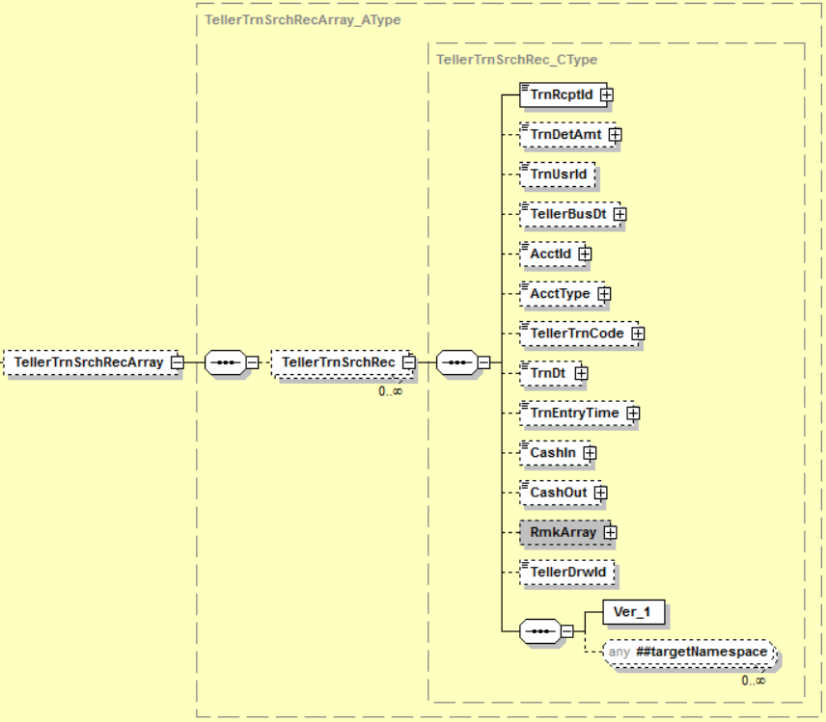

Simple Elements
The following simple elements are contained within this message.
TrnRcptId
Teller Transaction Receipt Id
TrnRcptId should include the following information; bank number, drawer number, transaction number, processing period, and time. It should be listed in the following format; (0079601515000720160718105807) and be broken out like this; TRBKID(00796), TSDWR(01515), TSNBR(0007), TSPD(20160718), TSTIME(105807).

TrnDetAmt
Transaction amount
Valid values: .00 to 999999999.99
TrnUsrId
User Id who performed transaction
Valid Values: 20 character alpha-numeric
TellerBusDt
Business (Processing) date of transaction
Valid Values: Business date in MM-DD-YYYY format
AcctId
Account Number
Valid Values: Numeric up to 16 digits
AcctType
Account Type
Valid Values: single character alpha-numeric (i.e.: D-Deposit/Checking; S-Savings; T-Time Deposit; X-Christmas Club; G-GL)
TellerTrnCode
Transaction Type Code
Valid Values: 3 digit numeric – must be a valid teller transaction code
TrnDt
Transaction Calendar Date
Valid Values: Calendar date in MM-DD-YYYY format
TrnEntryTime
Transaction time
Valid Values: Time in HH:MM:SS format followed by Coordinated Universal Time (UTC) offset; e.g.: 11:01:08.0000000-06:00
CashIn
Cash In amount
Valid values: .00 to 999999999.99
CashOut
Cash Out amount
Valid values: .00 to 999999999.99
TellerDrwId
Teller Drawer Number
Valid Values: 5 digit numeric

Rmk_AType
Rmk_AType is a message AType element.
Contains:
RmkInfo_CType
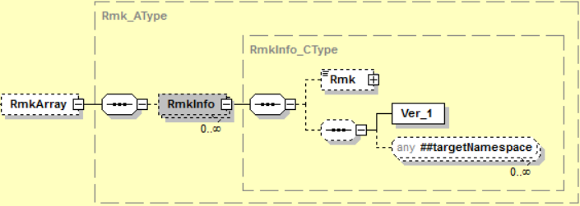

Simple Elements
The following simple elements are contained within this message.
Rmk
Instrument and extended Instrument field information (check number and notes)
Valid Values: 20 character alpha-numeric

Possible Error Codes:
104 | Error | Invalid drawer number.
114 | Error | Invalid time entered. Must be entered in military format.
1020 | Warning | The requested business service did not return any data responses or messages.
1021 | Error | Numeric data is not valid.
1022 | Error | Date is not valid.
1051 | Error | Required field.
1056 | Error | *USE authority to user profile required.
9040 | Error | Error opening file.
9999 | Error | Value entered must be greater than zero.
2005 | Error | Value does not match list of defined enumerations.
2008 | Error | No records match selection criteria.
2009 | Error | The maximum number of records must be greater than zero.
2010 | Error | At a minimum, one search value must be populated with a value.
2017 | Error | Invalid value based on data type.
2505 | Error | Access was denied.

Teller Transaction Inquiry
Teller Transaction Inquiry is a jXchange service designed to allow the consumer to retrieve Teller Transaction information using a unique transaction receipt ID provided from Teller Transaction Search.

Message Flow
In jXchange, the Teller Transaction Inquiry service uses a typical exchange of MType messages to retrieve Teller Transaction information for a specific date or range of dates from a Service Provider.

Primary Request
The Third Party Consumer forwards the TellerTrnInqRq_MType message to the Service Provider. The message contains the required element SrchMsgRqHdr_CType. The request also contains several optional simple elements designed to filter the response. The optional element Custom_CType can also be included in the request.

Primary Response
The Service Provider returns the TellerTrnInqRs_MType message to the Third Party Consumer. The message contains the required element SrchMsgRsHdr_CType. The optional element Custom_CType can also be included in the response.

Teller Transaction Inquiry Behavior
The Teller Transaction Inquiry root request message (TellerTrnInqRq_MType) requires a Transaction Receipt Identification <TrnRcptId>.

The Teller Transaction Inquiry root request message (TellerTrnInqRq_MType) optionally includes the Activity Intention element <ActIntent> default canonical value is ~ReadOnly~. The canonical values ~Upd~ or ~Dlt~ requires the service provider to return the Activity Intention Key element <ActIntentKey> used for subsequent modification service in conjunction with the adopted concurrency model.

The Teller Transaction Inquiry root response message (TellerTrnInqRs_MType) returns the Teller Transaction Information Record complex (TellerTrnInfoRec_CType), Activity Intention Key <ActIntentKey>, Transaction Receipt Identification <TrnRcptId> echoed back from request and Activity Intention <ActIntent> echoed back from request.

The Teller Transaction Information Record complex (TellerTrnInfoRec_CType) includes the Teller Transaction Information (TellerTrnInfo_CType), Teller Drawer Identification <TellerDrwId>, Teller Transaction Code Description <TellerTrnCodeDesc> and Teller Business Date <TellerBusDt>.

The standard Inquiry message tenets are applicable. Adhere to the tenets for fault reporting. Adhere to the tenets related to the correlation identifications. Adhere to the tenets related to the Concurrency model.

Teller Transaction Inquiry Business Case
The consumer is attempting to inquire on a specific set of Teller Transactions using the unique Transaction Receipt ID in this business case.
The Third Party Consumer sends the TellerTrnInqRq_MType message with the following values:
Complex Element | Simple Element | Example Value
 | TrnRcptId | 0079500001001220151028114226
 | ActIntent | ReadOnly

The Service Provider returns TellerTrnInqRs_MType with the following values:
Complex Element | Simple Element | Example Value
 | TrnRcptId | 0079500001001220151028114226
 | ActIntent | ReadOnly
 | ActIntentKey | AAAAAAAAmoU=
TellerTrnInfoRec | TellerDrwId | 103
 | TellerBusDt | 2017-01-03
 | TellerTrnCodeDesc | Cash Check
TellerTrnInfo | TellerTrnCode | 203
 | CashIn | .00
 | CashOut | 24.00
 | ChkDepAmt | 0.00
 | ChkCashAmt | 24.00
 | TrnAmt | 24.00
 | TrnDt | 2016-12-30
 | TrnEntryTime | 11:01:08.0000000-06:00
 | TrnUsrID | USER1234
TellerTrnDetArray
TellerTrnDet | TellerTrnItemId | 1
 | Amt | 24.00
 | AcctID | 12345678901
 | AcctType | D
 | ChkNum | 101
 | ChkType | OnUs
RmkArray
RmkInfo | Rmk | Check #101
TellerDrwComptArray
TellerDrwComptRec | ComptID | 1
 | CashCntType | CashOut
CashCntDet | CurrDenomCode | 30
 | CurrDenomDesc | Ones. . . . . . . . . . .
 | CashItemCnt | 24
 | CashAmt | 24.00
CashMachArray
CashMachTrnDet | TellerDrwId | 103
 | CashIn | 0.00
 | CashOut | 24.00

TellerTrnInqRq_MType
TellerTrnInqRq_MType is a message MType element.
Contains:
Custom_CType
MsgRqHdr_CType
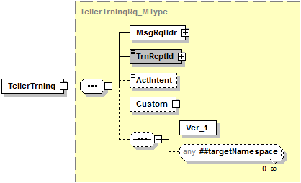

Simple Elements
The following simple elements are contained within this message.
This is a documented filter statement. Any or all of the following can be sent.

TrnRcptId
Teller Transaction Receipt Id
TrnRcptId should include the following information; bank number, drawer number, transaction number, processing period, and time. It should be listed in the following format; (0079601515000720160718105807) and be broken out like this; TRBKID(00796), TSDWR(01515), TSNBR(0007), TSPD(20160718), TSTIME(105807).

This is a required element.

ActIntent
Activity Intent
Valid Values: ReadOnly; Upd; Dlt; Add

TellerTrnInqRs_MType
TellerTrnInqRq_MType is a message MType element.
Contains:
Custom_CType
MsgRsHdr_CType
TellerTrnInfoRec_CType
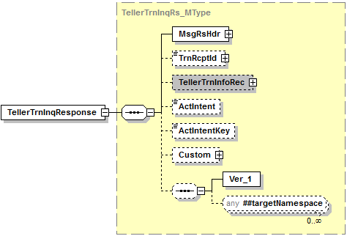

Simple Elements
The following simple elements are contained within this message.
These are an echo back of what was sent in the TellerTrnInqRq_MType
TrnRcptId
Teller Transaction Receipt Id
TrnRcptId should include the following information; bank number, drawer number, transaction number, processing period, and time. It should be listed in the following format; (0079601515000720160718105807) and be broken out like this; TRBKID(00796), TSDWR(01515), TSNBR(0007), TSPD(20160718), TSTIME(105807).

ActIntent
Activity Intent field
Valid Values: ReadOnly; Upd; Dlt; Add

ActIntentKey
Activity Intent Key
Will be used in the TellerTrnModRq_MType

TellerTrnInfoRec_CType
TellerTrnInfoRec_CType is a message CType element.
Contains:
TellerTrnInfo_CType
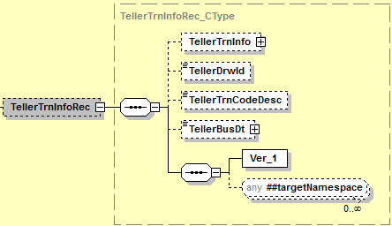

Simple Elements
The following simple elements are contained within this message.
TellerDrwId
Teller Drawer Number
Valid values: 5 digit numeric
TellerTrnCodeDesc
Teller Transaction Code Description
Valid values: 20 Character alpha-numeric
TellerBusDt
Business (Processing) date of transaction
Valid Values: Business date in MM-DD-YYYY format

TellerTrnInfo_CType
TellerTrnInfo_CType is a message CType element.
Contains:
TellerTrnDetArray_AType
TellerDrwComptArray_AType
CashMachArray_AType
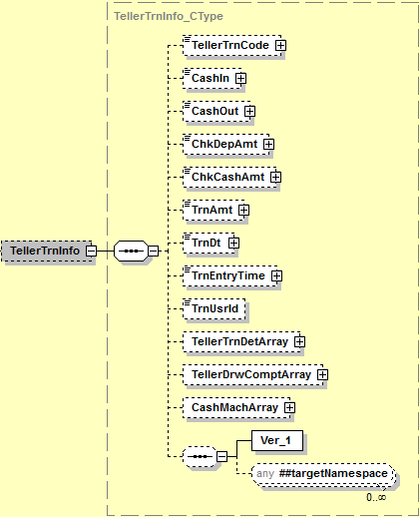

Simple Elements
The following simple elements are contained within this message.
TellerTrnCode
Transaction Type Code
Valid Values: 3 digit numeric – must be a valid teller transaction code
CashIn
Cash In amount
Valid values: .00 to 999999999.99
CashOut
Cash Out amount
Valid values: .00 to 999999999.99

ChkDepAmt
Cash Out amount
Valid values: .00 to 999999999.99
ChkCashAmt
Cash Out amount
Valid values: .00 to 999999999.99
TrnAmt
Transaction amount
Valid values: .00 to 999999999.99
TrnDt
Transaction Calendar Date
Valid Values: Calendar date in MM-DD-YYYY format
TrnEntryTime
Transaction time
Valid Values: Time in HH:MM:SS format followed by Coordinated Universal Time (UTC) offset; e.g.: 11:01:08.0000000-06:00
TrnUsrId
User Id who performed transaction
Valid Values: 20 character alpha-numeric

TellerTrnDetArray_AType
TellerTrnDetArray_AType is a message AType element.
There will be an entry in the array for each line item in the transaction.
Contains:
- TellerTrnDet_CType

TellerTrnDet_CType
TellerTrnDet_CType is a message CType element.
Contains:
Rmk_AType
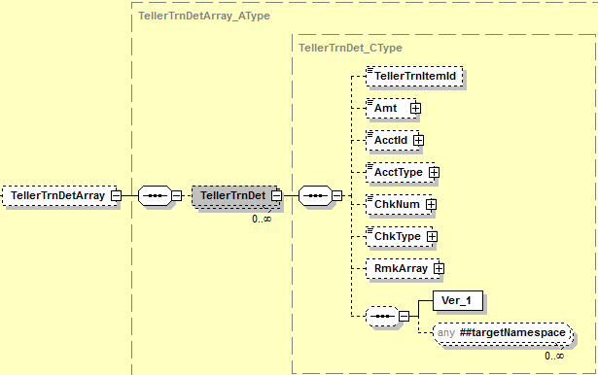

Simple Elements
The following simple elements are contained within this message.
TellerTrnItemId
Line Item Identifier
Valid Values: Numeric up to 4 digits (should equate to line item sequence number)
Amt
Line Item amount
Valid values: .00 to 999999999.99
AcctId
Account Number
Valid Values: Numeric up to 16 digits
AcctType
Account Type
Valid Values: single character alpha-numeric (i.e.: D-Deposit/Checking; S-Savings; T-Time Deposit; X-Christmas Club; G-GL)
ChkNum
Check Number
Valid Values: Numeric up to 20 digits
ChkType
Check Type
Valid Values: OnUs; Forn
If ChkType is left blank, TRONUS defaults to N

Rmk_AType
Rmk_AType is a message AType element.
Contains:
RmkInfo_CType

Simple Elements
The following simple elements are contained within this message.
Rmk
Instrument and extended Instrument field information (check number and notes)
Valid Values: 20 character alpha-numeric

TellerDrwComptArray_AType
TellerDrwComptArray _AType is a message AType element.
Contains:
TellerDrwComptRec_CType
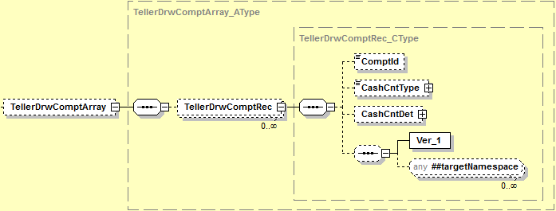

TellerDrwComptRec_CType
TellerDrwComptRec_CType is a message CType element.
Contains:
CashCntDet_CType

Simple Elements
The following simple elements are contained within this message.
ComptID
Compartment ID
Valid Values: 2 digit numeric
CashCntType
Cash Count Type
Valid Values: CashIn; CashOut

CashCntDet_CType
CashCntDet_CType is a message CType element.
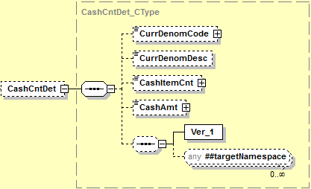

Simple Elements
The following simple elements are contained within this message.
CurrDenomCode
Currency Denomination Code
Valid Values: 2 digit numeric
CurrDenomDesc
Currency Denomination Description
Valid Values: 25 character alpha-numeric;
CashItemCnt
Cash Item Count
Valid Values: numeric count value; The CashItemCnt should be populated with what is in the Factor in Work with Drawer Compartments. 100 or 50 or 10, etc…
CashAmt
Cash amount
Valid values: .00 to 999999999.99

CashMachArray_AType
CashMachArray_AType is a message AType element.
When you have a CashMachArray you also have to include the TellerDrwComptArray for the denominations that were part of the Cash machine transactions.
Contains:
CashMachTrnDet_CType
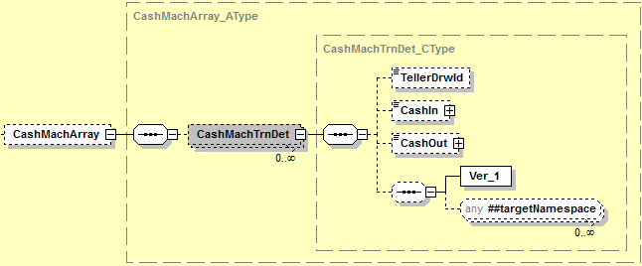

CashMachTrnDet_CType
CashMachTrnDet_CType is a message CType element.

Simple Elements
The following simple elements are contained within this message.
TellerDrwId
Cash Machine Drawer Number
Valid values: 5 digit numeric
CashIn
Cash In amount
Valid values: .00 to 999999999.99
CashOut
Cash Out amount
Valid values: .00 to 999999999.99

Possible Error Codes:
104 | Error | Invalid drawer number.
114 | Error | Invalid time entered. Must be entered in military format.
1020 | Warning | The requested business service did not return any data responses or messages.
1021 | Error | Numeric data is not valid.
1022 | Error | Date is not valid.
1051 | Error | Required field.
1056 | Error | *USE authority to use profile required.
9040 | Error | Error opening file.
9999 | Error | Value entered must be greater than zero.
2005 | Error | Value does not match defined list of enumerations.
2008 | Error | No records match selection criteria.
2009 | Error | The maximum number of records must be greater than zero.
2010 | Error | At a minimum, one search value must be populated with a value.
2017 | Error | Invalid value based on a data type.
2205 | Error | The unique identifier is required.
2505 | Error | Access was denied.

Teller Transaction Add
Teller Transaction Add is a jXchange service designed to allow the consumer to create Teller Transactions in the Teller system.

Message Flow
In jXchange, the Teller Transaction Add service uses a typical exchange of MType messages to add Teller Transactions to a Service Provider.

Primary Request
The Third Party Consumer forwards the TellerTrnAddRq_MType message to the Service Provider. The message contains the required element MsgRqHdr_CType. The request also contains several optional simple elements designed to filter the response. The optional element Custom_CType can also be included in the request.

Primary Response
The Service Provider returns the TellerTrnAddRs_MType message to the Third Party Consumer. The message contains the required element MsgRsHdr_CType. The optional element Custom_CType can also be included in the response.

Teller Transaction Add Behavior
The Teller Transaction Addition root request message (TellerTrnAdd_MType) requires a Teller Drawer Identification <TellerDrwId> and Teller Transaction complex (TellerTrn_CType).

The Teller Transaction Addition root request message (TellerTrnAdd_MType) optionally includes Teller Business Date <TellerBusDt>.

Teller Transaction complex (TellerTrn_CType) includes Teller Transaction Code <TellerTrnCode>, Cash In <CashIn>, Cash Out <CashOut>, Check Deposit Amount <ChkDepAmt>, Check Cash Amount <ChkCashAmt>, Transaction Amount <TrnAmt>, Transaction Date <TrnDt>, Transaction Entry Time <TrnEntryTime>, Teller Transaction Detail Array <TllerTrnDetArray>, Teller Drawer Compartment Array<TellerDrwComptArray> and Cash Machine Array <CashMachArray>.

The Teller Transaction Detail Array complex (TellerTrnDetailArray_AType) includes Teller Transaction Item Identification <TellerTrnItemId>, Amount <Amt>, Account Id <AcctId>, Account Type <AcctType>, Check Number <ChkNum>, Check Type <ChkType and Remark Array <RmkArray>.

The Teller Drawer Compartment Array complex (TellerDrwComptRecArray_AType) includes Compartment Identification <ComptId>, Cash Count Type <CashCntType> and Cash Count Detail complex (CashCntDet_CType).

The Cash Count Detail complex (CashCntDet_CType) includes Currency Denomination Code <CurrDenomCode>, Currency Denomination Description <CurrDenomDesc>, Cash Item Count <CashItemCnt> and Cash Amount <CashAmt>.

The Cash Machine Array complex (CashMachArray_AType) includes Teller Drawer Identification <TellerDrwId>, Cash In <CashIn> and Cash Out <CashOut>.

The Teller Transaction Addition root response message (TellerTrnAdd_MType) returns the Transaction Receipt Identification <TrnRcptId> and Response Status <RsStat>. The Transaction Receipt Identification <TrnRcptId> is a required element that can be made up of any key(s) required (DrwNum, TrnNum, ProcDt, etc.). The Consumer will need the Transaction Receipt Identification <TrnRcptId> in order to send a Teller Transaction Modification request or Teller Transaction Inquiry request.

The standard Addition message tenets are applicable.
Adhere to the tenets related to the JHANull attribute.
Adhere to the tenets for fault reporting.
Adhere to the tenets related to the correlation identifications.

Teller Transaction Add Business Case
The consumer is attempting to Add a transaction in this business case.
The Third Party Consumer sends the TellerTrnAddRq_MType message with the following values:
Complex Element | Simple Element | Example Value
 | TellerDrwId | 103
 | TellerBusDt | 2017-01-03
TellerTrn
TellerTrnInfo | TellerTrnCode | 203
 | CashIn | .00
 | CashOut | 24.00
 | ChkDepAmt | 0.00
 | ChkCashAmt | 24.00
 | TrnAmt | 24.00
 | TrnDt | 2016-12-30
 | TrnEntryTime | 11:01:08.0000000-06:00
 | TrnUsrId | USER1234
TellerTrnDetArray
TellerTrnDet | TellerTrnItemId | 1
 | Amt | 24.00
 | AcctId | 12345678901
 | AcctType | D
 | ChkNum | 101
 | ChkType | OnUs
RmkArray
RmkInfo | Rmk | Check #101
TellerDrwComptArray
TellerDrwComptRec | ComptId | 1
 | CashCntType | CashOut
CashCntDet | CurrDenomCode | 30
 | CurrDenomDesc | Ones. . . . . . . . . . .
 | CashItemCnt | 24
 | CashAmt | 24.00
CashMachArray
CashMachTrnDet | TellerDrwId | 103
 | CashIn | 0.00
 | CashOut | 24.00
ErrOvrRdInfoArray
ErrOvrRd | ErrCode | n/a

The Service Provider returns TellerTrnAddRs_MType with the following values:
Complex Element | Simple Element | Example Value
 | TrnRcptId | 0079500001001220151028114226
 | RsStat | Success

TellerTrnAddRq_MType
TellerTrnAddRq_MType is a message MType element.
Contains:
Custom_CType
MsgRqHdr_CType
TellerTrn_CType
ErrOvrRdInfoArray_AType
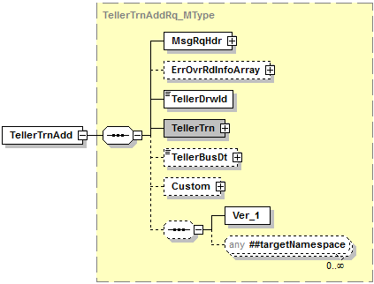

Simple Elements
The following simple elements are contained within this message.
TellerDrwId
Cash Machine Drawer Number. This is a required field.
Valid values: 5 digit numeric

TellerBusDt
Business (Processing) date of transaction
Valid Values: Business date in MM-DD-YYYY format

TellerTrn_CType
TellerTrn_CType is a message CType element. This is a required CType.
Contains:
TellerTrnInfo_CType
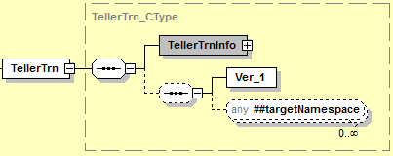

TellerTrnInfo_CType
TellerTrnInfo_CType is a message CType element. This is a required CType.
Contains:
TellerTrnDetArray_AType
TellerDrwComptArray_AType
CashMachArray_AType
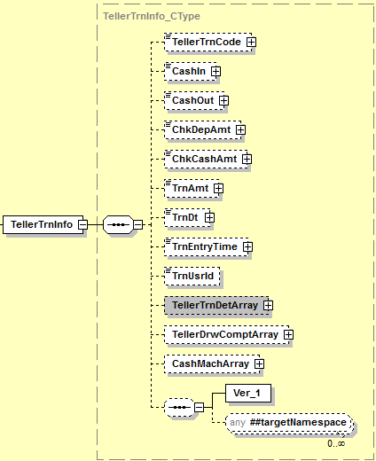

Simple Elements
The following simple elements are contained within this message.
TellerTrnCode
Transaction Type Code
Valid Values: 3 digit numeric – must be a valid teller transaction code
CashIn
Cash In amount
Valid values: .00 to 999999999.99
CashOut
Cash Out amount
Valid values: .00 to 999999999.99
ChkDepAmt
Cash Out amount
Valid values: .00 to 999999999.99
ChkCashAmt
Cash Out amount
Valid values: .00 to 999999999.99
TrnAmt
Transaction amount
Valid values: .00 to 999999999.99
TrnDt
Transaction Calendar Date
Valid Values: Calendar date in MM-DD-YYYY format
TrnEntryTime
Transaction time
Valid Values: Time in HH:MM:SS format owed by Coordinated Universal Time (UTC) offset; e.g.: 11:01:08.0000000-06:00
TrnUsrId
User Id who performed transaction
Valid Values: 20 character alpha-numeric

TellerTrnDetArray_AType
TellerTrnDetArray_AType is a message AType element.
There will be an entry in the array for each line item in the transaction.
Contains:
TellerTrnDet_CType

TellerTrnDet_CType
TellerTrnDet_CType is a message CType element.
Contains:
Rmk_AType

Simple Elements
The following simple elements are contained within this message.
TellerTrnItemId
Line Item Identifier
Valid Values: Numeric up to 4 digits (should equate to line item sequence number)
Amt
Line Item amount
Valid values: .00 to 999999999.99
AcctId
Account Number
Valid Values: Numeric up to 16 digits
AcctType
Account Type
Valid Values: single character alpha-numeric (i.e.: D-Deposit/Checking; S-Savings; T-Time Deposit; X-Christmas Club; G-GL)
ChkNum
Check Number
Valid Values: Numeric up to 20 digits
ChkType
Check Type
Valid Values: OnUs; Forn
If ChkType is left blank, TRONUS defaults to N

Rmk_AType
Rmk_AType is a message AType element.
Contains:
RmkInfo_CType

Simple Elements
The following simple elements are contained within this message.
Rmk
Instrument and extended Instrument field information (check number and notes)
Valid Values: 20 character alpha-numeric

TellerDrwComptArray_AType
TellerDrwComptArray _AType is a message AType element.
Contains:
TellerDrwComptRec_CType

TellerDrwComptRec_CType
TellerDrwComptRec_CType is a message CType element.
Contains:
CashCntDet_CType

Simple Elements
The following simple elements are contained within this message.
ComptID
Compartment ID
Valid Values: 2 digit numeric
CashCntType
Cash Count Type
Valid Values: CashIn; CashOut

CashCntDet_CType
CashCntDet_CType is a message CType element.

Simple Elements
The following simple elements are contained within this message.
CurrDenomCode
Currency Denomination Code
Valid Values: 2 digit numeric
CurrDenomDesc
Currency Denomination Description
Valid Values: 25 character alpha-numeric;
CashItemCnt
Cash Item Count
Valid Values: numeric count value; The CashItemCnt should be populated with what is in the Factor in Work with Drawer Compartments. 100 or 50 or 10, etc…
CashAmt
Cash amount
Valid values: .00 to 999999999.99

CashMachArray_AType
CashMachArray_AType is a message AType element.
When you have a CashMachArray you also have to include the TellerDrwComptArray for the denominations that were part of the Cash machine transactions.
Contains:
CashMachTrnDet_CType

CashMachTrnDet_CType
CashMachTrnDet_CType is a message CType element.

Simple Elements
The following simple elements are contained within this message.
TellerDrwId
Cash Machine Drawer Number
Valid values: 5 digit numeric
CashIn
Cash In amount
Valid values: .00 to 999999999.99
CashOut
Cash Out amount
Valid values: .00 to 999999999.99

ErrOvrRdInfoArray_AType
ErrOvrRdInfoArray_AType is a message AType element.
This Array is not used at this time.
Contains:
ErrOvrRd_CType
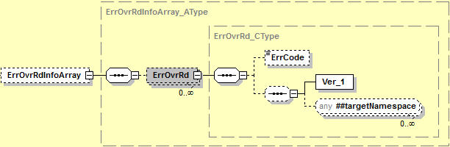

ErrOvrRd_CType
ErrOvrRd_CType is a message CType element.

Simple Elements
The following simple elements are contained within this message.
ErrCode
Error Code
Not used at this time

TellerTrnAddRs_MType
TellerTrnAddRs_MType is a message MType element.
Contains:
Custom_CType
MsgRsHdr_CType
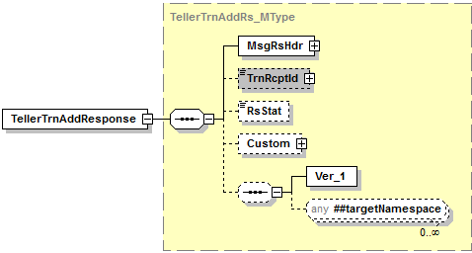

Simple Elements
The following simple elements are contained within this message.
TrnRcptId
Teller Transaction Receipt Id
TrnRcptId should include the following information; bank number, drawer number, transaction number, processing period, and time. It should be listed in the following format; (0079601515000720160718105807) and be broken out like this; TRBKID(00796), TSDWR(01515), TSNBR(0007), TSPD(20160718), TSTIME(105807).
RsStat
Response Status
Valid Values: Success, Failed

Possible Error Codes:
104 | Error | Invalid drawer number.
1020 | Warning | The requested business service did not return any data responses or messages.
1021 | Error | Numeric data is not valid.
1022 | Error | Date is not valid.
1051 | Error | Required field.
1052 | Error | Invalid user id.
1056 | Error | *USE authority to user profile required.
2005 | Error | Value does not match defined list of enumerations.
2008 | Error | No records match selection criteria.
2009 | Error | The maximum number of records must be greater than zero.
2010 | Error | At a minimum, one search value must be populated with a value.
2017 | Error | Invalid value based on data type.
2205 | Error | The unique identifier is required.
2505 | Error | Access was denied.
3100 | Error | Proposed addition failed because index combination already exists.
3101 | Error | Proposed modification failed because no match was found.
3103 | Error | The ield is required and cannot be null.
3112 | Error | The coordinated universal time (UTC) offset is invalid.
9040 | Error | Error opening file.
9999 | Error | Value entered must be greater than zero.

Teller Transaction Modification
Teller Transaction Modification is a jXchange service designed to allow the consumer to modify Teller Transactions in the Teller system. [**Teller Transaction details will not be allowed to be modified at this time; only Delete and Remark functions will be allowed**]

Message Flow
In jXchange, the Teller Transaction Modification service uses a typical exchange of MType messages to modify Teller Transactions at a Service Provider.

Primary Request
The Third Party Consumer forwards the TellerTrnModRq_MType message to the Service Provider. The message contains the required element MsgRqHdr_CType. The request also contains several optional simple elements designed to filter the response. The optional element Custom_CType can also be included in the request.

Primary Response
The Service Provider returns the TellerTrnAddRs_MType message to the Third Party Consumer. The message contains the required element MsgRsHdr_CType. The optional element Custom_CType can also be included in the response.

Teller Transaction Modification Behavior
The Teller Transaction Modification root request message (TellerTrnModRq_MType) requires a Transaction Receipt Identification <TrnRcptId> and Activity Intention key <ActIntentKey>.

The Teller Transaction Modification root request message (TellerTrnModRq_MType) optionally includes: Teller Transaction complex (TellerTrn_CType), Delete <Dlt> and Modification Remark Array <ModRmkArray>. [**Teller Transaction details will not be allowed to be modified at this time; only Delete and Remark functions will be allowed**]

The Modification Remark Array <ModRmkArray> is used to convey any remarks related to the action of the modification, not to be confused with other remarks that are encapsulated by the object(s) being modified.

The Teller Transaction Modification root response message (TellerTrnModRs_MType) returns the Response Status <RsStat>.

The standard Modification message tenets are applicable.
Adhere to the tenets related to the JHANull attribute.
Adhere to the tenets for fault reporting.
Adhere to the tenets related to the correlation identifications.
Adhere to the tenets related to the Concurrency model.

Teller Transaction Modification Business Case
The consumer is attempting to Delete a transaction in this business case. [**Teller Transaction details will not be allowed to be modified at this time; only Delete and Remark functions will be allowed**]
The Third Party Consumer sends the TellerTrnModRq_MType message with the following values:
Complex Element | Simple Element | Example Value
 | TrnRcptId | 0079500001001220151028114226
 | ActIntentKey | AAAAAAAAmoU=
 | Dlt | true
ModRmkArray
RmkInfo | Rmk | Deleting Due to Customer Request
TellerTrn
TellerTrnInfo | TellerTrnCode | n/a
 | CashIn | n/a
 | CashOut | n/a
 | ChkDepAmt | n/a
 | ChkCashAmt | n/a
 | TrnAmt | n/a
 | TrnDt | n/a
 | TrnEntryTime | n/a
 | TrnUsrId | n/a
TellerTrnDetArray
TellerTrnDet | TellerTrnItemId | n/a
 | Amt | n/a
 | AcctId | n/a
 | AcctType | n/a
 | ChkNum | n/a
 | ChkType | n/a
RmkArray
RmkInfo | Rmk | n/a
TellerDrwComptArray
TellerDrwComptRec | ComptId | n/a
 | CashCntType | n/a
CashCntDet | CurrDenomCode | n/a
 | CurrDenomDesc | n/a
 | CashItemCnt | n/a
 | CashAmt | n/a
CashMachArray
CashMachTrnDet | TellerDrwId | n/a
 | CashIn | n/a
 | CashOut | n/a
ErrOvrRdInfoArray
ErrOvrRd | ErrCode | n/a

The Service Provider returns TellerTrnModRs_MType with the following values:
Complex Element | Simple Element | Example Value
 | RsStat | Success

TellerTrnModRq_MType
TellerTrnModRq_MType is a message MType element.
Contains:
Custom_CType
MsgRqHdr_CType
ModRmkArray_AType
TellerTrn_CType
ErrOvrRdInfoArray_AType
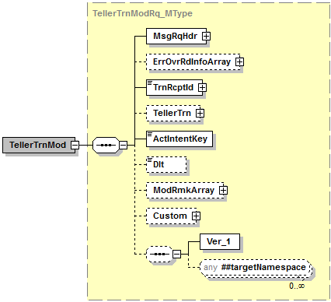

Simple Elements
The following simple elements are contained within this message.
TrnRcptId
Teller Transaction Receipt Id. This is a required field.
TrnRcptId should include the following information; bank number, drawer number, transaction number, processing period, and time. It should be listed in the following format; (0079601515000720160718105807) and be broken out like this; TRBKID(00796), TSDWR(01515), TSNBR(0007), TSPD(20160718), TSTIME(105807).

ActIntentKey
Activity Intent Key field. This is a required field.
Valid Values: ActIntentKey provided back in TellerTrnInqRs_MType

Dlt
Delete indicator
Valid values: true; false

TellerTrn_CType
TellerTrn_CType is a message CType element.
[**Teller Transaction details will not be allowed to be modified at this time; only Delete and Remark functions will be allowed**]
Contains:
TellerTrnInfo_CType
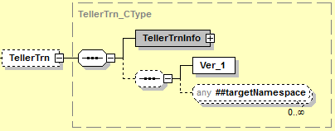

TellerTrnInfo_CType
TellerTrnInfo_CType is a message CType element.
[**Teller Transaction details will not be allowed to be modified at this time; only Delete and Remark functions will be allowed**]
Contains:
TellerTrnDetArray_AType
TellerDrwComptArray_AType
CashMachArray_AType

Simple Elements
The following simple elements are contained within this message.
TellerTrnCode
Transaction Type Code
Valid Values: n/a
CashIn
Cash In amount
Valid values: n/a
CashOut
Cash Out amount
Valid values: n/a
ChkDepAmt
Cash Out amount
Valid values: n/a
ChkCashAmt
Cash Out amount
Valid values: n/a

TrnAmt
Transaction amount
Valid values: n/a
TrnDt
Transaction Calendar Date
Valid Values: n/a
TrnEntryTime
Transaction time
Valid Values: n/a
TrnUsrId
User Id who performed transaction
Valid Values: n/a

TellerTrnDetArray_AType
TellerTrnDetArray_AType is a message AType element.
[**Teller Transaction details will not be allowed to be modified at this time; only Delete and Remark functions will be allowed**]
Contains:
TellerTrnDet_CType

TellerTrnDet_CType
TellerTrnDet_CType is a message CType element.
[**Teller Transaction details will not be allowed to be modified at this time; only Delete and Remark functions will be allowed**]
Contains:
Rmk_AType

Simple Elements
The following simple elements are contained within this message.

TellerTrnItemId
Line Item Identifier
Valid Values: n/a
Amt
Line Item amount
Valid values: n/a
AcctId
Account Number
Valid Values: n/a
AcctType
Account Type
Valid Values: n/a
ChkNum
Check Number
Valid Values: n/a
ChkType
Check Type
Valid Values: n/a
If ChkType is left blank, TRONUS defaults to N

Rmk_AType
Rmk_AType is a message AType element.
[**Teller Transaction details will not be allowed to be modified at this time; only Delete and ModRemark functions will be allowed**]
Contains:
RmkInfo_CType

Simple Elements
The following simple elements are contained within this message.
Rmk
Instrument and extended Instrument field information (check number and notes)
Valid Values: n/a

TellerDrwComptArray_AType
TellerDrwComptArray _AType is a message AType element.
[**Teller Transaction details will not be allowed to be modified at this time; only Delete and Remark functions will be allowed**]
Contains:
TellerDrwComptRec_CType

TellerDrwComptRec_CType
TellerDrwComptRec_CType is a message CType element.
[**Teller Transaction details will not be allowed to be modified at this time; only Delete and Remark functions will be allowed**]
Contains:
CashCntDet_CType

Simple Elements
The following simple elements are contained within this message.
ComptID
Compartment ID
Valid Values: n/a
CashCntType
Cash Count Type
Valid Values: n/a

CashCntDet_CType
CashCntDet_CType is a message CType element.
[**Teller Transaction details will not be allowed to be modified at this time; only Delete and Remark functions will be allowed**]

Simple Elements
The following simple elements are contained within this message.
CurrDenomCode
Currency Denomination Code
Valid Values: n/a
CurrDenomDesc
Currency Denomination Description
Valid Values: n/a
CashItemCnt
Cash Item Count
Valid Values: n/a
CashAmt
Cash amount
Valid values: n/a

CashMachArray_AType
CashMachArray_AType is a message AType element.
When you have a CashMachArray you also have to include the TellerDrwComptArray for the denominations that were part of the Cash machine transactions.
[**Teller Transaction details will not be allowed to be modified at this time; only Delete and Remark functions will be allowed**]
Contains:
CashMachTrnDet_CType

CashMachTrnDet_CType
CashMachTrnDet_CType is a message CType element.
[**Teller Transaction details will not be allowed to be modified at this time; only Delete and Remark functions will be allowed**]

Simple Elements
The following simple elements are contained within this message.
TellerDrwId
Cash Machine Drawer Number
Valid values: n/a
CashIn
Cash In amount
Valid values: n/a
CashOut
Cash Out amount
Valid values: n/a

ErrOvrRdInfoArray_AType
ErrOvrRdInfoArray_AType is a message AType element.
This Array is not used at this time.
Contains:
ErrOvrRd_CType

ErrOvrRd_CType
ErrOvrRd_CType is a message CType element.

Simple Elements
The following simple elements are contained within this message.
ErrCode
Error Code
Not used at this time

TellerTrnModRs_MType
TellerTrnModRs_MType is a message MType element.
Contains:
Custom_CType
MsgRsHdr_CType
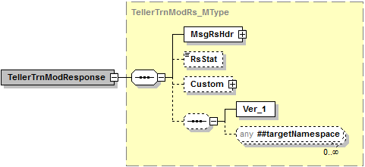

Simple Elements
The following simple elements are contained within this message.
RsStat
Response Status
Valid Values: Success, Failed

Possible Error Codes:
104 | Error | Invalid drawer number.
1020 | Warning | The requested business service did not return any data responses or messages.
1021 | Error | Numeric data is not valid.
1022 | Error | Date is not valid.
1027
1051 | Error | Required field.
1052 | Error | Invalid user Id.
1056 | Error | *USE authority to user profile required.
2005 | Error | Value does not match defined list of enumerations.
2008 | Error | No records match selection criteria.
2009 | Error | The maximum number of records must be greater than zero.
2010 | Error | At a minimum, one search value must be populated with a value.
2017 | Error | Invalid value based on data type.
2205 | Error | The unique identifier is required.
2505 | Error | Access was denied.
3100 | Error | Proposed addition failed because index combination already exists.
3101 | Error | Proposed modification failed because no match was found.
3103 | Error | The field is required and cannot be null.
3112 | Error | The coordinated universal timestamp (UTC) offset is invalid.
9040 | Error | Error opening file.
9999 | Error | Value entered must be greater than zero.

Teller Drawer Search
Teller Drawer Search is a jXchange service designed to allow the consumer to retrieve a list of teller drawers along with related drawer transition information.

Message Flow
In jXchange, the Teller Drawer Search service uses a typical exchange of MType messages to retrieve Teller drawer information from a Service Provider.

Primary Request
The Third Party Consumer forwards the TellerDrwSrchRq_MType message to the Service Provider. The message contains the required element SrchMsgRqHdr_CType. The request also contains several optional simple elements designed to filter the response. The optional element Custom_CType can also be included in the request.

Primary Response
The Service Provider returns the TellerDrwSrchRs_MType message to the Third Party Consumer. The message contains the required element SrchMsgRsHdr_CType. The optional elements TellerDrwSrchRecArray_AType and Custom_CType can also be included in the response.

Teller Drawer Search Behavior
The Teller Drawer Search provides consumers with a listing of drawers from Teller, based upon search filters provided, such as cash deposits, check deposits, cash withdrawals and cash checks.

The Teller Drawer Search root request message TellerDrwSrchRq_MType contains a documented filter statement where the elements at the root are optional but at least one of the elements are required, Teller Drawer Identification <TellerDrwId>, Branch Code <BrCode>, Teller Drawer Status <TellerDrwStat>, Teller User Identification <TellerUsrId>, and Include Extended Element Array <IncXtendElemArray>. We will not be using the IncXtendElemArray at this time.

The service provider reserves the right to limit the response set.

The Teller Drawer Search root response TellerDrwSrchRs_MType echoes back the request elements along with the Teller Drawer Search Record array TellerDrwSrchRecArray_AType which returns all of the items related to the Drawer Search request documented filters and four additional informational elements, TellerDrwWsId <TellerDrwWsId>, Teller Drawer Type <TellerDrwType>, Cash Machine Information <CashMachInfo>, Last Transition Information <LastTrnsitnInfo>, and the Teller Drawer Compartment Array <TellerDrwComptArray>. The Teller Drawer Compartment Array will also contain the records Cash Count Detail <CashCntDet>.

The Cash Machine Information record will contain the following elements; Cash Machine Type Code <CashMachTypeCode> and Cash Machine IP Information Array <CashMachIPInfoArray>.

The Cash Machine IP Information Array will contain the following elements; Cash Machine IP Type <CashMachIPType>, Cash Machine IP Address <CashMachIPAddr>, and Cash Machine IP Port <CashMachIPPort>.

The Last Transition Information <LastTrnsitnInfo> record will contain the following elements; Transition Date <TrnsitnDt>, Transition Time <TrnsitnTime>, Beginning Balance Amount <BegBalAmt>, Ending Balance Amount <EndBalAmt>, Cash In <CashIn>, Cash Out <Cash Out>, Overage Amount <OvrAmt>, Shortage Amount <ShortAmt>, Cash Machine Cash In <CashMachCashIn>, Cash Machine Cash Out <CashMachCashOut>, Cash Machine Cash In Batch <CashMachCashInBatch>, Cash Machine Cash Out Batch <CashMachCashOutBatch>, Transition Close Time <TrnsitnClsTime>, Transition Close Date <TrnsitnClsDt>.

The Teller Drawer Compartment Array record will contain the following elements; Compartment Id <ComptId>, Cash Count Type <CashCntType>, and Cash Count Detail <CashCntDet>.

The Cash Count Detail <CashCntDetail> record will contain the following elements; Currency Denomination Code <CurDenomCode>, Currency Denomination Description <CurrDenomDesc>, Cash Item Count <CashItemCnt>, and Cash Amount <CashAmt>.

Teller Drawer Search Business Case
The consumer is attempting to search Teller Drawers in this business case. When sending this search request, at least one search element will be required. Any fields listed below in red will not be used at this time.
The Third Party Consumer sends the TellerDrwSrchRq_MType message with the following values:
Complex Element | Simple Element | Example Value
 | TellerDrwId | 102
 | BrCode | 0001
 | TellerDrwStat | Live
 | TellerUsrId | User1234
IncXtendElemArray
IncXtendElemInfo | ExtendElem

The Service Provider returns TellerDrwSrchRs_MType with the following values:
Complex Element | Simple Element | Example Value
 | TellerDrwId | 102
 | BrCode | 0001
 | TellerDrwStat | Live
 | TellerUsrId | User1234
TellerDrwSrchRecArray
TellerDrwSrchRec | TellerDrwId | 102
 | TellerDrwIdDesc | Teller Drw 102 East Branch
 | BrCode | 0001
 | TellerDrwStat | Live
 | TellerUsrId | User1234
 | TellerDrwWsId | Workstation-Lap-2
 | TellerDrwType | Blank = Teller
CashMachInfo
 | CashMachTypeCode | TMRDELRU
CashMachIPInfoArray
CashMachIPInfoRec | CashMachIPType | RightCash
 | CashMachIPAddr | 192.168.62.22
 | CashMachIPPort | 4998
LastTrnsitnIfno | TrnsitnDt | 2017-01-12
 | TrnsitnTime | 11:01:08.0000000-06:00
 | BegBalAmt | 22300.00
 | EndBalAmt | 13300.00
 | CashIn | 10000.00
 | CashOut | 19000.00
 | OvrAmt | 23.00
 | ShortAmt | 23.00
 | CashMachCashIn | 56000.00
 | CashMachCashOut | 23000.00
 | CashMachCashInBatch | 25000.00
 | CashMachCashOutBatch | 67000.00
 | TrnsitnClsTime | 11:01:08.0000000-06:00
 | TrnsitnClsDt | 2017-01-12
TellerDrwComptArray
TellerDrwComptRec | ComptId | 1
 | CashCntType | N/A
CashCntDet
 | CurrDenomCode | 5
 | CurrDenomDesc | Hundreds
 | CashItemCnt | 100.00
 | CashAmt | 12000.00

TellerDrwSrchRq_MType
TellerDrwSrchRq_MType is a message MType element.
Contains:
Custom_CType
SrchMsgRqHdr_CType
IncXtendElemArray_AType

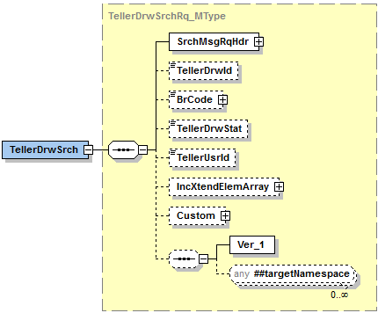

Simple Elements
The following simple elements are contained within this message.
This is a documented filter statement. Any or all of the following can be sent.
At least one search criterea should be provided.
TellerDrwId
Teller drawer number.
Valid values: blank, 5 digit numeric
BrCode
Branch Id.
Valid values: blank, 4 digit numeric
TellerDrwStat
Teller drawer status.
Valid Values: blank, Live, Test
TellerUsrId
User Id of the user currently signed into the teller drawer.
Valid values: blank, 24 character alpha-numeric

IncXtendElemArray_AType
IncXtendElemArray_AType is a message AType element.
Contains:
- IncXtendElemInfo_CType
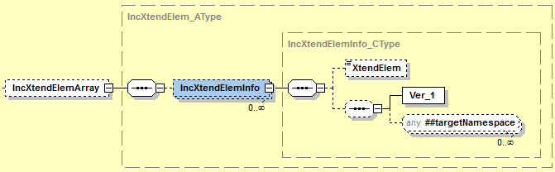

IncXtendElemInfo_CType
IncXtendElemInfo_CType is a message CType element.

Simple Elements
XtendElem
Included Extended elements which the consumer would ask by name full out to ask for “x_” prefix elements to be included in the response. Will not be used at this time.
Valid values: Not used at this time.

TellerDrwSrchRs_MType
TellerDrwSrchRs_MType is a message MType element.
Contains:
Custom_CType
SrchMsgRsHdr_CType
TellerDrwSrchRecArray_AType
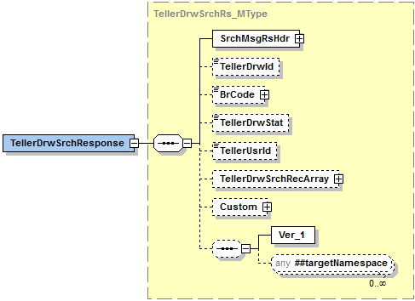

Simple Elements
The following simple elements are contained within this message.
These are an echo back of what was sent in the TellerDrwSrchRq_MType
TellerDrwId
Teller drawer number.
Valid values: 5 digit numeric
BrCode
Branch Id.
Valid values: 4 digit numeric
TellerDrwStat
Teller drawer status.
Valid Values: Live, Test
TellerUsrId
User Id of the user currently signed into the teller drawer.
Valid values: 24 character alpha numeric.

TellerDrwSrchRecArray_AType
TellerDrwSrchRecArray_AType is a message AType element.

Contains:
- CashMachInfo_CType
- TrnsitnInfo_CType
- TellerDrwComptArray_AType

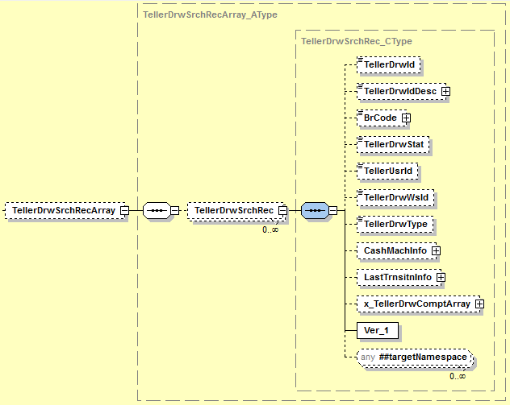

Simple Elements
The following simple elements are contained within this message.
TellerDrwId
Teller Drawer Number
Valid values: 5 digit numeric
TellerDrwIdDesc
Teller Drawer Description.
Valid values: 20 Character alpha numeric.
BrCode
Branch Id.
Valid values: 4 digit numeric
TellerDrwStat
Teller drawer status.
Valid Values: Live, Test
TellerDrwWsId
Workstation Id of the drawer currently signed into the workstation
Valid values: 24 character alpha numeric.
TellerDrwType
Type of teller drawer.
Valid values: Blank = Teller, A = ATM, D = Disp, R = RDC, V = Vault, C = CoinMach, L = Ln, S = CSR, N = NonCash

CashMachInfo_CType
CashMachInfo_CType is a message CType element.
Contains:
- CashMachIPInfoArray_AType
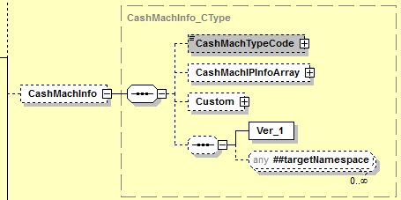

Simple Elements
The following simple elements are contained within this message.
CashMachTypeCode
The vendor model or type of cash machine.
Valid values: TMRDBOLD, TMRDELRU, TMRGLORY, TMRMS400, TMRNCR, TMRRBG100, TMRTEST, TMRUNISYS, TMRVERT6G, TMRWINCOR, MDSDBOLD, MDSDELRU, MDSGLORY, MDSNCR, MDSTEST.

CashMachIPInfoArray_AType
CashMachIPInfoArray_AType is a message AType element.

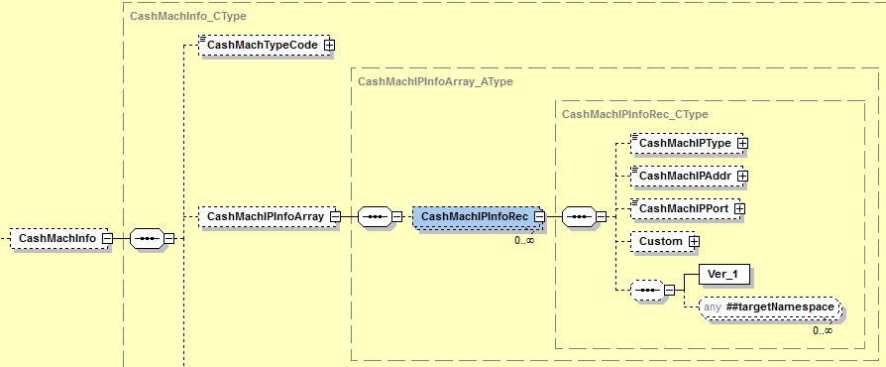

Simple Elements
The following simple elements are contained within this message.
CashMachIPType
Will identify whether the cash machine IP is for cash or coin and which side is left or right.
Valid Values: LeftCash, RightCash, LeftCoin, RightCoin
CashMachIPAddr
The left or right IP address associated with the cash machine.
Valid values: 15 digit numeric
CashMachIPPort
The left or right port associated with the cash machine.

Valid values: 11 digit numeric

TrnsitnInfo_CType
TrnsitnInfo_CType is a message CType element.

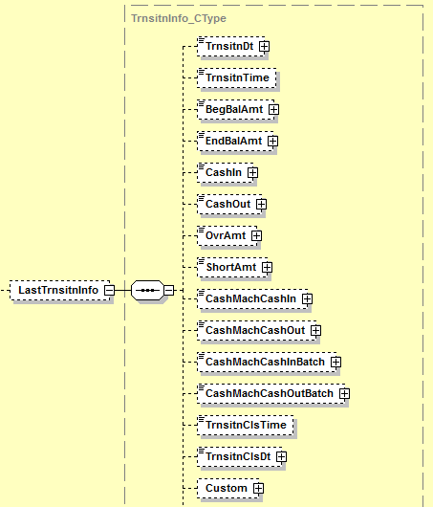

Simple Elements
The following simple elements are contained within this message.
TrnsitnDt
The transition date of the teller drawer.
Valid Values: Transition Date in YYYY-MM-DD format.
TrnsitnTime
The transition time of the teller drawer.
Valid Values: Transition time in 11:01:08.0000000-06:00 format.

BegBalAmt
The starting amount of the drawer at transition.
Valid Values: .00 to 999999999.99
EndBalAmt
The ending amount of the drawer at transition.
Valid Values: .00 to 999999999.99
CashIn
The total of Cash In transactions ran in the drawer.
Valid Values: .00 to 999999999.99
CashOut
The total of Cash Out transactions ran in the drawer.
Valid Values: .00 to 999999999.99
OvrAmt
The overage amount of the drawer at transition.
Valid Values: .00 to 999999999.99
ShortAmt
The shortage amount of the drawer at transition.
Valid Values: .00 to 999999999.99
CashMachCashIn
This is the total amount cash in’s collected into the cash machine.
Valid Values: .00 to 999999999.99
CashMachCashOut
This is the total amount of cash out’s dispensed from the cash machine.
Valid Values: .00 to 999999999.99
CashMachCashInBatch
Amount of cash in collected to be held for end of day tickets.
Valid Values: .00 to 999999999.99
CashMachCashOutBatch
Amount of cash out dispensed to be held for end of day tickets.
Valid Values: .00 to 999999999.99
TrnsitnClsTime
The teller drawer transition closing time.
Valid Values: Transition time in 11:01:08.0000000-06:00 format.

TrnsitnClsDt
The teller drawer transition closing date.
Valid Values: Transition Date in YYYY-MM-DD format.

TellerDrwComptArray_AType
TellerDrwComptArray_AType is a message AType element.

Contains:
- CashCntDet_CType
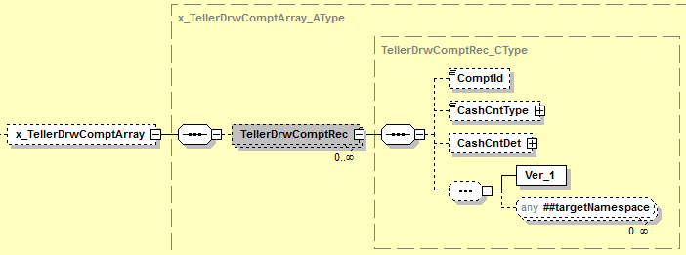

Simple Elements
The following simple elements are contained within this message.
ComptId
The compartment id.
Valid Values: 2 digit numeric
CashCntType
The type of cash used in a transaction. NOTE: We will not use this field in the DrwSrch.
Valid Values:CashIn, CashOut

CashCntDet_CType
CashCntDet_CType is a message CType element.
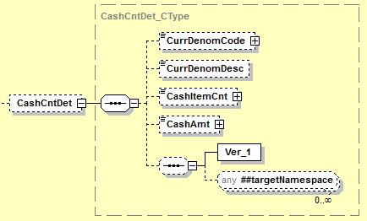

Simple Elements
The following simple elements are contained within this message.
CurrDenomCode
This is the code that will reference the type of currency denomination.
Valid Values: 2 digit numeric
CurrDenomDesc
The description of the currency code denomination.
Valid Values: 25 character alpha numeric field
CashItemCnt
The factor for a specific currency.
Valid Values: .01 to 999999999.99
CashAmt
The cash amount keyed into the compartment.
Valid Values: .00 to 999999999.99

Possible Error Codes:
1 | Error | Record not found.
100 | Error | Invalid status – Must be “L=Live or T=Test”.
103 | Error | Invalid drawer type.
104 | Error | Invalid drawer number
1020 | Warning | The requested business service did not return any data responses or messages.
1022 | Error | Data is not valid.
1051 | Error | Required field.
1052 | Error | Invalid user id.
9999 | Error | Value entered must be greater than zero.
2005 | Error | Value does not match list of defined enumerations.
2008 | Error | No records match selection criteria.
2009 | Error | The maximum number of records must be greater than zero.
2010 | Error | At a minimum, one search value must be populated by a value.
2017 | Error | Invalid value based on data type.
2505 | Error | Access was denied.

Teller Drawer Mod
Teller Drawer Mod is a jXchange service designed to allow the consumer to Claim, Release, Transition, or Balance a drawer.
The Claim drawer service is claiming the drawer when a user signs in to keep any other users from signing in.
Release drawer is to release the drawer that had previously been claimed.
Drawer Transition will update PTDWRT with the transition totals and will record the closing timestamp and Over/Short totals.
The balance function will allow the teller the ability key in balance totals for the drawers.

Message Flow
In jXchange, the Teller Drawer Mod service uses a typical exchange of MType messages to Claim, Release, Transition, or Balance a drawer.

Primary Request
The Third Party Consumer forwards the TellerDrwModRq_MType message to the Service Provider. The message contains the required element MsgRqHdr_CType. The request also contains several optional simple elements designed to filter the response. The optional element Custom_CType can also be included in the request.

Primary Response
The Service Provider returns the TellerDrwModRs_MType message to the Third Party Consumer. The message contains the required element MsgRsHdr_CType. The optional element Custom_CType can also be included in the response.

Teller Drawer Mod Behavior
The Teller Drawer Mod provides consumers with the ability to Claim a drawer, Release a drawer, Transition a drawer, and balance a drawer. Consumers will not be able to delete a drawer of any type with the Teller Drawer Mod service.

The Teller Drawer Mod root request message TellerDrwModRq_MType contains the Drawer Activity Type <DrwActType>, Claim Modification Information <ClaimModInfo>, Release Modification Information <RlsModInfo>, Transition Modification Information <TrnsitnModInfo>, Balance Modification Information <BalModInfo>, and Modification Remark Array <ModRmkArray>.

The Claim Mod Information record will contain the following elements; Teller Drawer Identification <TellerDrwId>, Teller User Identification <TellerUsrId>, and Teller Business Date <TellerBusDt>.

The Release Mod Information record will contain the following elements; Teller Drawer Identification <TellerDrwId>, Teller User Identification <TellerUsrId>, and Teller Business Date <TellerBusDt>.

The Transition Mod Information record will contain the following elements; Teller Drawer Identification <TellerDrwId>, Teller User Identification <TellerUsrId>, Teller Business Date <TellerBusDt>, Overage Amount <OvrAmt>, Shortage Amount <ShortAmt>, Transition Close Time <TrnsitnClsTime>, and Transition Close Date <TrnsitnClsDt>.

The Balance Mod Information record will contain the following elements; Teller Drawer Identification <TellerDrwId>, Teller User Identification <TellerUsrId>, Teller Business Date <TellerBusDt>, and the Teller Drawer Compartment Array <TellerDrwComptArray>.

The Teller Drawer Compartment Array record will contain the following elements; Compartment Id <ComptId>, Cash Count Type <CashCntType>, and Cash Count Detail <CashCntDet>.

The Cash Count Detail <CashCntDetail> record will contain the following elements; Currency Denomination Code <CurDenomCode>, Currency Denomination Description <CurrDenomDesc>, Cash Item Count <CashItemCnt>, and Cash Amount <CashAmt>.

The Modification Remark Array record will contain the following elements; Remark <Rmk>.

The service provider reserves the right to limit the response set.

The Teller Drawer Mod root response message (TellerDrwModRs_MType) returns the Response Status <RsStat>.

Teller Drawer Mod ClaimModInfo Business Case
The consumer is attempting to Claim the Teller Drawers in this business case.
The Third Party Consumer sends the TellerDrwModRq_MType message with the following values:
Complex Element | Simple Element | Example Value
 | DrwActType | Claim
ClaimModInfo | TellerDrwId | 101
 | TellerUsrId | User1234
 | TellerBusDt | 2017-01-22
ModRmkArray | Rmk | N/A

The Service Provider returns TellerDrwModRs_MType with the following values:
Complex Element | Simple Element | Example Value
 | RsStat | Success

Teller Drawer Mod RlsModInfo Business Case
The consumer is attempting to Release the Teller Drawers in this business case.
The Third Party Consumer sends the TellerDrwModRq_MType message with the following values:
Complex Element | Simple Element | Example Value
 | DrwActType | Rls
RlsModInfo | TellerDrwId | 101
 | TellerUsrId | User124
 | TellerBusDt | 2017-01-12
ModRmkArray | Rmk | N/A

The Service Provider returns TellerDrwModRs_MType with the following values:
Complex Element | Simple Element | Example Value
 | RsStat | Success

Teller Drawer Mod TrnsitnModInfo Business Case
The consumer is attempting to Transition the Teller Drawers in this business case.
The Third Party Consumer sends the TellerDrwModRq_MType message with the following values:
Complex Element | Simple Element | Example Value
 | DrwActType | Trnsitn
TrnsitnInfo | TellerDrwId | 101
 | TellerUsrId | User1234
 | TellerBusDt | 2017-02-12
 | OvrAmt | 44.00
 | ShortAmt | 12.00
 | TrnsitnClsTime | 11:01:03.0000000-06:00
 | TrnsitnClsDt | 2016-02-04
ModRmkArray | Rmk | N/A

The Service Provider returns TellerDrwModRs_MType with the following values:
Complex Element | Simple Element | Example Value
 | RsStat | Success

Teller Drawer Mod BalModInfo Business Case
The consumer is attempting to Balance the Teller Drawers in this business case.
The Third Party Consumer sends the TellerDrwModRq_MType message with the following values:
Complex Element | Simple Element | Example Value
 | DrwActType | Bal
BalModInfo | TellerDrwId | 101
 | TellerUsrId | User1234
 | TellerBusDt | 2017-01-01
TellerDrwComtArray
TellerDrwComptRec | ComptId | 1
 | CashCntType | CashIn
CashCntDet | CurrDenomCode | 5
 | CurrDenomDesc | Hundreds
 | CashItemCnt | 100.00
 | CashAmt | 12000.00
ModRmkArray | Rmk | N/A

The Service Provider returns TellerDrwModRs_MType with the following values:
Complex Element | Simple Element | Example Value
 | RsStat | Success

TellerDrwModRq_MType
TellerDrwModRq_MType is a message MType element.
Contains:
Custom_CType
MsgRqHdr_CType
ClaimModInfo_CType
RlsModInfo_CType
TrnsitnModInfo_CType
BalModInfo_CType
ModRmkArray_AType
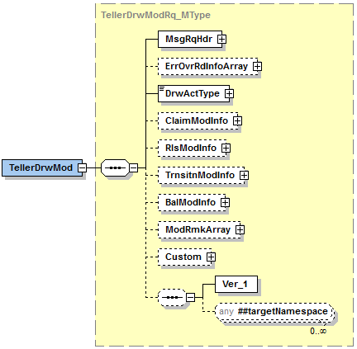

Simple Elements
The following simple elements are contained within this message.
DrwActType
This is the type of drawer activity. This is a required field.
Valid values: Claim, Rls, Trnsitn, Bal

ClaimModInfo_CType
ClaimModInfo_CType is a message CType element. The ClaimModInfo complex is to get the information to claim a drawer when a user signs in to keep anyone else from being able to sign in.
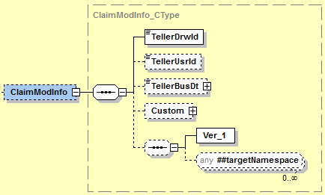

Simple Elements
The following simple elements are contained within this message.
TellerDrwId
Teller drawer number. This is a required field.
Valid values: blank, 5 digit numeric
TellerUsrId
User Id of the user currently signed into the teller drawer.
Valid values: blank, 24 character alpha-numeric
TellerBusDt
Business (Processing) date of the drawer.
Valid Values: Business date in MM-DD-YYYY format

RlsModInfo_CType
RlsModInfo_CType is a message CType element. The RlsModInfo complex will release a previously claimed drawer when a user signs out of the drawer.
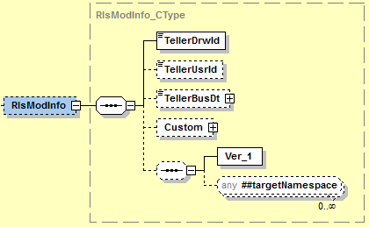

Simple Elements
The following simple elements are contained within this message.
TellerDrwId
Teller drawer number. This is a required field.
Valid values: blank, 5 digit numeric
TellerUsrId
User Id of the user currently signed into the teller drawer.
Valid values: blank, 24 character alpha-numeric
TellerBusDt
Business (Processing) date of the drawer.
Valid Values: Business date in MM-DD-YYYY format

TrnsitnModInfo_CType
TrnsitnModInfo_CType is a message CType element. The TrnsitnModInfo complex will allow a user to transition the drawer, and will store the transition totals as well as the timestamp and over/short totals.
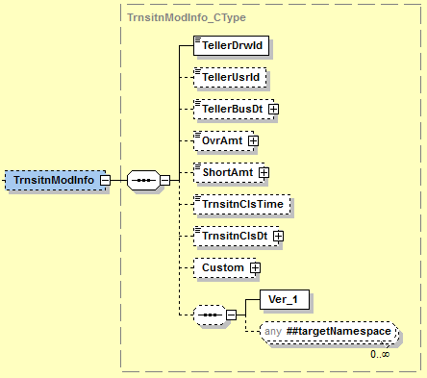

Simple Elements
The following simple elements are contained within this message.
TellerDrwId
Teller drawer number. This is a required field.
Valid values: blank, 5 digit numeric
TellerUsrId
User Id of the user currently signed into the teller drawer.
Valid values: blank, 24 character alpha-numeric
TellerBusDt
Business (Processing) date of the drawer.
Valid Values: Business date in MM-DD-YYYY format
OvrAmt
The overage amount of the drawer at transition.
Valid Values: .00 to 999999999.99
ShortAmt
The shortage amount of the drawer at transition.
Valid Values: .00 to 999999999.99
TrnsitnClsTime
The teller drawer transition closing time.
Valid Values: Transition time in 11:01:08.0000000-06:00 format.

TrnsitnClsDt
The teller drawer transition closing date.
Valid Values: Transition Date in YYYY-MM-DD format.

BalModInfo_CType
BalModInfo_CType is a message CType element. The BalModInfo complex will allow a user to balance a drawer.
Contains:
- TellerDrwComptArray_AType
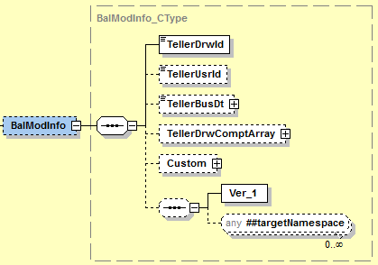

Simple Elements
The following simple elements are contained within this message.
TellerDrwId
Teller drawer number. This is a required field.
Valid values: blank, 5 digit numeric
TellerUsrId
User Id of the user currently signed into the teller drawer.
Valid values: blank, 24 character alpha-numeric
TellerBusDt
Business (Processing) date of the drawer.
Valid Values: Business date in MM-DD-YYYY format

TellerDrwComptArray_AType
TellerDrwComptArray_AType is a message AType element. The TellerDrwComptArray will be used to input the cash totals when a teller wants to balance and transition a drawer.
Contains:
- CashCntDet_CType
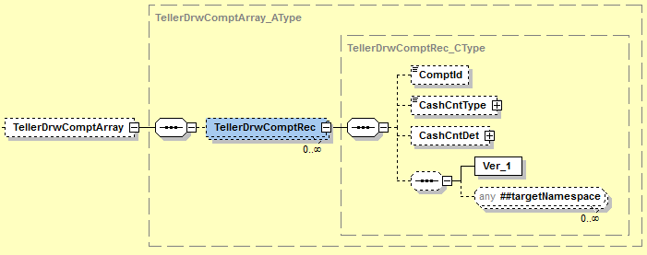

Simple Elements
The following simple elements are contained within this message.
ComptId
The compartment id.
Valid Values: 2 digit numeric
CashCntType
The type of cash used in a transaction.
Valid Values: CashIn, CashOut

CashCntDet_CType
CashCntDet_CType is a message CType element.
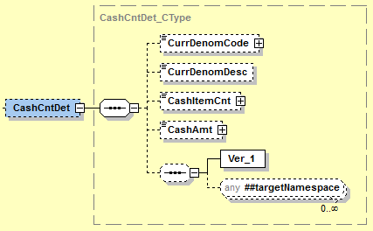

Simple Elements
The following simple elements are contained within this message.
CurrDenomCode
This is the code that will reference the type of currency denomination.
Valid Values: 2 digit numeric
CurrDenomDesc
The description of the currency code denomination.
Valid Values: 25 character alpha numeric field
CashItemCnt
The factor for a specific currency.
Valid Values: .01 to 999999999.99
CashAmt
The cash amount keyed into the compartment.
Valid Values: .00 to 999999999.99

ModRmkArray_AType
ModRmkArray_AType is a message AType element. The ModRmkArray will be used at balancing and transition time so a user can input comments.
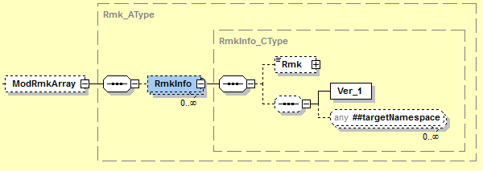

Simple Elements
The following simple elements are contained within this message.
Rmk
Instrument field value (check number or other notes)
Valid Values: blank; 20 character alpha-numeric
We will not use this element with this service.

TellerDrwModRs_MType
TellerDrwModRs_MType is a message MType element.
Contains:
- MsgRsHdr_CType

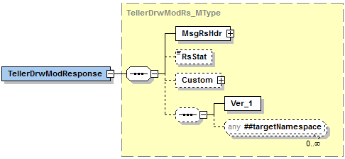

Simple Elements
The following simple elements are contained within this message.
RsStat
Status of the response.
Valid values: Success, Fail

Possible Error Codes:
104 | Error | Invalid drawer number.
114 | Error | Invalid time entered. Must be in Military format.
136 | Error | Invalid compartment.
164 | Error | User is not set up in the Vertex System.
228 | Error | Error occurred while parsing XML from the request.
1020 | Error | The requested business service did not return any data responses or messages.
1022 | Error | Date is not valid.
1051 | Error | Required field.
1056 | Error | *Usr authority to user profile required.
2005 | Error | Value does not match defined list of enumerations.
2402 | Error | Invalid Activity Type.
2403 | Error | Business date can't be more than 4 days in the future
9999 | Error | Value entered must be greater than zero.

Teller Drawer Transition Search
Teller Drawer Transition Search is a jXchange service designed to allow the consumer to retrieve a list of teller drawers along with related drawer transition information.

Message Flow
In jXchange, the Teller Drawer Transition Search service uses a typical exchange of MType messages to retrieve Teller drawer information from a Service Provider.

Primary Request
The Third Party Consumer forwards the TellerDrwTrnsitnSrchRq_MType message to the Service Provider. The message contains the required element SrchMsgRqHdr_CType. The request also contains several optional simple elements designed to filter the response. The optional element Custom_CType can also be included in the request.

Primary Response
The Service Provider returns the TellerDrwTrnsitnSrchRs_MType message to the Third Party Consumer. The message contains the required element SrchMsgRsHdr_CType. The optional elements TrnsitnSrchArray_AType and Custom_CType can also be included in the response.

Teller Drawer Transition Search Behavior
The Teller Drawer Transition Search provides consumers with a record of the last transition information for a drawer.

The Teller Drawer Transition Search root request message TellerDrwTrnsitnSrchRq_MType contains a documented filter statement where the elements at the root are optional but at least one of the elements are required, Teller Drawer Identification <TellerDrwId>, Transition Start Date <TrnsitnStartDt>, Transition End Date <TrnsitnEndDt>, and Last Transition Type <LastTrnsitnType>.

The service provider reserves the right to limit the response set.

The Teller Drawer Transition Search root response TellerDrwTrsitnSrchRq_MType echoes back the request elements along with the Transition Search Array TrnsitnSrchArray_AType which returns all of the items related to the Transition Search request documented filters and four additional informational elements, Teller Drawer Identification <TellerDrwId>, Transition Start Date <TrnsitnStartDt>, Transition End Date <TrnsitnEndDt>, Last Transition Type <LastTrnsitnType>, and Transition Search Array <TrnsitnSrchArray>.

The Transition Search Array record will contain the following elements; Teller Drawer Identification <TellerDrwId>, Transition Date <TrnsitnDt>, Transition Time <TrnsitnTime>, Beginning Balance Amount <BegBalAmt>, Ending Balance Amount <EndBalAmt>, Cash In <CashIn>, Cash Out <CashOut>, Overage Amount <OvrAmt>, Shortage Amount <ShortAmt>, Cash Machine Cash In <CashMachCashIn>, Cash Machine Cash Out <CashMachCashOut>, Cash Machine Cash In Batch <CashMachCashInBatch>, Cash Machine Cash Out Batch <CashMachCashOutBatch>, Transition Close Time <TrnsitnClsTime>, Transition Close Date <TrnsitnClsDt>.

Teller Drawer Transition Search Business Case
The consumer is attempting to search Teller Drawer Transition in this business case. When sending this search request, at least one search element will be required.
The Third Party Consumer sends the TellerDrwTrsitnSrchRq_MType message with the following values:
Complex Element | Simple Element | Example Value
 | TellerDrwId | 102
 | TrnsitnStartDt | 2013-09-20
 | TrnsitnEndDt | 2012-01-01
 | LastTrnsitnType | False

The Service Provider returns TellerDrwTrnsitnSrchRs_MType with the following values:
Complex Element | Simple Element | Example Value
 | TellerDrwId | 102
 | TrnsitnStartDt | 2013-09-20
 | TrnsitnEndDt | 2012-01-01
 | LastTrnsitnType | False
TrnsitnSrchArray
TrnsitnSrchRec | TellerDrwId | 102
 | TrnsitnDt | 2017-01-12
 | TrnsitnTime | 11:01:08.0000000-06:00
 | BegBalAmt | 22300.00
 | EndBalAmt | 13300.00
 | CashIn | 10000.00
 | CashOut | 19000.00
 | OvrAmt | 23.00
 | ShortAmt | 23.00
 | CashMachCashIn | 56000.00
 | CashMachCashOut | 23000.00
 | CashMachCashInBatch | 25000.00
 | CashMachCashOutBatch | 67000.00
 | TrnsitnClsTime | 11:01:08.0000000-06:00
 | TrnsitnClsDt | 2017-01-12
 | TrnsitnDt | 2017-01-12

TellerDrwTrnsitnSrchRq_MType
TellerDrwTrnsitnSrchRq_MType is a message MType element.
Contains:
- Custom_CType
SrchMsgRqHdr_CType

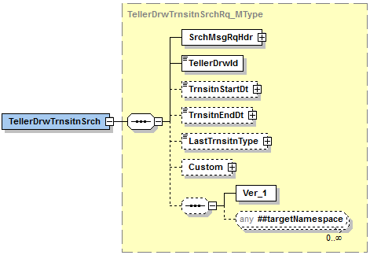

Simple Elements
The following simple elements are contained within this message.
This is a documented filter statement. Any or all of the following can be sent.
At least one search criterea should be provided.
TellerDrwId
Teller drawer number. This is a required field.
Valid values: blank, 5 digit numeric
TrnsitnStartDt
Transition Start Date
Valid values: blank, Transition Date in YYYY-MM-DD format.
TrnsitnEndDt
Transition End Date
Valid Values: blank, Transition Date in YYYY-MM-DD format.
LastTrnsitnType
Last Transition Type – Most recent transition entry for the teller drawer to be returned.
Default value = False; Valid values = True, False

TellerDrwTrnsitnSrchRs_MType
TellerDrwTrnsitnSrchRs_MType is a message MType element.
Contains:
Custom_CType
SrchMsgRsHdr_CType
TrnsitnSrchArray_AType
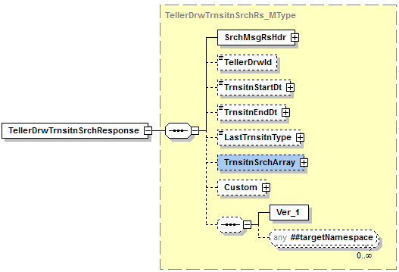

Simple Elements
The following simple elements are contained within this message.
These are an echo back of what was sent in the TellerDrwTrnsitnSrchRq_MType
TellerDrwId
Teller drawer number.
Valid values: 5 digit numeric
TrnsitnStartDt
Transition Start Date
Valid values: Transition Date in YYYY-MM-DD format.
TrnsitnEndDt
Transition End Date
Valid Values: Transition Date in YYYY-MM-DD format.
LastTrnsitnType
Last Transition Type – Most recent transition entry for the teller drawer to be returned.
Default value = False; Valid values = True, False

TrnsitnSrchArray_AType
TrnsitnSrchArray_AType is a message AType element.

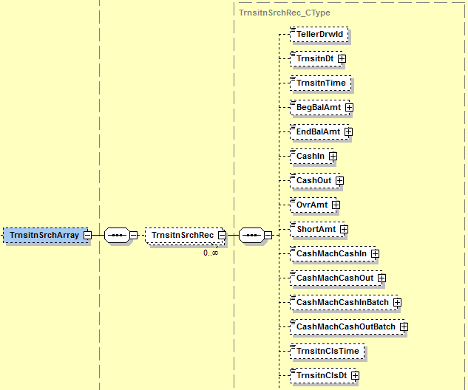

Simple Elements
The following simple elements are contained within this message.
TellerDrwId
Teller Drawer Number
Valid values: 5 digit numeric
TrnsitnDt
The transition date of the teller drawer.
Valid Values: Transition Date in YYYY-MM-DD format.
TrnsitnTime
The transition time of the teller drawer.
Valid Values: Transition time in 11:01:08.0000000-06:00 format.

BegBalAmt
The starting amount of the drawer at transition.
Valid Values: .00 to 999999999.99
EndBalAmt
The ending amount of the drawer at transition.
Valid Values: .00 to 999999999.99
CashIn
The total of Cash In transactions ran in the drawer.
Valid Values: .00 to 999999999.99
CashOut
The total of Cash Out transactions ran in the drawer.
Valid Values: .00 to 999999999.99
OvrAmt
The overage amount of the drawer at transition.
Valid Values: .00 to 999999999.99
ShortAmt
The shortage amount of the drawer at transition.
Valid Values: .00 to 999999999.99
CashMachCashIn
This is the total amount cash in’s collected into the cash machine.
Valid Values: .00 to 999999999.99
CashMachCashOut
This is the total amount of cash out’s dispensed from the cash machine.
Valid Values: .00 to 999999999.99
CashMachCashInBatch
Amount of cash in collected to be held for end of day tickets.
Valid Values: .00 to 999999999.99
CashMachCashOutBatch
Amount of cash out dispensed to be held for end of day tickets.
Valid Values: .00 to 999999999.99
TrnsitnClsTime
The teller drawer transition closing time.
Valid Values: Transition time in 11:01:08.0000000-06:00 format.

TrnsitnClsDt
The teller drawer transition closing date.
Valid Values: Transition Date in YYYY-MM-DD format.

Possible Error Codes:
1 | Error | Record not found.
104 | Error | Invalid drawer number.
1020 | Warning | The requested business service did not return any data responses or messages.
1021 | Error | Numeric data is not valid.
1022 | Error | Date is not valid.
1051 | Error | Required field.
9999 | Error | Value entered must be greater than zero.
2005 | Error | Value does not match defined list of enumerations.
2008 | Error | No records match selection criteria.
2009 | Error | The maximum number of records must be greater than zero.
2010 | Error | At a minimum, one search value must be populated with a value.
2017 | Error | Invalid value based on data type.
2505 | Error | Access was denied.

Teller Non Customer Add
Teller Non Customer Add is a jXchange service designed to allow the consumer to add a person record any time there is a requirement for a transactor for CTR, Monetary Instrument Log, Bond Transactions, and RegCC Holds when the person information needs to be stored in the teller system.

Message Flow
In jXchange, the Teller Non Customer Add service uses a typical exchange of MType messages to retrieve Teller drawer information from a Service Provider.

Primary Request
The Third Party Consumer forwards the TellerNonCustAddRq_MType message to the Service Provider. The message contains the required element MsgRqHdr_CType. The request also contains several optional simple elements designed to filter the response. The optional element Custom_CType can also be included in the request.

Primary Response
The Service Provider returns the TellerNonCustAddRs_MType message to the Third Party Consumer. The message contains the required element MsgRsHdr_CType. The optional elements Custom_CType can also be included in the response.

Teller Non Customer Add Behavior
NOTE: All items marked below in red are fields we will not use.
Teller Non Customer Add is a jXchange service designed to allow the consumer to add a person record any time there is a requirement for a benefactor or transactor for CTR, Monetary Instrument Log, Bond Transactions, and RegCC Holds when the person information needs to be stored in the teller system.
The Teller Non Customer Add root request message TellerNonCustAddRq_MType contains a documented filter statement where the elements at the root are optional but at least one of the elements are required, Teller Non Customer Detail <TellerNonCustDet>.

The Teller Non Customer Detail record will contain the following elements; Customer Name <CustName>, Customer Type <CustType>, Address <Addr>, Tax Identification <TaxId>, Tax Identification Code <TINCode>, Birth Date <BirthDt>, Occupation Type <OccType>, Gender <Gender>, NAICS Code <NAICSCode>, Identification Verification Array <IdVerifyArray>, Phone Array <PhoneArray>, and Email Array <EmailArray>.

This Customer Name record will contain the following elements; Common Name <ComName>, First Name <FirstName>, Middle Name <MiddleName>, Last Name <Last Name>, X_Person Name <X_PersonName>.

The X_Person Name record will contain the following elements; Title Prefix <TitlePrefix>, Name Suffix <NameSuffix>, Legal Name <LegalName>, Salutation Name <SalName>.

The Address <Addr> record will contain the following elements; Free Form Addres Array <FreeFormAddrArray>, Street Adddress 1 <StreetAddr1>, Street Address 2 <StreetAddr2>, City <City>, State or Province <StateProv>, State Code <StateCode>, Postal Code <Postal Code>, Delivery Point <DlvryPt>, County <County>, Country <Cntry>, Country Type <CntryType>, Business Address <BusAddr>, Foreign Address <FornAddr>, Invalid Address <InvAddr>.

The Identification Verification Array record will contain the following elements; Id Verify Description <IdVerifyDesc>, Id Verify Code <IdVerifyCode>, Id Verify Value <IdVerifyVal>, Id Verify By <IdVerifyBy>, Id Issue By <IdIssueBy>, and Id Verify Query Array <IdVerifyQueryArray>.

The Id Verify Query Array record will contain the following elements; Id Verify Query <IdVerifyQuery>, Id Verify Query Value <IdverifyQueryVal>, Id Verify Query Data Type <IdVerifyQueryDataType>.

The Phone Array record will contain the following elements; Phone Number <PhoneNum>, Phone Type <Phone Type>, Phone Time <PhoneTime>, Phone Extension <PhoneExt>, Conference Start Time <ConStartTime>, Conference End Time <ConEndTime>, Mobile Phone Information <MobPhoneInfo>, and Priority Sequence <PrioritySeq>.

The Email Array Record will contain the following elements; Email Address <EmailAddr>, and Email Type <Email Type>.

The service provider reserves the right to limit the response set.

The Teller Non Customer Add root response TellerNonCustAddRs_MType will return the element Non Customer Identification <NonCustId>.

Teller Non Customer Add Business Case
The consumer is attempting to search Teller Non Customer Add in this business case.
The Third Party Consumer sends the TellerNonCustAddRq_MType message with the following values:
Complex Element | Simple Element | Example Value
TellerNonCustDetail
CustName | ComName | Bob Dole
 | FirstName | Bob
 | MiddleName | Larry
 | LastName | Dole
X_PersonName | TitlePrefix | N/A
 | NameSuffix | III
 | LegalName | N/A
 | SalName | N/A
 | CustType | I
FreeFormAddrArray
AddrLineInfo | AddrLine | N/A
Addr | StreetAddr1 | 123 JHA Lane
 | StreetAddr2 | Suite 762
 | City | Jasper
 | StateProv | Alabama
 | StateCode | AL
 | PostalCode | 35501
 | DlvryPt | 1234
 | County | N/A
 | Cntry | United States
 | CntryType | US
 | BusAddr | N
 | FornAddr | N
 | InvAddr | N/A
 | TaxId | 123456789
 | TINCode | B
 | BirthDt | 1980-09-20
 | OccType | President
 | Gender | M
 | NAICSCode | 0
IdVerifyArray
IdVerify | IdVerifyDesc | Drivers License
 | IdVerifyCode | D
 | IdVerifyVal | 11201210
 | IdVerifyBy | N/A
 | IdIssueBy | AL
IdVerifyQueryArray |  | N/A
IdVerifyQueryInfo | IdVerifyQuery | N/A
 | IdVerifyQueryVal | N/A
 | IdVerifyQueryDataType | N/A
PhoneArray
PhoneInfo | PhoneNum | 2052139871
 | PhoneType | H
 | PhoneTime | N/A
 | PhoneExt | 0
 | ConStartTime | N/A
 | ConEndTime | N/A
 | MobPhoneInfo | N/A
 | PrioritySeq | N/A
EmailArray
EmailInfo | EmailAddr | Bod.dole@whitehouse.org
 | EmailType | N/A

The Service Provider returns TellerNonCustAddRs_MType with the following values:
Complex Element | Simple Element | Example Value
 | NonCustId | 12345

TellerNonCustAddRq_MType
TellerNonCustAddRq_MType is a message MType element.
Contains:
- Custom_CType
- MsgRqHdr_CType
- TellerNonCustDetail_CType
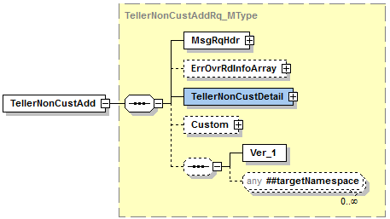

TellerNonCustDetail_CType
- The TellerNonCustDetail complex is a required complex, but the fields within the complex are not. However, information will have to be passed in this complex in order to create a person record.
Contains:
- PersonName_CType
- Addr_CType
- IdVerifyArray_AType
- PhoneArray_AType
- EmailArray_AType
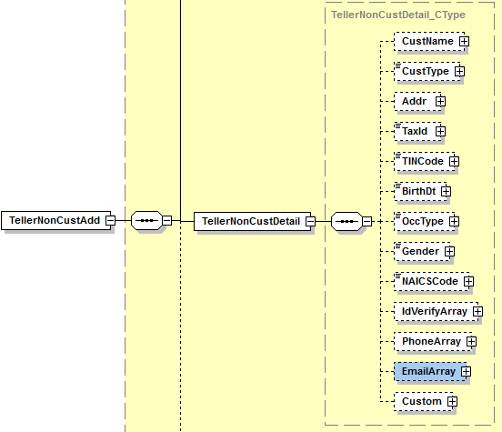
The following simple elements are contained within this message.
CustType
Customer Type
- This field is required by Vertex.
Valid values: I or O (I=Individual, O=Organization)
TaxId
Tax Id Number
- This is a required field.
Default value = Numeric value up to 9 digits unless person is foreign in which case alpha numeric up to 25 characters.

TINCode
Tax Id Code
- This is a required field.
Valid Values: A, B, or C (A=US Employer Identification Number, B=Social Sec# or Indiv Taxpayer ID#, C=Foreign TIN (any type(Including entity)).
BirthDt
BirthDate
- The birth date is not a required field.
Valid Values: Date in YYYY-MM-DD format.
OccType
Description of Occupation
- The Occupation type is not a required field.

Valid Values: Alpha numeric value up to 30 characters.
Gender
Sex of the Person
- The Gender is not a required field.
Valid Values: Male, Female, Other
NAICSCode
NAICS Code
- The NAICS code is not a required field.
Valid Values: blank, Numeric value up to 6 digits. Should match valid government issued NAICS Code list.

PersonName_CType
PersonName_CType is a message CType element.
Contains:
X_PersonName_CType
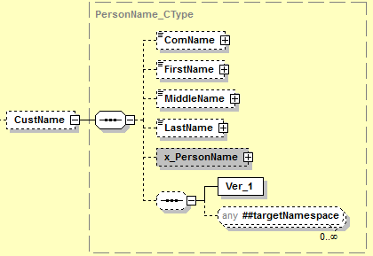

Simple Elements
The following simple elements are contained within this message.
ComName
Common full name for the customer.
Valid values: blank, Up to 40 aplha numeric characters.
FirstName
Customer’s first name.
- This is a required field.
Valid values: Up to 20 alpha numeric characters
MiddleName
Customer’s middle name.
- The Middle Name is not a required field.
Valid Values: blank, Up to 20 alpha numeric characters
LastName
Customer’s last name.
- This is a required field.
Default value = Up to 20 alpha numeric characters

X_PersonName_CType
X_PersonName_CType is a message CType element.
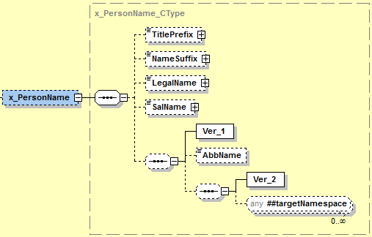

Simple Elements
The following simple elements are contained within this message.
TitlePrefix
Title Prefix – Examples Mr., Mrs.
Valid values: N/A
NameSuffix
Name suffix such as .jr, III, MD, etc…
- The Name Suffix is not a required field.
Valid Values: blank, 4 character alpha numeric field.
LegalName
The legal name used by entities like trusts or businesses in the case where an individual is “doing business as” a company or when a legal name is different than the common name.
Valid Values: N/A

SalName
The full text line name like what is used in mailings. Example; Mr. and Mrs. Bob Dole.
Valid Values: N/A

Addr_CType
Addr_CType is a message CType element.
Contains:
- FreeFormAddrArray_AType
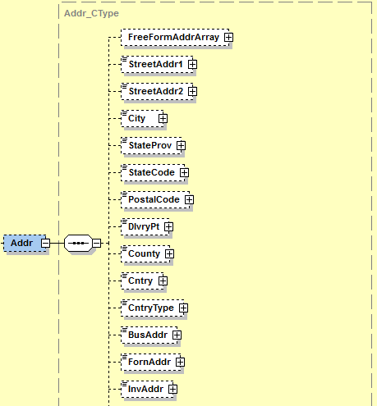

Simple Elements
The following simple elements are contained within this message.
StreetAddr1
Street Address Line 1
- This is a required field.
Valid Values: 40 character alpha numeric field
StreetAddr2
Street address line 2
- The Street Address 2 is not a required field.
Valid Values: 40 character alpha numeric
City
City
- This is a required field.
Valid Values: 20 character alpha numeric
StateProv
State or Provice
- The StateProv element will allow for the addition of state codes in the JHA teller system unless one is already defined. For example, if AL is already defined for Alabama, we will not accept the value of ALA for Alabama.
- This is a required field.
Valid Values: 30 Character alpha field
StateCode
State Code
- This is a required field.
Valid Values: 3 digit alpa character field.
PostalCode
Postal Code
- This is a required field.
Valid Values: 5 dig it numeric
DlvryPt
Delivery Point (4 digits proceeding the zip code)
- The Delivery Point is not a required field.
Valid Values: 4 digit numeric
County
County
Valid Values: N/A

Cntry
Country (Description of the country)
Valid Values: 30 alpha character field
- This is a required field.
CntryType
Country Type (ISO Country Code)
- This is a required field.
Valid Values: 2 alpha character field

BusAddr
Customer’s business address.
Valid Values: blank, Y or N (Yes or No)
FornAddr
Customer’s foreign address?
- The Foreign Address is not a required field.
Valid Values: Y or N (Yes or No)
InvAddr
Invalid Address.
Valid Values: N/A
StreetAddr3
Street Address line 3.
Valid Values: N/A

FreeFormAddrArray_AType
FreeFormAddrArray_AType is a message AType element.
Contains:
- AddrLineInfo_CType
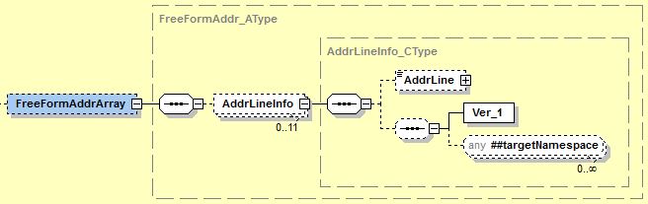

AddrLineInfo_CType
AddrLineInfo_CType is a message CType element.

Simple Elements
The following simple elements are contained within this message.
AddrLine
Free Form Addresss Line
Valid Values: N/A

IdVerifyArray_AType
FreeFormAddrArray_AType is a message AType element.
Contains:
- IdVerifyQueryArray_AType
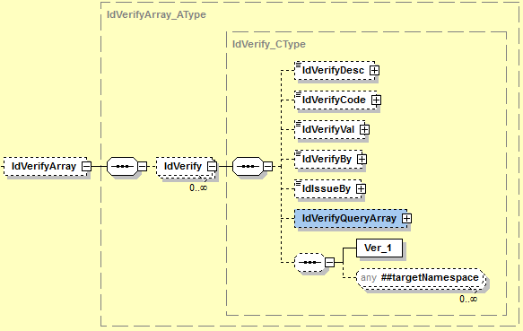

Simple Elements
The following simple elements are contained within this message.
IdVerifyDesc
The description of the identification code that is used to authenticate the customer.
- The IdVerifyDesc is not a required field.
Valid Values: A – Alien Registration, D – Drivers License/State Id, E – Disabled/Elderly, F – Foreign Entity, G – Government Agency, L – Law Enforcement, M – Amish Customer, O – Other Identification, P – Passport.

IdVerifyCode
The identification code that is used to authenticate the customer.
- The IdVerifyCode is not a required field.
Valid Values: A – Alien Registration, D – Drivers License/State Id, E – Disabled/Elderly, F – Foreign Entity, G – Government Agency, L – Law Enforcement, M – Amish Customer, O – Other Identification, P – Passport.
IdVerifyVal
The identification value that is used to authenticate the customer.
- The IdVerifyVal is not a required field.
Valid Values: 22 digit numeric field.
IdVerifyBy
The individual that verified the authenticity of the identification.
Valid Values: N/A
IdIssueBy
The individual that issued the identification value.
- The IdIssueBy is not a required field.
Valid Values: 3 character field.

IdVerifyQueryArray_AType
FreeFormAddrArray_AType is a message AType element.

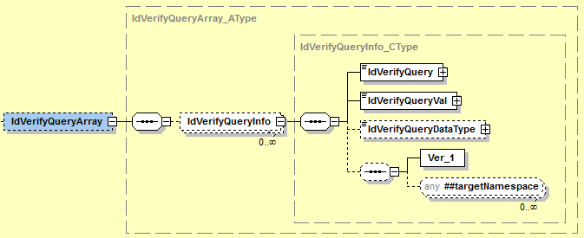

Simple Elements
The following simple elements are contained within this message.
IdVerifyQuery
A description of the query/question that could be used for customer/account identification purposes.

Valid Values: N/A
IdVerifyQueryVal
A value that corresponds with the description of the query/question that could be used for customer/account identification.
Valid Values: N/A
IdVerifyQueryDataType
This element identifies what type of attributes corresponds with the IDVerifyQueryVal.
Valid Values: N/A

PhoneArray_AType
FreeFormAddrArray_AType is a message AType element.
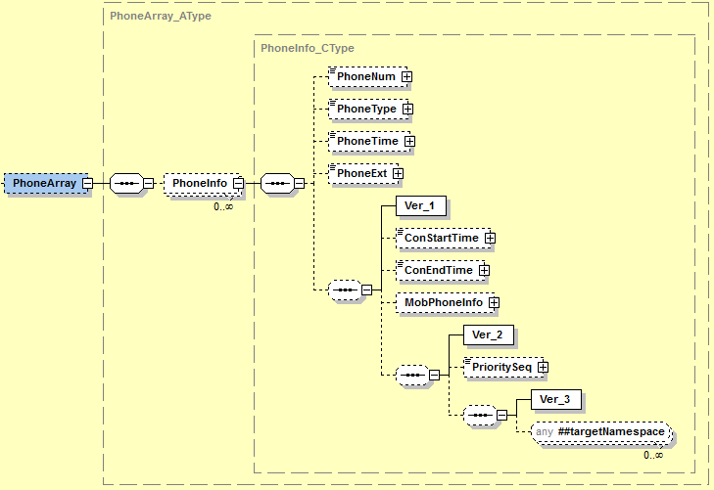

Simple Elements
The following simple elements are contained within this message.
PhoneNum
Phone Number
- The PhoneNum is not a required field.
- If a Phone Number is sent, We will also require a PhoneType.
Valid Values: blank, 16 character numeric field
PhoneType
Phone Type. Examples; Home, Work, Fax, Cell
- The PhoneType is conditionally required. If a phone number is sent then a phone type MUST be sent along with the phone number.
Valid Values: blank,10 character alpha numeric
PhoneTime
Phone Time – Best Usage Time – Day or Evening.
Valid Values: N/A
PhoneExt
Phone Extension.
- The Phone Ext is not a required field.
Valid Values: blank, 6 character numeric field
ConStartTime
Conference Starat Time.
Valid Values: N/A
ConEndTime
Conference End time.
Valid Values: N/A
MobPhoneInfo
Provider Code of the mobile service.
Valid Values: N/A
PrioritySeq
The assignment of a priority sequence for an array of items.
Valid Values: N/A

EmailArray_AType
FreeFormAddrArray_AType is a message AType element.
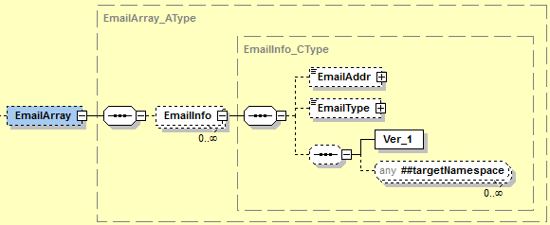

Simple Elements
The following simple elements are contained within this message.
EmailAddr
Email Address
- The email address is not a required field.
Valid Values: blank, 50 character alpha numeric field
EmailType
Email Type
Valid Values: N/A

TellerNonCustAddRs_MType
TellerNonCustAddRs_MType is a message MType element.
Contains:
Custom_CType
- MsgRsHdr_CType
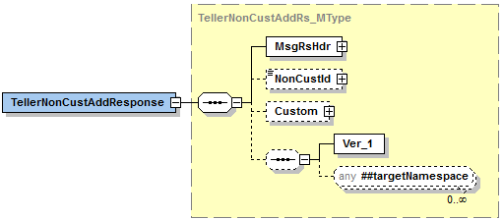

Simple Elements
The following simple elements are contained within this message.
NonCustId
Teller Person Number – The business service should assign the non-customer Id and provide back to the consumer in the response.
Valid Values: Numeric Value up to 7 digits.

Possible Error Codes:
169 | Error | Invalid ID Type entered.
172 | Error | Valid person type is I=individual or O=organization.
1020 | Warning | The requested business service did not return any data responses or messages.
1051 | Error | Required field.
9920050 | Error | Numeric data is not valid.

Teller Non Customer Modification
Teller Non Customer Modification is a jXchange service designed to allow the consumer to modify stored customer and non-customer records.

Message Flow
In jXchange, the Teller Non Customer Modification service uses a typical exchange of MType messages to modify customer and non-customer information from a Service Provider.

Primary Request
The Third Party Consumer forwards the TellerNonCustModRq_MType message to the Service Provider. The message contains the required element MsgRqHdr_CType. The request also contains several optional simple elements designed to filter the response. The optional elements ErrOvrRdInfoArray_AType TellerNonCustDetail_CType, ModRmkArray_AType, and Custom_CType can also be included in the request.

Primary Response
The Service Provider returns the TellerNonCustModRs_MType message to the Third Party Consumer. The message contains the required element MsgRsHdr_CType. The optional element Custom_CType can also be included in the response.

Teller Non Customer Modification Behavior
The Teller Non Customer Modifiication provides consumers with a record of the last transition information for a drawer.

The Teller Non Customer Modificaiton root request message TellerNonCustModRq_MType contains a documented filter statement where the elements at the root are optional but at least one of the elements are required, Non Customer Identification <NonCustId>, Activity Intent Key <ActIntentKey>, Delete <Dlt>.

The Teller Non Customer Modification root request message (TellerNonCustMod_MType) optionally includes; Teller Non Customer Detail complex <TellerNonCustDetail>, and Modification Remark Array <ModRmkArray>.

The Teller Non Customer Detail Complex will contain the following elements; Customer Name complex <CustName>, Customer Type <CustType>, Address complex <Addr>, Tax Identification <TaxId>, Tax Identification Code <TINCode>, Birth Date <BirthDt>, Occupation Type <OccType>, Gender <Gender>, NAICS Code <NAICSCode>, Identification Verification Array <IdVerifyArray>, Phone Array <PhoneArray>, Email Array <Email Array>.

This Customer Name record will contain the following elements; Common Name <ComName>, First Name <FirstName>, Middle Name <MiddleName>, Last Name <Last Name>, X_Person Name <X_PersonName>.

The X_Person Name record will contain the following elements; Title Prefix <TitlePrefix>, Name Suffix <NameSuffix>, Legal Name <LegalName>, Salutation Name <SalName>.

The Address <Addr> record will contain the following elements; Free Form Addres Array <FreeFormAddrArray>, Street Adddress 1 <StreetAddr1>, Street Address 2 <StreetAddr2>, City <City>, State or Province <StateProv>, State Code <StateCode>, Postal Code <Postal Code>, Delivery Point <DlvryPt>, County <County>, Country <Cntry>, Country Type <CntryType>, Business Address <BusAddr>, Foreign Address <FornAddr>, Invalid Address <InvAddr>.

The Identification Verification Array record will contain the following elements; Id Verify Description <IdVerifyDesc>, Id Verify Code <IdVerifyCode>, Id Verify Value <IdVerifyVal>, Id Verify By <IdVerifyBy>, Id Issue By <IdIssueBy>, and Id Verify Query Array <IdVerifyQueryArray>.

The Id Verify Query Array record will contain the following elements; Id Verify Query <IdVerifyQuery>, Id Verify Query Value <IdverifyQueryVal>, Id Verify Query Data Type <IdVerifyQueryDataType>.

The Phone Array record will contain the following elements; Phone Number <PhoneNum>, Phone Type <Phone Type>, Phone Time <PhoneTime>, Phone Extension <PhoneExt>, Conference Start Time <ConStartTime>, Conference End Time <ConEndTime>, Mobile Phone Information <MobPhoneInfo>, and Priority Sequence <PrioritySeq>.

The Email Array Record will contain the following elements; Email Address <EmailAddr>, and Email Type <Email Type>.

The Modification Remark Array <ModRmkArray> is used to convey any remarks related to the action of the modification, not to be confused with other remarks that are encapsulated by the object(s) being modified.

The service provider reserves the right to limit the response set.

The Teller Transaction Modification root response message (TellerTrnModRs_MType) returns the Response Status <RsStat>.

The standard Modification message tenets are applicable.
Adhere to the tenets related to the JHANull attribute.
Adhere to the tenets for fault reporting.
Adhere to the tenets related to the correlation identifications.
Adhere to the tenets related to the Concurrency model.

Teller Non Customer Modification Business Case
The consumer is attempting to modify customer or non-customer information in this business case. When sending this search request, at least one search element will be required.
The Third Party Consumer sends the TellerDrwTrsitnSrchRq_MType message with the following values:
Complex Element | Simple Element | Example Value
ErrOverRdInfoArray
ErrOvrd | ErrCode | N/A
 | NonCustId | 12345
 | ActIntentKey | AAAAAAAAmoU=
 | Dlt | True
TellerNonCustDetail | CustType | I
 | TaxId | 123451234
 | TINCode | B
 | BirthDt | 1980-09-20
 | OccType | Salesman
 | Gender | Male
 | NAICSCode | 0
CustName | ComName | Bill Bilson
 | FirstName | Bill
 | MiddleName | Bilbo
 | LastName | Bilson
X_PersonName | TitlePrefix | N/A
 | NameSuffix | Jr.
 | LegalName | N/A
 | SalName | N/A
Addr
FreeFormAddrArray
AddrLineInfo | AddrLine | N/A
Addr | StreetAddr1 | 234 Bilbo Way
 | StreetAddr2 | Suite 2
 | City | Hobbiton
 | StateProv | Alabama
 | StateCode | AL
 | PostalCode | 32450
 | DlvryPt | 1123
 | County | N/A
 | Cntry | United States
 | CntryType | US
 | BusAddr | N
 | FornAddr | N
 | InvAddr | N/A
IdVerifyArray
IdVerify | IdVerifyDesc | Driver’s License
 | IdverifyCode | D
 | IdVerifyVal | 1155540
 | IdVerifyBy | N/A
 | IdIssueby | AL
IdVerifyQueryArray
IdVerifyQueryInfo | IdVerifyQuery | N/A
 | IfVerifyQueryVal | N/A
 | IdVerifyQueryDataType | N/A
PhoneArray
PhoneInfo | PhoneNum | 2568931267
 | PhoneType | Home
 | PhoneTime | N/A
 | PhoneExt | 0
 | ConStartTime | N/A
 | ConEndTime | N/A
 | MobPhoneInfo | N/A
 | PrioritySeq | N/A
EmailArray
EmailInfo | EmailAddr | billbo@hobbithouse.com
 | EmailType | N/A
ModRmkArray
RmkInfo | Rmk | Deleting due to customer request.

The Service Provider returns TellerNonCustModRs_MType with the following values:
Complex Element | Simple Element | Example Value
 | RsStat | Success

TellerNonCustModRq_MType
TellerNonCustModRq_MType is a message MType element.
Contains:
- Custom_CType
- MsgRqHdr_CType
- TellerNonCustDetail_CType
- IdVerifyArray_AType
- PhoneArray_AType
- EmailArray_AType
- ModRmkArray_AType

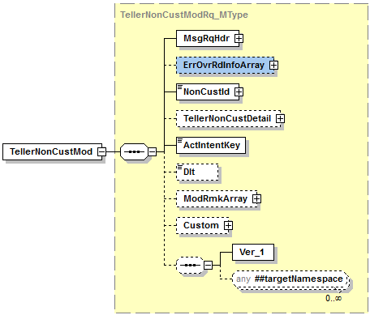

Simple Elements
The following simple elements are contained within this message.
NonCustId
Teller Person Number – The business service should assign the non-customer Id and provide back to the consumer in the response.
- The TellerCustSrch will take place before the TellerNonCustMod service is used. Both the CustID and the NonCustId are returned in the TellerCustSrch. The user will need to take the NonCustId from TellerCustSrch and use that to perform the Mod in TellerNonCustMod even if the user is modifying/deleting a customer record.
Valid Values: Numeric Value up to 7 digits.
ActIntentKey
Activity Intent Key
Will be used in the TellerNonCustModRq_MType
Dlt
Delete indicator
Valid values: True, False

ErrOvrRdInfoArray_AType
ErrOvrRdInfoArray_AType is a message AType element.
This Array is not used at this time.
Contains:
ErrOvrRd_CType

ErrOvrRd_CType
ErrOvrRd_CType is a message CType element.

Simple Elements
The following simple elements are contained within this message.
ErrCode
Error Code
Not used at this time

TellerNonCustDetail_CType
Contains:
- PersonName_CType
- Addr_CType
- IdVerifyArray_AType
- PhoneArray_AType
- EmailArray_AType
The following simple elements are contained within this message.
CustType
Customer Type
- This field is required by Vertex.
Valid values: I or O (I=Individual, O=Organization)
TaxId
Tax Id Number
- This is a required field.
Default value = Numeric value up to 9 digits unless person is foreign in which case alpha numeric up to 25 characters.
TINCode
Tax Id Code
- This is a required field.
Valid Values: A, B, or C (A=US Employer Identification Number, B=Social Sec# or Indiv Taxpayer ID#, C=Foreign TIN (any type(Including entity)).
BirthDt
BirthDate
- The birth date is not a required field.
Valid Values: Date in YYYY-MM-DD format.
Gender
Sex of the Person
- The Gender is not a required field.
Valid Values: Male, Female, Other
OccType
Description of Occupation
- The Occupation type is not a required field.

Valid Values: Alpha numeric value up to 30 characters.
NAICSCode
NAICS Code
- The NAICS code is not a required field.
Valid Values: blank, Numeric value up to 6 digits. Should match valid government issued NAICS Code list.

PersonName_CType
PersonName_CType is a message CType element.
Contains:
X_PersonName_CType

Simple Elements
The following simple elements are contained within this message.
ComName
Common full name for the customer.
Valid values: blank, Up to 40 aplha numeric characters.
FirstName
Customer’s first name.
- This is a required field.
Valid values: Up to 20 alpha numeric characters

MiddleName
Customer’s middle name.
- The Middle Name is not a required field.
Valid Values: blank, Up to 20 alpha numeric characters
LastName
Customer’s last name.
- This is a required field.
Default value = Up to 20 alpha numeric characters

X_PersonName_CType
X_PersonName_CType is a message CType element.

Simple Elements
The following simple elements are contained within this message.
TitlePrefix
Title Prefix – Examples Mr., Mrs.
Valid values: N/A
NameSuffix
Name suffix such as .jr, III, MD, etc…
- The Name Suffix is not a required field.
Valid Values: blank, 4 character alpha numeric field.

LegalName
The legal name used by entities like trusts or businesses in the case where an individual is “doing business as” a company or when a legal name is different than the common name.
Valid Values: N/A

SalName
The full text line name like what is used in mailings. Example; Mr. and Mrs. Bob Dole.
Valid Values: N/A

Addr_CType
Addr_CType is a message CType element.
Contains:
- FreeFormAddrArray_AType

Simple Elements
The following simple elements are contained within this message.
StreetAddr1
Street Address Line 1
- This is a required field.
Valid Values: 40 character alpha numeric field
StreetAddr2
Street address line 2
- The Street Address 2 is not a required field.
Valid Values: 40 character alpha numeric
City
City
- This is a required field.
Valid Values: 20 character alpha numeric
StateProv
State or Provice
- The StateProv element will allow for the addition of state codes in the JHA teller system unless one is already defined. For example, if AL is already defined for Alabama, we will not accept the value of ALA for Alabama.
- This is a required field.
Valid Values: 30 Character alpha field
StateCode
State Code
- This is a required field.
Valid Values: 3 digit alpa character field.
PostalCode
Postal Code
- This is a required field.
Valid Values: 5 dig it numeric
DlvryPt
Delivery Point (4 digits proceeding the zip code)
- The Delivery Point is not a required field.
Valid Values: 4 digit numeric
County
County
Valid Values: N/A

Cntry
Country (Description of the country)
- This is a required field.
Valid Values: 30 alpha character field
CntryType
Country Type (ISO Country Code)
- This is a required field.
Valid Values: 2 alpha character field

BusAddr
Customer’s business address.
Valid Values: blank, Y or N (Yes or No)
FornAddr
Customer’s foreign address
- The Foreign Address is not a required field.
Valid Values: Y or N (Yes or No)
InvAddr
Invalid Address
Valid Values: N/A
StreetAddr3
Street Address line 3.
Valid Values: N/A

FreeFormAddrArray_AType
FreeFormAddrArray_AType is a message AType element.
Contains:
- AddrLineInfo_CType

AddrLineInfo_CType
AddrLineInfo_CType is a message CType element.

Simple Elements
The following simple elements are contained within this message.
AddrLine
Free Form Addresss Line
Valid Values: N/A

IdVerifyArray_AType
FreeFormAddrArray_AType is a message AType element.
Contains:
- IdVerifyQueryArray_AType

Simple Elements
The following simple elements are contained within this message.
IdVerifyDesc
The description of the identification code that is used to authenticate the customer.
- The IdVerifyDesc is not a required field.
Valid Values: A – Alien Registration, D – Drivers License/State Id, E – Disabled/Elderly, F – Foreign Entity, G – Government Agency, L – Law Enforcement, M – Amish Customer, O – Other Identification, P – Passport.

IdVerifyCode
The identification code that is used to authenticate the customer.
- The IdVerifyCode is not a required field.
Valid Values: A – Alien Registration, D – Drivers License/State Id, E – Disabled/Elderly, F – Foreign Entity, G – Government Agency, L – Law Enforcement, M – Amish Customer, O – Other Identification, P – Passport.
IdVerifyVal
The identification value that is used to authenticate the customer.
- The IdVerifyVal is not a required field.
Valid Values: 22 digit numeric field.
IdVerifyBy
The individual that verified the authenticity of the identification.
Valid Values: N/A
IdIssueBy
The individual that issued the identification value.
- The IdIssueBy is not a required field.
Valid Values: 3 character field.

IdVerifyQueryArray_AType
FreeFormAddrArray_AType is a message AType element.

Simple Elements
The following simple elements are contained within this message.
IdVerifyQuery
A description of the query/question that could be used for customer/account identification purposes.

Valid Values: N/A
IdVerifyQueryVal
A value that corresponds with the description of the query/question that could be used for customer/account identification.
Valid Values: N/A
IdVerifyQueryDataType
This element identifies what type of attributes corresponds with the IDVerifyQueryVal.
Valid Values: N/A

PhoneArray_AType
FreeFormAddrArray_AType is a message AType element.

Simple Elements
The following simple elements are contained within this message.
PhoneNum
Phone Number
- The PhoneNum is not a required field.
- If a Phone Number is sent, We will also require a PhoneType.
Valid Values: blank, 16 character numeric field
PhoneType
Phone Type. Examples; Home, Work, Fax, Cell
- The PhoneType is conditionally required. If a phone number is sent then a phone type MUST be sent along with the phone number.
Valid Values: blank,10 character alpha numeric
PhoneTime
Phone Time – Best Usage Time – Day or Evening.
Valid Values: N/A
PhoneExt
Phone Extension.
- The Phone Ext is not a required field.
Valid Values: blank, 6 character numeric field
ConStartTime
Conference Starat Time.
Valid Values: N/A
ConEndTime
Conference End time.
Valid Values: N/A
MobPhoneInfo
Provider Code of the mobile service.
Valid Values: N/A
PrioritySeq
The assignment of a priority sequence for an array of items.
Valid Values: N/A

EmailArray_AType
FreeFormAddrArray_AType is a message AType element.

Simple Elements
The following simple elements are contained within this message.
EmailAddr
Email Address
- The email address is not a required field.
Valid Values: blank, 50 character alpha numeric field
EmailType
Email Type
Valid Values: N/A

ModRmkArray_AType
ModRmkArray_AType is a message AType element.

Simple Elements
The following simple elements are contained within this message.
Rmk
Instrument field value (check number or other notes)
Valid Values: blank; 20 character alpha-numeric
The Remark <Rmk> element allow for wild card searches. The Search Type attribute canonical values ~Exact~, ~StartsWith~ and ~Contains~ is supported by the service provider.

TellerNonCustModRs_MType
TellerNonCustModRs_MType is a message MType element.
Contains:
MsgRqHdr_CType

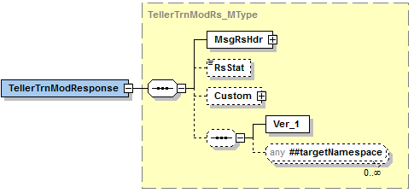

Simple Elements
The following simple elements are contained within this message.
These are an echo back of what was sent in the TellerDrwTrnsitnSrchRq_MType
RsStat
Teller drawer number.
Valid values: 5 digit numeric

Possible Error Codes:
169 | Error | Invalid ID Type entered.
170 | Error | Invalid Invalid I.D. issuer entered.
172 | Error | Valid person type is I=Individual or O=Organization.
229 | Error | The Person# does not exist in the master file.
244 | Error | That Tax ID number is already being used.
245 | Error | That Tax ID and Person Type is already being used.
1020 | Warning | The requested business service did not return any data responses or messages.
1021 | Error | Numeric data is not valid.
1051 | Error | Required field.
1056 | Error | *USE authority to user profile required. | Had to change the authority on my role.
3101 | Error | Proposed modification failed because no match was found.
9920011 | Error | Unmonitored error occurred setting Data Stream value. | Occurred when mapping was incorrect. Field was not indicated as a date field.
9920210 | Error | Array has too many elements to map to the provider.
9920215 | Error | Arrays element length is greater than maximum allowed.
9930216 | Error | Error occurred deleting record.
9930217 | Error | Error occurred updating record.
9930218 | Error | Error occurred writing record.

Teller Customer Search
Teller Customer Search is a jXchange service designed to allow the consumer to retrieve Customer and Non Customer information.

Message Flow
In jXchange, the Teller Customer Search service uses a typical exchange of MType messages to retrieve Teller drawer information from a Service Provider.

Primary Request
The Third Party Consumer forwards the TellerCustSrchRq_MType message to the Service Provider. The message contains the required element SrchMsgRqHdr_CType. The request also contains several optional simple elements designed to filter the response. The optional element Custom_CType can also be included in the request.

Primary Response
The Service Provider returns the TellerCustSrchRs_MType message to the Third Party Consumer. The message contains the required element SrchMsgRsHdr_CType. The optional elements TellerCustSrchRecArray_AType and Custom_CType can also be included in the response.

Teller Drawer Transition Search Behavior
The Teller Drawer Transition Search provides consumers with a record of the last transition information for a drawer.

The Teller Customer Search root request message TellerCustSrchRq_MType contains a documented filter statement where the elements at the root are optional but at least one of the elements are required, First Name <FirstName>, Last Name <LastName>, Common Name <ComName>, Tax Identification <TaxId>, Customer Identification <CustID>, Account Identification <AcctId>, Account Type <AcctType>.

The service provider reserves the right to limit the response set.

The Teller Customer Search root response TellerCustSrchRs_MType echoes back the request elements along with the Teller Customer Search Record Array TellerCustSrchRecArray_AType which returns all of the items related to the Teller Customer Search request documented filters and four additional informational elements, First Name <FirstName>, Last Name <LastName>, Common Name <ComName>, Tax Identification <TaxId>, Customer Identification <CustId>, Account Identification <AcctId>, Account Type <AcctType>.

The Teller Custsomer Search Record Array record will contain the following elements; Customer Identification <CustId>, Non-Customer Identification <NonCustId>, First Name <FirstName>, Last Name <LastName>, Common Name <ComName>, Tax Identification <TaxId>, Tax Identification Code <TINCode>, Tax Identification Description <TINDesc>, Customer Type <CustType>, Account Identification <AcctId>, Account Type <AcctType>.

Teller Customer Search Business Case
The consumer is attempting to search Teller Customer Search in this business case. When sending this search request, at least one search element will be required.
The Third Party Consumer sends the TellerCustSrchRq_MType message with the following values:
Complex Element | Simple Element | Example Value
 | FirstName | Bob
 | LastName | Dole
 | ComName | Bob Dole
 | TaxId | 128113456
 | CustId | T000024
 | AcctId | 12345
 | AcctType | D

The Service Provider returns TellerCustSrchRs_MType with the following values:
Complex Element | Simple Element | Example Value
 | FirstName | Bob
 | LastName | Dole
 | ComName | Bob Dole
 | TaxId | 128113456
 | CustId | T000024
 | AcctId | 12345
 | AcctType | D
TekkerCustSrchRecArracy
TellerCustSrchRec | CustId | T000024
 | NonCustId | 123456
 | FirstName | Bob
 | LastName | Dole
 | ComName | Bob Dole
 | TINCode | B
 | TINDesc | US Social Sec # or IndivTaxpayer ID#
 | CustType | O
 | AcctId | 12345
 | AcctType | D

TellerCustSrchRq_MType
TellerCustSrchRq_MType is a message MType element.
Contains:
- Custom_CType
SrchMsgRqHdr_CType
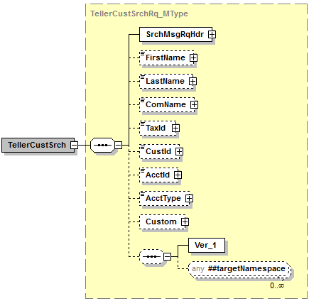

Simple Elements
The following simple elements are contained within this message.
This is a documented filter statement. Any or all of the following can be sent.
At least one search criterea should be provided.
FirstName
Customer’s first name.
Valid values: blank, Up to 20 alpha numeric characters
LastName
Customer’s last name.
Default value = Up to 20 alpha numeric characters
ComName
Common full name for the customer.
Valid values: blank, Up to 40 aplha numeric characters.
TaxId
Tax Id Number
Default value = blank, Numeric value up to 9 digits unless person is foreign in which case alpha numeric up to 25 characters.
CustId
Customer Identification (CIF Number).
Valid values: blank, 20 character alpha numeric field.
AcctId
Account Number
- When sending the account number the account type will also have to be sent. These two elements cannot be sent separately.
Valid Values: 16 digit numeric field.
AcctType
Account Type
- When sending the account type the account number will also have to be sent. These two elements cannot be sent separately.
Valid Values: single character alpha-numeric (i.e.: D-Deposit/Checking; S-Savings; T-Time Deposit; X-Christmas Club; G-GL)

TellerCustSrchRs_MType
TellerDrwTrnsitnSrchRs_MType is a message MType element.
Contains:
Custom_CType
SrchMsgRsHdr_CType
TellerCustSrchRecArray_AType
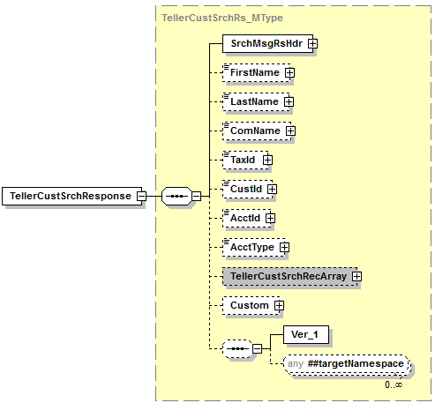

Simple Elements
The following simple elements are contained within this message.
These are an echo back of what was sent in the TellerCustSrchRs_MType
FirstName
Customer’s first name.
Valid values: blank, Up to 20 alpha numeric characters
LastName
Customer’s last name.
Default value = Up to 20 alpha numeric characters
ComName
Common full name for the customer.
Valid values: blank, Up to 40 aplha numeric characters.
TaxId
Tax Id Number
Default value = blank, Numeric value up to 9 digits unless person is foreign in which case alpha numeric up to 25 characters.

CustId
Customer Identification (CIF Number)
Valid Values: blank, 20 character alpha numeric field.
AcctId
Account Number
Valid Values: Numeric up to 16 digits
AcctType
Account Type
Valid Values: single character alpha-numeric (i.e.: D-Deposit/Checking; S-Savings; T-Time Deposit; X-Christmas Club; G-GL)

TellerCustSrchRecArray_AType
TellerCustSrchRecArray_AType is a message AType element.

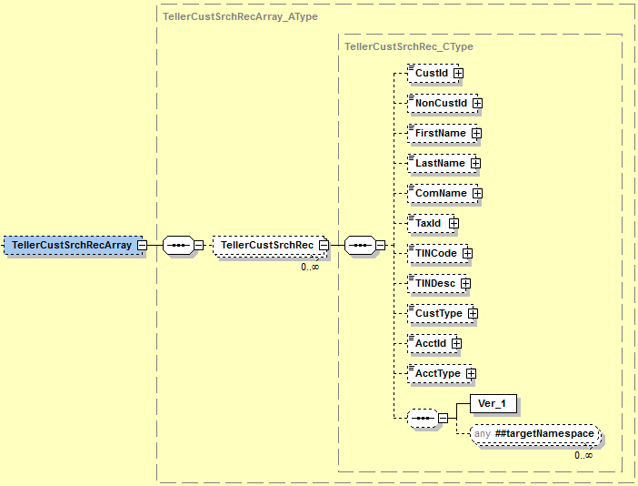

Simple Elements
The following simple elements are contained within this message.
CustId
Customer Identification (CIF Number)
Valid Values: blank, 20 character alpha numeric field.
NonCustId
Teller Person Number – The business service should assign the non-customer Id and provide back to the consumer in the response.
Valid Values: Numeric Value up to 7 digits.
FirstName
Customer’s first name.
Valid values: blank, Up to 20 alpha numeric characters
LastName
Customer’s last name.
Default value = Up to 20 alpha numeric characters
ComName
Common full name for the customer.
Valid values: blank, Up to 40 aplha numeric characters.
TaxId
Tax Id Number
Default value = blank, Numeric value up to 9 digits unless person is foreign in which case alpha numeric up to 25 characters.
TINCode
Tax Id Code
Valid Values: blank, A, B, or C (A=US Employer Identification Number, B=Social Sec# or Indiv Taxpayer ID#, C=Foreign TIN (any type(Including entity)).
TINDesc
Tax Id Code
Valid Values: blank, A, B, or C (A=US Employer Identification Number, B=Social Sec# or Indiv Taxpayer ID#, C=Foreign TIN (any type(Including entity)).
CustType
Customer Type
Valid values: I or O (I=Individual, O=Organization)
AcctId
Account Number
Valid Values: Numeric up to 16 digits
AcctType
Account Type
Valid Values: single character alpha-numeric (i.e.: D-Deposit/Checking; S-Savings; T-Time Deposit; X-Christmas Club; G-GL)

Possible Error Codes:
48 | Error | Maximum records must be greater than zero and less than or equal to 4000.
49 | Error | No records match selection criterea.
1020 | Warning | The requested business service did not return any data responses or messages.
9900102 | Error | The iadapter service did not return a valid response.

Teller Non Customer Inquiry
Teller Non Customer Inquiry is a jXchange service designed to allow the consumer to retrieve a list of customer and non-customer information.

Message Flow
In jXchange, the Teller Non Customer Inquiry service uses a typical exchange of MType messages to retrieve Teller drawer information from a Service Provider.

Primary Request
The Third Party Consumer forwards the TellerNonCustInqRq_MType message to the Service Provider. The message contains the required element MsgRqHdr_CType. The request also contains several optional simple elements designed to filter the response. The optional elements IncXtendElemArray_AType and Custom_CType can also be included in the request.

Primary Response
The Service Provider returns the TellerNonCustInqRs_MType message to the Third Party Consumer. The message contains the required element MsgRsHdr_CType. The optional elements TellerNonCustDetail_CType and Custom_CType can also be included in the response.

Teller Non Customer Inquiry Behavior
The Teller Non Customer Inquiry Search provides consumers with a record of the last transition information for a drawer.

The Teller Non Customer Inquiry root request message TellerNonCustInqRq_MType contains a documented filter statement where the elements at the root are optional but at least one of the elements are required; Non Customer Identification <NonCustId>, Activity Intent <ActIntent>.

The IncXtendElemArray_AType will include the following simple element; XtendElem.

The service provider reserves the right to limit the response set.

The Teller Non Customer Inquiry root response TellerNonCustInqRs_MType echoes back the request elements along with the Teller Non Customer Inquiry Record <TellerNonCustInqRec_CType> which returns all of the items related to the Transition Search request documented filters and four additional informational elements; Non Customer Identification <NonCustId>, Activity Intent <ActIntent>, Activity Intent Key <ActIntentKey>.

The Teller Non Customer Inquiry Record will contain the following elements; TellerNonCustDetail_CType, Tax Identification Description <TINDesc>, NAICS Description <NAICSDesc>.

The Teller Non Customer Detail record will contain the following simple elements; Customer Name <CustName>, Customer Type <CustType>, Address <Addr>, Tax Identification <TaxId>, Tax Identification Code <TINCode>, Birth Date <BirthDt>, Occupation Type <OccType>, Gender <Gender>, NAICS Code <NAICSCode>, Identification Verification Array <IdVerifyArray>, Phone Array <PhoneArray>, Email Array <Email Array>.

This Customer Name record will contain the following elements; Common Name <ComName>, First Name <FirstName>, Middle Name <MiddleName>, Last Name <Last Name>, X_Person Name <X_PersonName>.

The X_Person Name record will contain the following elements; Title Prefix <TitlePrefix>, Name Suffix <NameSuffix>, Legal Name <LegalName>, Salutation Name <SalName>.

The Address <Addr> record will contain the following elements; Free Form Addres Array <FreeFormAddrArray>, Street Adddress 1 <StreetAddr1>, Street Address 2 <StreetAddr2>, City <City>, State or Province <StateProv>, State Code <StateCode>, Postal Code <Postal Code>, Delivery Point <DlvryPt>, County <County>, Country <Cntry>, Country Type <CntryType>, Business Address <BusAddr>, Foreign Address <FornAddr>, Invalid Address <InvAddr>.

The Identification Verification Array record will contain the following elements; Id Verify Description <IdVerifyDesc>, Id Verify Code <IdVerifyCode>, Id Verify Value <IdVerifyVal>, Id Verify By <IdVerifyBy>, Id Issue By <IdIssueBy>, and Id Verify Query Array <IdVerifyQueryArray>.

The Id Verify Query Array record will contain the following elements; Id Verify Query <IdVerifyQuery>, Id Verify Query Value <IdverifyQueryVal>, Id Verify Query Data Type <IdVerifyQueryDataType>.

The Phone Array record will contain the following elements; Phone Number <PhoneNum>, Phone Type <Phone Type>, Phone Time <PhoneTime>, Phone Extension <PhoneExt>, Conference Start Time <ConStartTime>, Conference End Time <ConEndTime>, Mobile Phone Information <MobPhoneInfo>, and Priority Sequence <PrioritySeq>.

The Email Array Record will contain the following elements; Email Address <EmailAddr>, and Email Type <Email Type>.

Teller Non Customer Inquiry Business Case
The consumer is attempting to search Teller Non Customer Inquiry in this business case. When sending this search request, at least one search element will be required.
The Third Party Consumer sends the TellerNonCustInqRq_MType message with the following values:
Complex Element | Simple Element | Example Value
 | NonCustId | 12345
 | Actintent | ReadOnly
IncXtendElemArray
IncXtendElemInfo | XtendElem

The Service Provider returns TellerNonCustInqRs_MType with the following values:
Complex Element | Simple Element | Example Value
 | NonCustId | 12345
 | ActIntent | ReadOnly
 | ActIntentKey | AAAAAAAAmoU=
TellerNonCustInqRec | TINDesc
 | NAICSDesc
TellerNonCustDetail
CustName | ComName | Bob Dole
 | FirstName | Bob
 | MiddleName | Larry
 | LastName | Dole
X_PersonName | TitlePrefix | N/A
 | NameSuffix | Jr.
 | LegalName | N/A
 | SalName | N/A
 | CustType | I
Addr
FreeFormAddrArray
AddrLineInfo | AddrLine | N/A
Addr | StreetAddr1 | 123 JHA Lane
 | StreetAddr2 | Suite 762
 | City | Jasper
 | StateProv | Alabama
 | StateCode | AL
 | PostalCode | 35501
 | DlvryPt | 1234
 | County | N/A
 | Cntry | United States
 | CntryType | US
 | BusAddr | N
 | FornAddr | N
 | InvAddr | N/A
 | TaxId | 123451234
 | TINCode | B
 | BirthDt | 1980-09-20
 | OccType | President
 | Gender | Other
 | NAICSCode | 0
IdVerifyArray
IdVerify | IdVerifyDesc | Driver’s License
 | IdVerifyCode | D
 | IdVerifyVal | 11332242
 | IdVerifyBy | N/A
 | IdIssueBy | AL
IdVerifyQueryArray
IdVerifyQueryInfo | IdVerifyQuery | N/A
 | IdVerifyQueryVal | N/A
 | IdVerifyQueryDataType | N/A
PhoneArray
PhoneInfo | PhoneNum | 2053421123
 | PhoneType | Home
 | PhoneTime | N/A
 | PhoneExt | 0
 | ConStartTime | N/A
 | ConEndTime | N/A
 | MobPhoneInfo | N/A
 | PrioritySeq | N/A
EmailArray
EmailInfo | EmailAddr | bobdole@whitehouse.org
 | EmailType | N/A

TellerNonCustInqSrchRq_MType
TellerNonCustInqRq_MType is a message MType element.
Contains:
- Custom_CType
- MsgRqHdr_CType
- IncXtendElemArray_AType
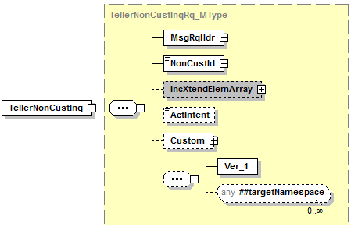

Simple Elements
The following simple elements are contained within this message.
This is a documented filter statement. Any or all of the following can be sent.
At least one search criterea should be provided.
NonCustId
Teller Person Number – The business service should assign the non-customer Id and provide back to the consumer in the response.
Valid Values: Numeric Value up to 7 digits.
ActIntent
Activity Intent field
Valid Values: ReadOnly; Upd; Dlt; Add

IncXtendElemArray_AType
IncXtendElemArray_AType is a message AType element.

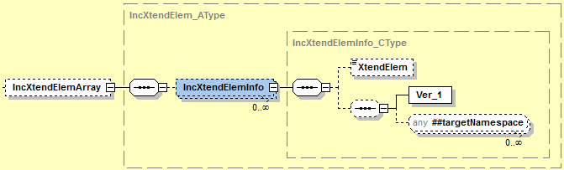

XtendElem
- Included Extended elements which the consumer would ask by name fill out to ask for "x_" prefix elements to be included in the response
- In order for the IncXTendElemArray to pass back any results in the respond, we will have to pass the element x_PersonName in that field. The results it would return are the title prefix and name suffix.
Default value = False; Valid values = True, False

TellerNonCustInqRs_MType
TellerNonCustInqRs_MType is a message MType element.
Contains:
Custom_CType
MsgRsHdr_CType
TellerNonCustInqRec_CType
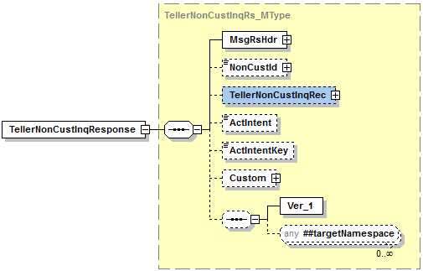

Simple Elements
The following simple elements are contained within this message.
These are an echo back of what was sent in the TellerDrwTrnsitnSrchRq_MType
NonCustId
Teller Person Number – The business service should assign the non-customer Id and provide back to the consumer in the response.
Valid Values: Numeric Value up to 7 digits.
ActIntent
Activity Intent field
Valid Values: ReadOnly; Upd; Dlt; Add

ActIntentKey
Activity Intent Key
Will be used in the TellerNonCustInqRq_MType

TellerNonCustInqRec_CType
TellerNonCustInqRec_CType is a message CType element.
Contains:
- TellerNonCustDetail_CType

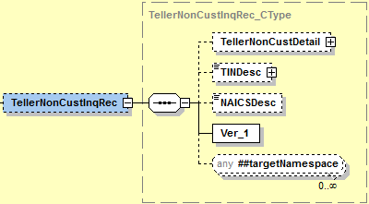

Simple Elements
The following simple elements are contained within this message.
TINDesc
Tax Id Code
Valid Values: blank, A, B, or C (A=US Employer Identification Number, B=Social Sec# or Indiv Taxpayer ID#, C=Foreign TIN (any type(Including entity)).
NAICSDesc
The transition date of the teller drawer.
Valid Values: Up to 50 character alpha numeric field.

TellerNonCustDetail_CType
TellerNonCustInqRec_CType is a message CType element.
Contains:
- PersonName_CType
- Addr_CType
- IdVerifyArray_AType
- PhoneArray_AType
- EmailArray_AType
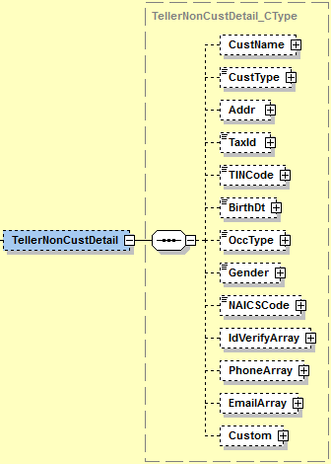

Simple Elements
The following simple elements are contained within this message.
CustType
Customer Type
Valid values: I or O (I=Individual, O=Organization)
TaxId
Tax Id Number
Default value = blank, Numeric value up to 9 digits unless person is foreign in which case alpha numeric up to 25 characters.
TINCode
Tax Id Code
Valid Values: blank, A, B, or C (A=US Employer Identification Number, B=Social Sec# or Indiv Taxpayer ID#, C=Foreign TIN (any type(Including entity)).
BirthDt
BirthDate
Valid Values: blank, Date in YYYY-MM-DD format.
OccType
Description of Occupation
Valid Values: blank, Alpha numeric value up to 30 characters.
Gender
Sex of the Person
Valid Values: blank, Male, Female, Other
NAICSCode
NAICS Code
Valid Values: blank, Numeric value up to 6 digits. Should match valid government issued NAICS Code list.

PersonName_CType
PersonName_CType is a message CType element.
Contains:
- X_PersonName_CType
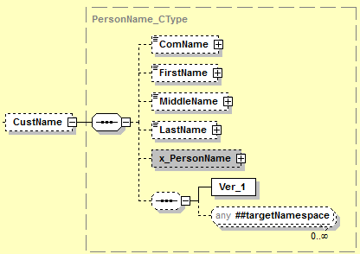

Simple Elements
The following simple elements are contained within this message.
ComName
Common full name for the customer.
Valid values: blank, Up to 40 aplha numeric characters.
FirstName
Customer’s first name.
Valid values: blank, Up to 20 alpha numeric characters
MiddleName
Customer’s middle name.
Valid Values: blank, Up to 20 alpha numeric characters
LastName
Customer’s last name.
Default value = Up to 20 alpha numeric characters

X_PersonName_CType
X_PersonName_CType is a message CType element.

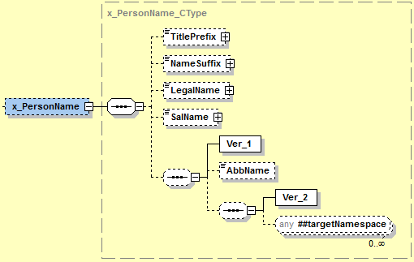

Simple Elements
The following simple elements are contained within this message.
TitlePrefix
Title Prefix – Examples Mr., Mrs.
Valid values: N/A
NameSuffix
Name suffix such as .jr, III, MD, etc…
Valid Values: blank, 4 character alpha numeric field.
LegalName
The legal name used by entities like trusts or businesses in the case where an individual is “doing business as” a company or when a legal name is different than the common name.
Valid Values: N/A

SalName
The full text line name like what is used in mailings. Example; Mr. and Mrs. Bob Dole.
Valid Values: N/A
Values: Transition Date in YYYY-MM-DD format.

Addr_CType
Addr_CType is a message CType element.
Contains:
- FreeFormAddrArray_AType
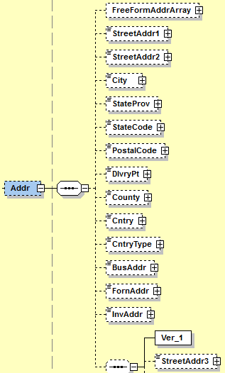

Simple Elements
The following simple elements are contained within this message.
- All elements below will be used to do an inquiry for the customer’s physical address.
StreetAddr1
Street Address Line 1
Valid Values: blank, 40 character alpha numeric field
StreetAddr2
Street address line 2
Valid Values: blank, 40 character alpha numeric
City
City
Valid Values: blank, 20 character alpha numeric
StateProv
State or Provice
Valid Values: blank, 30 Character alpha field
StateCode
State Code
Valid Values: blank, 3 digit alpha character field.
PostalCode
Postal Code
Valid Values: blank, 5 digit numeric
DlvryPt
Delivery Point (4 digits proceeding the zip code)
Valid Values: blank, 4 digit numeric
County
County
Valid Values: N/A
Cntry
Country (Description of the country)
Valid Values: blank, 30 alpha character field
CntryType
Country Type (ISO Country Code)
Valid Values: blank, 2 alpha character field

BusAddr
Customer’s business address?
Valid Values: blank, Y or N (Yes or No)
FornAddr
Customer’s foreign address?
Valid Values: blank, Y or N (Yes or No)
InvAddr
Is this an Invalid Address?
Valid Values: N/A
StreetAddr3
Street Address line 3.
Valid Values: N/A

FreeFormAddrArray_AType
FreeFormAddrArray_AType is a message AType element.
Contains:
- AddrLineInfo_CType

AddrLineInfo_CType
AddrLineInfo_CType is a message CType element.

Simple Elements
The following simple elements are contained within this message.
AddrLine
Free Form Addresss Line
Valid Values: N/A

IdVerifyArray_AType
FreeFormAddrArray_AType is a message AType element.
Contains:
- IdVerifyQueryArray_AType

Simple Elements
The following simple elements are contained within this message.
IdVerifyDesc
The description of the identification code that is used to authenticate the customer.
Valid Values: blank, A – Alien Registration, D – Drivers License/State Id, E – Disabled/Elderly, F – Foreign Entity, G – Government Agency, L – Law Enforcement, M – Amish Customer, O – Other Identification, P – Passport.

IdVerifyCode
The identification code that is used to authenticate the customer.
Valid Values: blank, A – Alien Registration, D – Drivers License/State Id, E – Disabled/Elderly, F – Foreign Entity, G – Government Agency, L – Law Enforcement, M – Amish Customer, O – Other Identification, P – Passport.
IdVerifyVal
The identification value that is used to authenticate the customer.
Valid Values: blank, 22 digit numeric field.
IdVerifyBy
The individual that verified the authenticity of the identification.
Valid Values: N/A
IdIssueBy
The individual that issued the identification value.
Valid Values: blank, 3 character field.

IdVerifyQueryArray_AType
FreeFormAddrArray_AType is a message AType element.

Simple Elements
The following simple elements are contained within this message.
IdVerifyQuery
A description of the query/question that could be used for customer/account identification purposes.

Valid Values: N/A
IdVerifyQueryVal
A value that corresponds with the description of the query/question that could be used for customer/account identification.
Valid Values: N/A
IdVerifyQueryDataType
This element identifies what type of attributes corresponds with the IDVerifyQueryVal.
Valid Values: N/A

PhoneArray_AType
FreeFormAddrArray_AType is a message AType element.

Simple Elements
The following simple elements are contained within this message.
PhoneNum
Phone Number
Valid Values: blank, 16 character numeric field
PhoneType
Phone Type. Examples; Home, Work, Fax, Cell
Valid Values: blank,10 character alpha numeric
PhoneTime
Phone Time – Best Usage Time – Day or Evening.
Valid Values: N/A
PhoneExt
Phone Extension.
Valid Values: blank, 6 character numeric field
ConStartTime
Conference Starat Time.
Valid Values: N/A
ConEndTime
Conference End time.
Valid Values: N/A
MobPhoneInfo
Provider Code of the mobile service.
Valid Values: N/A
PrioritySeq
The assignment of a priority sequence for an array of items.
Valid Values: N/A

EmailArray_AType
FreeFormAddrArray_AType is a message AType element.

Simple Elements
The following simple elements are contained within this message.
EmailAddr
Email Address
Valid Values: blank, 50 character alpha numeric field
EmailType
Email Type
Valid Values: N/A

Possible Error Codes:
1020 | Warning | The requested business service did not return any data responses or messages.
1021 | Error | Numeric Data is not Valid.
1051 | Error | Required field.
3103 | Error | This field is required and cannot be null.
2008 | Error | No records match selection criteria.
2010 | Error | At a minimum, one search value must be populated with a value.
9900102 | Error | The iadapter service did not return a valid response.
9920047 | Error | The numeric value is greater than the maximum allowed.
9920048 | Error | Value cannot be less than zero.
9920050 | Error | Numeric value is invalid.
9920051 | Error | Unmonitored error occurred setting Numeric Value

Teller Currency Transaction Add
Teller Currency Transaction Add is a jXchange service designed to allow the consumer to add transactions that exceed the amounts configured to trigger a CTR.

Message Flow
In jXchange, the Teller Currency Transaction Add service uses a typical exchange of MType messages to add CTR transaction information to a Service Provider.

Primary Request
The Third Party Consumer forwards the TellerCurrTrnAddRq_MType message to the Service Provider. The message contains the required element MsgRqHdr_CType. The request also contains several optional simple elements designed to filter the response. The optional element’s ErrOvrRdInfoArray_AType, CurrTrnInfo_CType, and Custom_CType can also be included in the request.

Primary Response
The Service Provider returns the TellerCurrTrnAddRs_MType message to the Third Party Consumer. The message contains the required element MsgRsHdr_CType. The optional element Custom_CType can also be included in the response.

Teller Currency Transaction Add Behavior
The Teller Currency Transaction Add root request message TellerCurrTrnAddRq_MType contains a documented filter statement where the elements at the root are optional but at least one of the elements are required, Error Override Information Array <ErrOvrRdInfoArray>, Transaction Receipt Id <TrnRcptId>, CTR Report Date <CTRRptDt>, Currency Transaction Information complex <CurrTrnInfo>.

The Error Override Information Array will contain the following elements; Error Code <ErrCode>.

The service provider reserves the right to limit the response set.

The Teller Currency Transaction Add root response TellerCurrTrnAddRs_MType returns the Currency Transaction Identification <CurrTrnId>, and Response Status <RsStat>.

Teller Currency Transaction Add Business Case
The consumer is attempting to search Teller Currency Transaction Add in this business case. When sending this search request, at least one search element will be required.
The Third Party Consumer sends the TellerCurrTrnAddRq_MType message with the following values:
Complex Element | Simple Element | Example Value
 | TrnRcptId | 0079500001001220151028114226
 | CTRRptDt | 2017-01-02
CurrTrnInfo
CurrTrnAcctArray | AcctId | 1234
 | AcctType | D
 | CashIn | 13,245.00
 | CashOut | 14, 222.45
 | CTRCatType | FornCurr
CurrTrnCustArray | CTREntityType | Benf
 | CustId | T0000024
 | NonCustId | 12345
 | TaxId | 123456789
 | TINCode | B
 | TrnOwnerExmpRsnType | NightDep
CustName | ComName | James Carson
 | FirstName | James
 | MiddleName | Daniel
 | LastName | Carson
X_PersonName | TitlePrefix | N/A
 | NameSuffix | III
 | LegalName | N/A
 | SalName | N/A
 | AbbName | N/A
IdVerifyArray | IdVerifyDesc | Driver’s License
 | IdVerifyCode | D
 | IdVerifyVal | 1120202192
 | IdVerifyBy | N/A
 | IdIssueBy | AL
IdVerifyQueryArray | IdVerifyQuery | N/A
 | IdVerifyQueryVal | N/A
 | IdVerifyQueryDataType | N/A
ErrOvrRdInfoArray
ErrOvrRd | ErrCode | N/A

The Service Provider returns TellerCurrTrnAddRs_MType with the following values:
Complex Element | Simple Element | Example Value
 | CurrTrnId | 201608180001546
 | RsStat | Success

TellerCurrTrnAddRq_MType
TellerCurrTrnAddRq_MType is a message MType element.
Contains:
- Custom_CType
- MsgRqHdr_CType
- ErrOvrRdInfoArray_AType
- CurrTrnInfo_CType
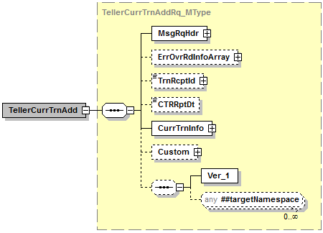

Simple Elements
The following simple elements are contained within this message.
This is a documented filter statement. Any or all of the following can be sent.
TrnRcptId
Teller Transaction Receipt Id
TrnRcptId should include the following information; bank number, drawer number, transaction number, processing period, and time. It should be listed in the following format; (0079601515000720160718105807) and be broken out like this; TRBKID(00796), TSDWR(01515), TSNBR(0007), TSPD(20160718), TSTIME(105807).
- In the event that the TrnRcptId is passed in the request, then we will NOT pass the Account Array.
CTRRptDt
The date of the currency transaction report.
Valid values: Calendar date in MM-DD-YYYY format.

CurrTrnInfo_CType
CurrTrnInfo_CType is a message CType element.
Contains:
CurrTrnAcctArray_AType
CurrTrnCustArray_AType
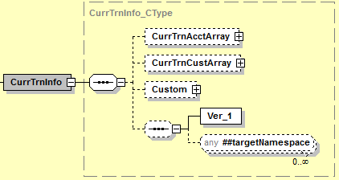

CurrTrnAcctArray_AType
CurrTrnAcctArray_AType is a message AType element.
Contains:
- CurrTrnAcctDetail_CType

CurrTrnAcctDetail_CType
CurrTrnAcctDetail_CType is a message CType element.
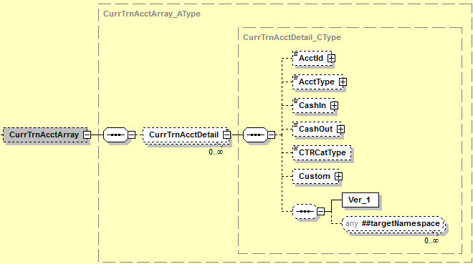

Simple Elements
The following simple elements are contained within this message.
AcctId
Account Number
Valid Values: Numeric up to 16 digits
AcctType
Account Type
Valid Values: single character alpha-numeric (i.e.: D-Deposit/Checking; S-Savings; T-Time Deposit; X-Christmas Club; G-GL)
CashIn
Cash In amount
Valid values: .00 to 999999999.99
CashOut
Cash Out amount
Valid values: .00 to 999999999.99
CTRCatType
The category related to the currency transaction.
Valid values: FornCurr, WireXfer, NegInstPur, NegInstCash, CurrExch, DepWthdwl, Oth, AcctAffWthdwl, Pmt, Adv, PrepaidAccess.

CurrTrnCustArray_AType
CurrTrnCustArray_AType is a message AType element.
Contains:
CustName_CType
IdVerifyArray_AType
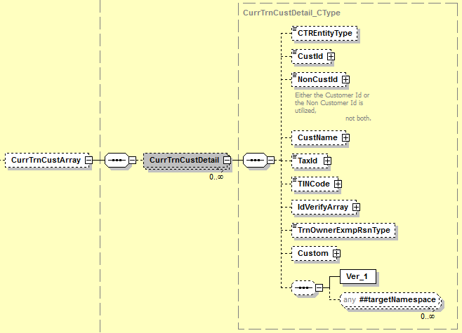

Simple Elements
The following simple elements are contained within this message.
CTREntityType
Identifies the part of the currency transaction report.
Valid values: Benf, TrnOwner, Curr
CustId
Customer Identification (CIF Number).
Valid values: blank, 20 character alpha numeric field.
NonCustId
Teller Person Number.
Valid values: Numeric Value up to 7 digits.
TaxId
Tax Id Number
Default value = blank, Numeric value up to 9 digits unless person is foreign in which case alpha numeric up to 25 characters.
TINCode
Tax Id Code
Valid Values: blank, A, B, or C (A=US Employer Identification Number, B=Social Sec# or Indiv Taxpayer ID#, C=Foreign TIN (any type(Including entity)).
TrnOwnerExmpRsnType
Reason why the currency transaction does not have a person transactor identified.
Valid values: ArmoredCar, NightDep, ATM, MailDep, MultiTrn, ConductBnf

IdVerifyArray_AType
FreeFormAddrArray_AType is a message AType element.
Contains:
- IdVerifyQueryArray_AType

Simple Elements
The following simple elements are contained within this message.
IdVerifyDesc
The description of the identification code that is used to authenticate the customer.
Valid Values: blank, A – Alien Registration, D – Drivers License/State Id, E – Disabled/Elderly, F – Foreign Entity, G – Government Agency, L – Law Enforcement, M – Amish Customer, O – Other Identification, P – Passport.

IdVerifyCode
The identification code that is used to authenticate the customer.
Valid Values: blank, A – Alien Registration, D – Drivers License/State Id, E – Disabled/Elderly, F – Foreign Entity, G – Government Agency, L – Law Enforcement, M – Amish Customer, O – Other Identification, P – Passport.
IdVerifyVal
The identification value that is used to authenticate the customer.
Valid Values: blank, 22 digit numeric field.
IdVerifyBy
The individual that verified the authenticity of the identification.
Valid Values: N/A
IdIssueBy
The individual that issued the identification value.
Valid Values: blank, 3 character field.

IdVerifyQueryArray_AType
FreeFormAddrArray_AType is a message AType element.
Contains:
- IdVerifyQueryInfo_CType

IdVerifyQueryInfo_CType
IdVerifyQueryInfo_CType is a message CType element.

Simple Elements
The following simple elements are contained within this message.
IdVerifyQuery
A description of the query/question that could be used for customer/account identification purposes.

Valid Values: N/A
IdVerifyQueryVal
A value that corresponds with the description of the query/question that could be used for customer/account identification.
Valid Values: N/A
IdVerifyQueryDataType
This element identifies what type of attributes corresponds with the IDVerifyQueryVal.
Valid Values: N/A

ErrOvrRdInfoArray_AType
ErrOvrRdInfoArray_AType is a message AType element.
This Array is not used at this time.
Contains:
ErrOvrRd_CType

ErrOvrRd_CType
ErrOvrRd_CType is a message CType element.

Simple Elements
The following simple elements are contained within this message.
ErrCode
Error Code
Not used at this time

TellerCurrTrnAddRs_MType
TellerCurrTrnAddRs_MType is a message MType element.
Contains:
- Custom_CType
- MsgRsHdr_CType

Simple Elements
The following simple elements are contained within this message.
CurrTrnId
- Currency Transaction Identification.
- An identifier provided for each submitted currency transaction.
- VMVALUE – Parameter Value – should be build in the following format. DatePersonNumber. 201704060001546.
Valid Values: blank, 16 digit numeric field.
RsStat
Response Status
Valid Values: Success, Failed

Possible Error Codes:
2 | Error | Record already exists.
138 | Error | CTR Category must be in range from 0 to 9.
169 | Error | Invalid ID type entered.
170 | Error | Invalid ID Issuer entered.
228 | Error | Error occurred while parsing XML from the request.
229 | Error | The person number does not exist in the master file.
230 | Error | Valid values are ‘A’, ‘B’, ‘C’, ‘D’, ‘E’, or ‘F’.
1020 | Warning | The requested business service did not return any data responses or messages.
1021 | Error | Numeric data is not valid.
1022 | Error | Date is not valid.
9999 | Error | Value entered must be greater than zero.
1056 | Error | *USE authority to user profile required.
2005 | Error | Value does not match defined list of enumerations.
254 | Error | Invalid Transaction Receipt Id entered.
9900102 | Error | The iAdapter service did not return a valid response.
9920047 | Error | The numeric value is greater than maximum allowed.
9920048 | Error | Value cannot be less than zero.
9920050 | Error | Numeric value is invalid.

Teller Currency Transaction Search
Teller Currency Transaction Search is a jXchange service designed to allow the consumer to retrieve a list of transactions related to Currency Transaction Reports.

Message Flow
In jXchange, the Teller Currency Transaction Search service uses a typical exchange of MType messages to retrieve Teller Currency Transaction information from a Service Provider.

Primary Request
The Third Party Consumer forwards the TellerCurrTrnSrchRq_MType message to the Service Provider. The message contains the required element SrchMsgRqHdr_CType. The request also contains several optional simple elements designed to filter the response. The optional element Custom_CType can also be included in the request.

Primary Response
The Service Provider returns the TellerCurrTrnSrchRs_MType message to the Third Party Consumer. The message contains the required element SrchMsgRsHdr_CType. The optional elements TellerCurrTrnSrchRecArray_AType and Custom_CType can also be included in the response.

Teller Currency Transaction Search Behavior
The Teller Currency Transaction Search provides consumers with a record of the Currency Transaction Information.

The Teller Currency Transaction Search root request message TellerCurrTrnSrchRq_MType contains a documented filter statement where the elements at the root are optional but at least one of the elements are required, First Name <FirstName>, Last Name <LastName>, Common Name <ComName>, Tax Identification Number <TaxId>, Customer Identification <CustId>, Account Identification <AcctId>, Account Type <AcctType>, CTR Report Start Date <CTRRptStartDt>, CTR Report End Date <CTRRptEndDt>, Cash In Low Amount <CashInLowAmt>, Cash In High Amount <CashInHighAmt>, Cash Out Low Amount <CashOutLowAmt>, Cash Out High Amount <CashOutHighAmt>.

The service provider reserves the right to limit the response set.

The Teller Currency Transaction Search root response TellerCurrTrnSrchRs_MType echoes back the request elements along with the Teller Currency Transaction Record Array TellerCurrTrnSrchRecArray_AType which returns all of the items related to the Teller Currency Transaction Search request documented filters and the following informational elements; First Name <FirstName>, Last Name <LastName>, Common Name <ComName>, Tax Identification Number <TaxId>, Customer Identification <CustId>, Account Identification <AcctId>, Account Type <AcctType>, CTR Report Start Date <CTRRptStartDt>, CTR Report End Date <CTRRptEndDt>, Cash In Low Amount <CashInLowAmt>, Cash In High Amount <CashInHighAmt>, Cash Out Low Amount <CashOutLowAmt>, Cash Out High Amount <CashOutHighAmt>.

The Teller Currency Transaction Search Record Array record will contain the following elements; Currency Transaction Id <CurrTrnId>, Customer Name Complex <CustName>, Tax Identification <TaxId>, Customer Identification <CustId>, Non-Customer Identification <NonCustId>, Account Identification <AcctId>, Account Type <AcctType>, CTR Report Date <CTRRptDt>, Cash In <CashIn>, Cash Out <CashOut>.
The Person Name complex will contain the following elements; Common Name <ComName>, First Name <FirstName>, Middle Name <MiddleName>, Last Name <LastName>, x_Person Name Complex <x_PersonName>.

The x_Person Name complex will contain the following elements; Title Prefix <TitlePrefix>, Name Suffix <NameSuffix>, Legal Name <Legal Name>, Salutation Name <SalName>, and Abbreviated Name <AbbName>.

SrchType_Type
TellerCurrencyTrnSrch contains a SrchType element. The SrchType element is used because a service provider cannot require exact case matches. For example, if the a consumer submits a last name data value of ‘McGrath’, with the SrchType ‘CONTAINS’, then the service provider should respond back with any data values that match regardless of case. This could include but is not limited to ‘McGrath’, Mcgrath’, ‘mcgrath’, ‘MCGRATH’ or any combination of case difference. The consumer needs to convey to the service provider as to the type of partial search such as but not limited to Exact Match, Contains within, Starts With, and Ends With.

SrchType_Type Element Description
<xsd:simpleType name="SrchType_Type">
<xsd:annotation>
<xsd:documentation>
<Jx>
<ElemDesc>The search type element used as an attribute for elements. The search
type conveys to the service provider the type of search expression for
search message filters</ElemDesc>
<CanonicalVal>Exact,StartsWith,EndsWith,Contains,ContainsAll</CanonicalVal>
</Jx>
</xsd:documentation>
</xsd:annotation>

SrchType_TypeExamples
Exact Match Search Response Example

Request: <LastName SrchType="Exact">Smi</LastName>

Response: <LastName>Smi</LastName>
<FirstName>John</FirstName>
<LastName>Smi</LastName>
<FirstName>Joe</FirstName>

Contains Match Search Response Example

Request: <LastName SrchType="Contains">Smi</LastName>

Response: <LastName>Smi</LastName>
<FirstName>John</FirstName>
<LastName>Smi</LastName>
<FirstName>Joe</FirstName>
<LastName>Gunsmith</LastName>
<FirstName>Jane</FirstName>

Ends With Match Search Response Example

Request: <LastName SrchType="EndsWith">Smi</LastName>

Response: <LastName>Dritiesmi</LastName>
<FirstName>Lucas</FirstName>

Starts With ​Match Search Response Example

Request: <LastName SrchType="StartsWith">Smi</LastName>

Response: <LastName>Smith</LastName>
<FirstName>Mike</FirstName>
<LastName>Smitherrens</LastName>
<FirstName>Jason</FirstName>
<LastName>Smitty</LastName>
<FirstName>James</FirstName>

Contains All Match Search Response Example

Request: <ComName SrchType="ContainsAll">Martha G jones</ComName>

Response: <ComName>Martha G Jones</ComName>
<ComName>G Martha Jones</ComName>
<ComName>Jones G Martha</ComName>
<ComName>Martha Glayds Jonestien</ComName>

Teller Currency Transaction Search Business Case
The consumer is attempting to search Teller Currency Transaction Search in this business case. When sending this search request, at least one search element will be required.
The Third Party Consumer sends the TellerCurrTrnSrchRq_MType message with the following values:
Complex Element | Simple Element | Example Value
 | FirstName | Mickey
 | LastName | Mouse
 | ComName | Mickey Mouse
 | TaxId | 123456789
 | CustId | T000024
 | AcctId | 21345
 | AcctType | D
 | CTRRptStartDt | 2016-01-01
 | CTRRptEndDt | 2017-01-01
 | CashInLowAmt | 0.00
 | CashInHighAmt | 999999999.99
 | CashOutLowAmt | 0.00
 | CashOutHighAmt | 999999999.99

The Service Provider returns TellerCurrTrnSrchRs_MType with the following values:
Complex Element | Simple Element | Example Value
 | FirstName | Mickey
 | LastName | Mouse
 | ComName | Mickey Mouse
 | TaxId | 123456789
 | CustId | T000024
 | Acctid | 21345
 | AcctType | D
 | CTRRptStartDt | 2016-01-01
 | CTRRptEndDt | 2017-01-01
 | CashInLowAmt | 0.00
 | CashInHighAmt | 999999999.99
 | CashOutLowAmt | 0.00
 | CashOutHighAmt | 999999999.99
TellerCurrTrnSrchRecArray | CurrTrnId | 201608180001546
 | TaxId | 123456789
 | CustId | T000024
 | NonCustId | 12345
 | AcctId | 21345
 | AcctType | D
 | CTRRptDt | 2017-01-02
 | CashIn | 12000.00
 | CashOut | 24000.00
CustName | ComName | Mickey Mouse
 | FirstName | Mickey
 | MiddleName | Daniel
 | LastName | Mouse
X_PersonName | TitlePrefix | N/A
 | NameSuffix | IV
 | LegalName | N/A
 | SalName | N/A

TellerCurrTrnSrchRq_MType
TellerCurrTrnSrchRq_MType is a message MType element.
Contains:
- Custom_CType
SrchMsgRqHdr_CType

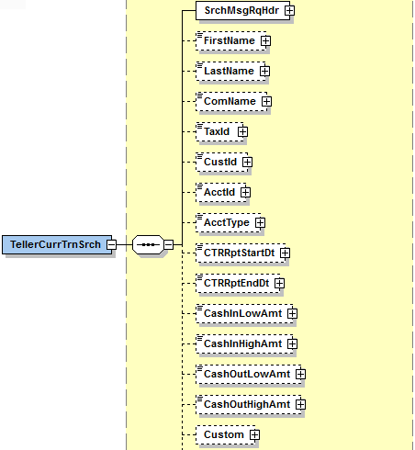

Simple Elements
The following simple elements are contained within this message.
This is a documented filter statement. Any or all of the following can be sent.
At least one search criterea should be provided.
FirstName
Customer’s first name.
Valid values: blank, Up to 20 alpha numeric characters

LastName
Customer’s last name.
Default value = Up to 20 alpha numeric characters
ComName
Common full name for the customer.
Valid values: blank, Up to 40 aplha numeric characters.
TaxId
Tax Id Number
Default value = blank, Numeric value up to 9 digits unless person is foreign in which case alpha numeric up to 25 characters.
CustId
Customer Identification (CIF Number).
- Due to there only being a CustId in the request it has been coded to allow for either the CIF Number or the Person Number. For example, if a user keys in an ‘Alpha’ character in the CustId field we will treat it as a CIF number. If the user keys in all numeric values we will treat it as the Person System Number.
Valid values: blank, 20 character alpha numeric field.
AcctId
Account Number
Valid Values: 16 digit numeric field.
AcctType
Account Type
Valid Values: single character alpha-numeric (i.e.: D-Deposit/Checking; S-Savings; T-Time Deposit; X-Christmas Club; G-GL)
CTRRptStartDt
CTR Report Start Date
Valid values: blank; Business date in MM-DD-YYYY format
If CTRRptStartDt is sent without a CTRRptEndDt, then all transactions on processing date equal to or greater than the CTRRptStartDt should be returned.
CTRRptEndDt
CTR Report End Date
Valid values: blank; Business date in MM-DD-YYYY format
If CTRRptEndDt is sent without a CTRRptStartDt, then all transactions on processing date equal to or less than the CTRRptEndDt should be returned.
CashInLowAmt
Cash In Low amount
Valid values: blank; .00 to 999999999.99
If CashInLowAmt is sent without a CashInHighAmt, then all transaction amounts equal to or greater than the CashInLowAmt should be returned.
CashInHighAmt
Cash In High amount
Valid values: blank; .00 to 999999999.99
If CashInHighAmt is sent without a CashInLowAmt, then all transaction amounts equal to or less than the CashInHighAmt should be returned.
CashOutLowAmt
Cash Out Low amount
Valid values: blank; .00 to 999999999.99
If CashOutLowAmt is sent without a CashOutHighAmt, then all transaction amounts equal to or greater than the CashOutLowAmt should be returned.
CashOutHighAmt
Cash Out High amount
Valid values: blank; .00 to 999999999.99
If CashOutHighAmt is sent without a CashOutLowAmt, then all transaction amounts equal to or less than the CashOutHighAmt should be returned.

TellerCurrTrnSrchRs_MType
TellerCurrTrnSrchRs_MType is a message MType element.
Contains:
Custom_CType
SrchMsgRsHdr_CType
TellerCurrTrnSrchRecArray_AType
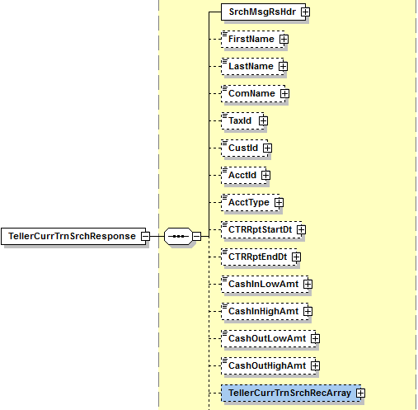

Simple Elements
The following simple elements are contained within this message.
These are an echo back of what was sent in the TellerCurrTrnSrchRq_MType
FirstName
Customer’s first name.
Valid values: blank, Up to 20 alpha numeric characters

LastName
Customer’s last name.
Default value = Up to 20 alpha numeric characters
ComName
Common full name for the customer.
Valid values: blank, Up to 40 aplha numeric characters.
TaxId
Tax Id Number
Default value = blank, Numeric value up to 9 digits unless person is foreign in which case alpha numeric up to 25 characters.
CustId
Customer Identification (CIF Number).
Valid values: blank, 20 character alpha numeric field.
AcctId
Account Number
Valid Values: 16 digit numeric field.
AcctType
Account Type
Valid Values: single character alpha-numeric (i.e.: D-Deposit/Checking; S-Savings; T-Time Deposit; X-Christmas Club; G-GL)
CTRRptStartDt
CTR Report Start Date
Valid values: blank; Business date in MM-DD-YYYY format
If CTRRptStartDt is sent without a CTRRptEndDt, then all transactions on processing date equal to or greater than the CTRRptStartDt should be returned.
CTRRptEndDt
CTR Report End Date
Valid values: blank; Business date in MM-DD-YYYY format
If CTRRptEndDt is sent without a CTRRptStartDt, then all transactions on processing date equal to or less than the CTRRptEndDt should be returned.
CashInLowAmt
Cash In Low amount
Valid values: blank; .00 to 999999999.99
If CashInLowAmt is sent without a CashInHighAmt, then all transaction amounts equal to or greater than the CashInLowAmt should be returned.
CashInHighAmt
Cash In High amount
Valid values: blank; .00 to 999999999.99
If CashInHighAmt is sent without a CashInLowAmt, then all transaction amounts equal to or less than the CashInHighAmt should be returned.

CashOutLowAmt
Cash Out Low amount
Valid values: blank; .00 to 999999999.99
If CashOutLowAmt is sent without a CashOutHighAmt, then all transaction amounts equal to or greater than the CashOutLowAmt should be returned.
CashOutHighAmt
Cash Out High amount
Valid values: blank; .00 to 999999999.99
If CashOutHighAmt is sent without a CashOutLowAmt, then all transaction amounts equal to or less than the CashOutHighAmt should be returned.

TellerCurrTrnSrchRecArray_AType
TellerCurrTrnSrchRecArray_AType is a message AType element.

TellerCurrTrnSrchRec_CType
TellerCurrTrnSrchRec_CType is a message CType element.
Contains:
- CustName_CType

Simple Elements
The following simple elements are contained within this message.
CurrTrnId
- Currency Transaction Identification.
- An identifier provided for each submitted currency transaction.
- VMVALUE – Parameter Value – should be build in the following format. DatePersonNumber. 201704060001546.
Valid Values: blank, 16 digit numeric field. TaxId
Tax Id Number
Default value = blank, Numeric value up to 9 digits unless person is foreign in which case alpha numeric up to 25 characters.
CustId
Customer Identification (CIF Number).
Valid values: blank, 20 character alpha numeric field.
NonCustId
Teller Person Number – The business service should assign the non-customer Id and provide back to the consumer in the response.
Valid Values: Numeric Value up to 7 digits.
AcctId
Account Number
Valid Values: 16 digit numeric field.
AcctType
Account Type
Valid Values: single character alpha-numeric (i.e.: D-Deposit/Checking; S-Savings; T-Time Deposit; X-Christmas Club; G-GL)
CTRRptDt
The date of the currency transaction report.
Valid values: Calendar date in MM-DD-YYYY format.
CashIn
Cash In amount
Valid values: .00 to 999999999.99
CashOut
Cash Out amount
Valid values: .00 to 999999999.99

CustName_CType
CustName_CType is a message CType element.
Contains:
- X_PersonName_CType
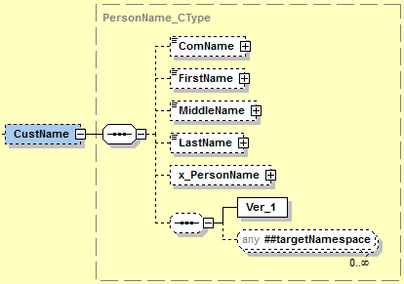

Simple Elements
The following simple elements are contained within this message.
ComName
Common full name for the customer.
Valid values: blank, Up to 40 aplha numeric characters.

FirstName
Customer’s first name.
Valid values: blank, Up to 20 alpha numeric characters
MiddleName
Customer’s middle name.
Valid Values: blank, Up to 20 alpha numeric characters
LastName
Customer’s last name.
Default value = Up to 20 alpha numeric characters

X_PersonName_CType
X_PersonName_CType is a message CType element.
Contains:
- X_PersonName_CType
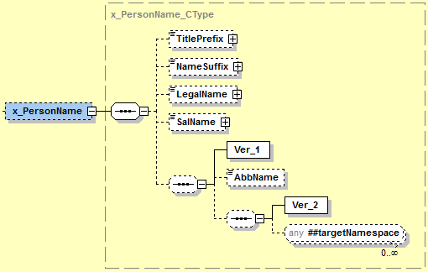

Simple Elements
The following simple elements are contained within this message.
TitlePrefix
Title Prefix – Examples Mr., Mrs.
Valid values: N/A
NameSuffix
Name suffix such as .jr, III, MD, etc…
Valid Values: blank, 4 character alpha numeric field.

LegalName
The legal name used by entities like trusts or businesses in the case where an individual is “doing business as” a company or when a legal name is different than the common name.
Valid Values: N/A

SalName
The full text line name like what is used in mailings. Example; Mr. and Mrs. Bob Dole.
Valid Values: N/A

Possible Error Codes:
49 | Warning | No records match selection criteria. | This error will be returned if there is an invalid request on a SrchType element.
16 | Error | Cannot open files. | This error should occur in the event the elements being requested are locked on the IBM i and cannot be opened.
228 | Error | Error occurred while parsing XML from the request. | This error would only occur in the event there is an issue with the iadapter.
1020 | Error | The requested business service did not return any data responses or messages. | This error would only occur in the event there is an issue with the iadapter.
1021 | Error | Numeric data is not valid.
9999 | Error | Value entered must be greater than zero.
2008 | Error | No records match selection criteria.
2009 | Error | The maximum number of records must be greater than zero.
2010 | Error | At a minimum, one search value must be populated with a value.
2017 | Error | Invalid value based on data type. | Occurs if a string request is sent in a numeric only field.
2505 | Error | Access was denied.

Teller Currency Transaction Modification
Teller Currency Transaction Modification is a jXchange service designed to allow the consumer to delete a CTR’s created by a consumer.

Message Flow
In jXchange, the Teller Currency Transaction Modification service uses a typical exchange of MType messages to retrieve Teller drawer information from a Service Provider.

Primary Request
The Third Party Consumer forwards the TellerCurrTrnModRq_MType message to the Service Provider. The message contains the required element MsgRqHdr_CType. The request also contains several optional simple elements designed to filter the response. The optional elements ErrOvrRdInfoArray_AType, CurrTrnInfo_CType, ModRmkArray_AType, Custom_CType can also be included in the request.

Primary Response
The Service Provider returns the TellerCurrTrnModRs_MType message to the Third Party Consumer. The message contains the required element MsgRsHdr_CType. The optional element Custom_CType can also be included in the response.

Teller Currency Transaction Modification Behavior
The Teller Currency Transaction Modification provides allows a consumer to delete a CTR created by the consumer.

The Teller Currency Transaction Modification root request message TellerCurrTrnModhRq_MType contains a documented filter statement where the elements at the root are optional but at least one of the elements are required, Error Overide Information Array <ErrOvrRdInfo>, Currency Transaction Id <CurrTrnId>, CTR Report Date <CTRRptDt>, Transaction Receipt Identification <TrnRcptId>, Currency Transaction Information Complex <CurrTrnInfo>, Activity Intent Key <ActIntentKey>, Delete <Dlt>, Modification Remark Array <ModRmkArray>.

The Error Override Information Array will contain the following elements; Error Code <ErrCode>.

The Currency Transaction Information will contain the following elements; Currency Transaction Account Array <CurrTrnAcctArray>, and Currency Transaction Customer Array <CurrTrnCustArray>.

The Currency Transaction Account Array will contain the following elements; Account Identification <AcctId>, Account Type <AcctType>, Cash In <CashIn>, Cash Out <CashOut>, CTR Category Type <CTRCatType>.

The Currency Transaction Customer Array will contain the following elements; CTR Entity Type <CTREntityType>, Customer Identification <CustId>, Non-Customer Identification <NonCustId>, Customer Name complex <CustName>, Tax Identification <TaxId>, TIN Code <TINCode>, Identification Verification Array <IdVerifyArray>, Transaction Owner Exempt Reason Type <TrnOwnerExmpRsnType>.

The Customer Name complex will contain the following elements; Common Name <ComName>, First Name <FirstName>, Middle Name <MiddleName>, Last Name <Last Name>, x_Person Name complex <x_PersonName>.

The x_Person Name complex will contain the following elements; Title Prefix <TitlePrefix>, Name Suffix <NameSuffix>, Legal Name <Legal Name>, Salutation Name <SalName>, and Abbreviated Name <AbbName>.

The Identification Verification Array will contain the following elements; Identification Verification Description <IdVerifyDesc>, Identification Verification Code <IdVerifyCode>, Identification Verification Value <IdVerifyVal>, Identification Verification By <IdVerifyBy>, Identification Issue By <IdIssueBy>, Identification Verification Query Array <IdVerifyQueryArray>.

The identification verification query array will contain the following elements; Identification Verification Query <IdVerifyQuery>, Identification Verification Query Value <IdVerifyQueryArray>, Identification Verification Query Data Type <IdVerifyQueryDataType>.

The Modification Remark Array <ModRmkArray> is used to convey any remarks related to the action of the modification, not to be confused with other remarks that are encapsulated by the object(s) being modified.

The service provider reserves the right to limit the response set.

The Teller Drawer Transition Search root response TellerCurrTrnModRq_MType requires the Response Status <RsStat>.

Teller Currency Transaction Modification Business Case
The consumer is attempting to Modify Teller Currency Transactions in this business case.
The Third Party Consumer sends the TellerCurrTrnModRq_MType message with the following values:
Complex Element | Simple Element | Example Value
 | CurrTrnId | 201608180001546
 | CTRRptDt | 2017-01-02
 | TrnRcptId | 0079500001001220151028114226
 | ActIntentKey | AAAAAAAAmoU=
 | Dlt | True
ErrOvrRdInfoArray
ErrOvrRd | ErrCode | N/A
CurrTrnInfo
CurrTrnAcctArray
CurrTrnAcctDetail | AcctId | 1234
 | AcctType | D
 | CashIn | 13,245.00
 | CashOut | 14, 222.45
 | CTRCatType | FornCurr
CurrTrnCustArray
CurrTrnCustDetail | CTREntityType | NightDep
 | CustId | T000024
 | NonCustId | 12345
 | TaxId | 123456789
 | TINCode | B
CustName | ComName | James Carson
 | FirstName | James
 | MiddleName | Lee
 | LastName | Carson
X_PersonName | TitlePrefix | N/A
 | NameSuffix | III
 | LegalName | N/A
 | SalName | N/A
IdVerifyArray
IdVerify | IdVerifyDesc | Driver’s License
 | IdVerifyCode | D
 | IdVerifyVal | 1120202192
 | IdVerifyBy | N/A
 | IdIssueBy | AL
IdVerifyQueryArray |  | N/A
IdVerifyQueryInfo | IdVerifyQuery | N/A
 | IdVerifyQueryVal | N/A
 | IdVerifyQueryDataType
ModRmkArray
RmkInfo | Rmk | Deleting this record.

The Service Provider returns TellerCurrTrnModRs_MType with the following values:
Complex Element | Simple Element | Example Value
 | RsStat | Success

TellerCurrTrnModRq_MType
TellerCurrTrnModRq_MType is a message MType element.
Contains:
- Custom_CType
- MsgRqHdr_CType
- ErrOvrRdInfoArray_AType
- CurrTrnInfo_CType
- ModRmkArray_AType

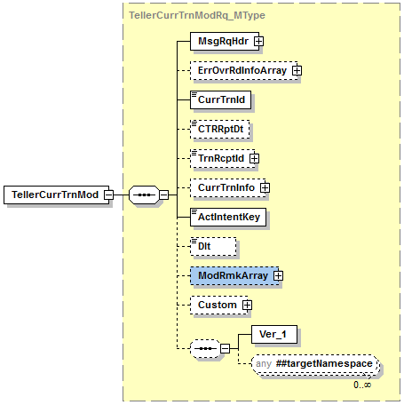

Simple Elements
The following simple elements are contained within this message.
This is a documented filter statement. Any or all of the following can be sent.
At least one search criterea should be provided.
CurrTrnId
- Currency Transaction Identification.
- An identifier provided for each submitted currency transaction.
- VMVALUE – Parameter Value – should be build in the following format. DatePersonNumber. 201704060001546.
Valid Values: blank, 16 digit numeric field.
CTRRptDt
The date of the currency transaction report.
Valid values: Calendar date in MM-DD-YYYY format.
TrnRcptId
Teller Transaction Receipt Id
TrnRcptId should include the following information; bank number, drawer number, transaction number, processing period, and time. It should be listed in the following format; (0079601515000720160718105807) and be broken out like this; TRBKID(00796), TSDWR(01515), TSNBR(0007), TSPD(20160718), TSTIME(105807).

ActIntentKey
- Activity Intent Key field.
- This is a required field.
Valid Values: ActIntentKey provided back in TellerCurrTrnInqRs_MType

Dlt
Delete indicator
Valid values: true; false

ErrOvrRdInfoArray_AType
ErrOvrRdInfoArray_AType is a message AType element.
This Array is not used at this time.
Contains:
ErrOvrRd_CType

ErrOvrRd_CType
ErrOvrRd_CType is a message CType element.

Simple Elements
The following simple elements are contained within this message.
ErrCode
Error Code
Not used at this time

CurrTrnInfo_CType
CurrTrnInfo_CType is a message CType element.
Contains:
CurrTrnAcctArray_AType
CurrTrnCustArray_AType

CurrTrnAcctArray_AType
CurrTrnAcctArray_AType is a message AType element.
Contains:
- CurrTrnAcctDetail_CType

CurrTrnAcctDetail_CType
CurrTrnAcctDetail_CType is a message CType element.

Simple Elements
The following simple elements are contained within this message.
AcctId
Account Number
Valid Values: Numeric up to 16 digits
AcctType
Account Type
Valid Values: single character alpha-numeric (i.e.: D-Deposit/Checking; S-Savings; T-Time Deposit; X-Christmas Club; G-GL)
CashIn
Cash In amount
Valid values: .00 to 999999999.99
CashOut
Cash Out amount
Valid values: .00 to 999999999.99
CTRCatType
The category related to the currency transaction.
Valid values: FornCurr, WireXfer, NegInstPur, NegInstCash, CurrExch, DepWthdwl, Oth, AcctAffWthdwl, Pmt, Adv, PrepaidAccess.

CurrTrnCustArray_AType
CurrTrnCustArray_AType is a message AType element.
Contains:
CustName_CType
IdVerifyArray_AType

Simple Elements
The following simple elements are contained within this message.
CTREntityType
Identifies the part of the currency transaction report.
Valid values: Benf, TrnOwner, Curr
CustId
Customer Identification (CIF Number).
Valid values: blank, 20 character alpha numeric field.
NonCustId
Teller Person Number.
Valid values: Numeric Value up to 7 digits.
TaxId
Tax Id Number
Default value = blank, Numeric value up to 9 digits unless person is foreign in which case alpha numeric up to 25 characters.

TINCode
Tax Id Code
Valid Values: blank, A, B, or C (A=US Employer Identification Number, B=Social Sec# or Indiv Taxpayer ID#, C=Foreign TIN (any type(Including entity)).
TrnOwnerExmpRsnType
Reason why the currency transaction does not have a person transactor identified.
Valid values: ArmoredCar, NightDep, ATM, MailDep, MultiTrn, ConductBnf

IdVerifyArray_AType
FreeFormAddrArray_AType is a message AType element.
Contains:
- IdVerifyQueryArray_AType

Simple Elements
The following simple elements are contained within this message.
IdVerifyDesc
The description of the identification code that is used to authenticate the customer.
Valid Values: blank, A – Alien Registration, D – Drivers License/State Id, E – Disabled/Elderly, F – Foreign Entity, G – Government Agency, L – Law Enforcement, M – Amish Customer, O – Other Identification, P – Passport.

IdVerifyCode
The identification code that is used to authenticate the customer.
Valid Values: blank, A – Alien Registration, D – Drivers License/State Id, E – Disabled/Elderly, F – Foreign Entity, G – Government Agency, L – Law Enforcement, M – Amish Customer, O – Other Identification, P – Passport.
IdVerifyVal
The identification value that is used to authenticate the customer.
Valid Values: blank, 22 digit numeric field.
IdVerifyBy
The individual that verified the authenticity of the identification.
Valid Values: N/A
IdIssueBy
The individual that issued the identification value.
Valid Values: blank, 3 character field.

IdVerifyQueryArray_AType
FreeFormAddrArray_AType is a message AType element.
Contains:
- IdVerifyQueryInfo_CType

IdVerifyQueryInfo_CType
IdVerifyQueryInfo_CType is a message CType element.

Simple Elements
The following simple elements are contained within this message.
IdVerifyQuery
A description of the query/question that could be used for customer/account identification purposes.

Valid Values: N/A
IdVerifyQueryVal
A value that corresponds with the description of the query/question that could be used for customer/account identification.
Valid Values: N/A
IdVerifyQueryDataType
This element identifies what type of attributes corresponds with the IDVerifyQueryVal.
Valid Values: N/A

ModRmkArray_AType
ModRmkArray_AType is a message AType element.

Simple Elements
The following simple elements are contained within this message.
Rmk
Instrument field value (check number or other notes)
Valid Values: blank; 20 character alpha-numeric
The Remark <Rmk> element allow for wild card searches. The Search Type attribute canonical values ~Exact~, ~StartsWith~ and ~Contains~ is supported by the service provider.

TellerCurrTrnModRq_MType
TellerCurrTrnModRq_MType is a message MType element.

Simple Elements
The following simple elements are contained within this message.
RsStat
Status of the response.
Valid values: Success, Fail

Possible Error Codes:
254 | Error | Invalid transaction receipt id entered.
255 | Error | Invalid CTR Transaction ID entered.
1020 | Error | The requested business service did not return any data responses or messages.
1021 | Error | Numeric data is not valid.
1022 | Error | Date is not valid.
1051 | Error | Required field.
1056 | Error | *use authority to user profile required.
2005 | Error | Value does not match defined list of enumerations.
9999 | Error | Value entered must be greater than zero.

Teller Currency Transaction Inquiry
Teller Currency Transaction Inquiry is a jXchange service designed to allow the consumer to retrieve Teller Currency Transaction information using a unique transaction receipt ID provided from Teller Currency Transaction Search.

Message Flow
In jXchange, the Teller Currency Transaction Inquiry service uses a typical exchange of MType messages to retrieve Teller drawer information from a Service Provider.

Primary Request
The Third Party Consumer forwards the TellerCurrTrnInqRq_MType message to the Service Provider. The message contains the required element MsgRqHdr_CType. The request also contains several optional simple elements designed to filter the response. The optional elements IncXtendElemArray_AType and Custom_CType can also be included in the request.

Primary Response
The Service Provider returns the TellerCurrTrnInqRs_MType message to the Third Party Consumer. The message contains the required element MsgRsHdr_CType. The optional elements CurrTrnInqRec_CType and Custom_CType can also be included in the response.

Teller Currency Transaction Inquiry Behavior
The Teller Currency Transaction Inquiry provides consumers with a record of Teller Currency Transaction Information.

The Teller Currency Transaction Inquiry root request message TellerCurrTrnInqRq_MType contains a documented filter statement where the elements at the root are optional but at least one of the elements are required; Currency Transaction Identification <CurrTrnId>, Activity Intent <ActIntent>.

The IncXtendElemArray_AType will include the following simple element; XtendElem.

The service provider reserves the right to limit the response set.

The Teller Currency Transaction Inquiry root response TellerCurrTrnInqRs_MType will provide the elements listed; Currency Transaction Identification <CurrTrnId>, Currency Transaction Inquiry Record <CurrTrnInqRec>, Activity Intent <ActIntent>, ActIntentKey <ActIntentKey>.

The Currency Transaction Inquiry Record Complex contains the Currency Transaction Information Complex <CurrTrnInfo>, and the Teller Transaction Receipt Array <TellerTrnRcptArray.

The Currency Transaction Information will contain the following elements; Currency Transaction Account Array <CurrTrnAcctArray>, and Currency Transaction Customer Array <CurrTrnCustArray>.

The Currency Transaction Account Array will contain the following elements; Account Identification <AcctId>, Account Type <AcctType>, Cash In <CashIn>, Cash Out <CashOut>, CTR Category Type <CTRCatType>.

The Currency Transaction Customer Array will contain the following elements; CTR Entity Type <CTREntityType>, Customer Identification <CustId>, Non-Customer Identification <NonCustId>, Customer Name complex <CustName>, Tax Identification <TaxId>, TIN Code <TINCode>, Identification Verification Array <IdVerifyArray>, Transaction Owner Exempt Reason Type <TrnOwnerExmpRsnType>.

The Customer Name complex will contain the following elements; Common Name <ComName>, First Name <FirstName>, Middle Name <MiddleName>, Last Name <Last Name>, x_Person Name complex <x_PersonName>.

The x_Person Name complex will contain the following elements; Title Prefix <TitlePrefix>, Name Suffix <NameSuffix>, Legal Name <Legal Name>, Salutation Name <SalName>, and Abbreviated Name <AbbName>.

The Identification Verification Array will contain the following elements; Identification Verification Description <IdVerifyDesc>, Identification Verification Code <IdVerifyCode>, Identification Verification Value <IdVerifyVal>, Identification Verification By <IdVerifyBy>, Identification Issue By <IdIssueBy>, Identification Verification Query Array <IdVerifyQueryArray>.

The identification verification query array will contain the following elements; Identification Verification Query <IdVerifyQuery>, Identification Verification Query Value <IdVerifyQueryArray>, Identification Verification Query Data Type <IdVerifyQueryDataType>.

The Teller Transaction Receipt Array contains the following elements; Transaction Receipt Identification <TrnRcptId>, Teller Drawer Identification <TellerDrwId>, Teller Transaction Item Identification <TellerTrnItemId>, Transaction Date <TrnDt>, Transaction Entry Time <TrnEntryTime>.

Teller Currency Transaction Inquiry Business Case
The consumer is attempting to inquire about Teller Currency Transaction information in this business case. When sending this search request, at least one search element will be required.
The Third Party Consumer sends the TellerCurrTrnInqRq_MType message with the following values:
Complex Element | Simple Element | Example Value
 | CurrTrnId | 201608180001546
 | ActIntent | ReadOnly
IncXtendElemArray
IncXtendElemInfo | XtendElem | N/A

The Service Provider returns TellerCurrTrnInqRs_MType with the following values:
Complex Element | Simple Element | Example Value
 | CurrTrnId | 201608180001546
 | ActIntent | ReadOnly
 | ActIntentKey | AAAAAAAAmoU=
CurrTrnInqRec
CurrTrnInfo
CurrTrnAcctArray
CurrTrnAcctDetail | AcctId | 12345
 | AcctType | D
 | CashIn | 13500.00
 | CashOut | 12300.00
 | CTRCatType | FornCurr
CurrTrnCustArray
CurrTrnCustDetail | CTREntityType | Benf
 | CustId | T000024
 | NonCustId | 12345
 | TaxId | 123456789
 | TINCode | B
 | TrnOwnerExempRsnType | NightDep
CustName | ComName | Johnny Depp
 | FirstName | Johnny
 | MiddleName | Lee
 | LastName | Depp
X_PersonName | TitlePrefix | N/A
 | NameSuffix | III
 | LegalName | N/A
 | SalName | N/A
IdVerifyArray
IdVerify | IdVerifyDesc | Dirver’s License
 | IdVerifyCode | D
 | IdVerifyVal | 1121128
 | IdVerifyBy | N/A
 | IdIssueBy | AL
IdVerifyQueryArray
IdVerifyQueryInfo | IdVerifyQuery | N/A
 | IdVerifyQueryVal | N/A
 | IdVerifyQueryDataType | N/A
TellerTrnRcptArray
TellerTrnRcptRec | TrnRcptId | 0079500001001220151028114226
 | TellerDrwId | 123
 | TellerTrnItemId | 1
 | TrnDt | 2017-01-01
 | TrnEntryTime | 11:01:08.0000000-06:00

TellerCurrTrnInqRq_MType
TellerCurrTrnInqRq_MType is a message MType element.
Contains:
- Custom_CType
- MsgRqHdr_CType
- IncXtendElemArray_AType

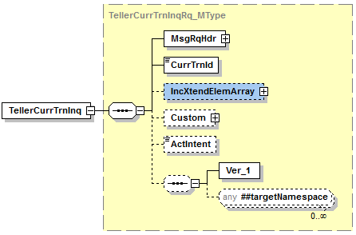

Simple Elements
The following simple elements are contained within this message.
This is a documented filter statement. Any or all of the following can be sent.
At least one search criterea should be provided.
CurrTrnId
- Currency Transaction Identification.
- An identifier provided for each submitted currency transaction.
- VMVALUE – Parameter Value – should be build in the following format. DatePersonNumber. 201704060001546.
Valid Values: blank, 16 digit numeric field.
ActIntent
Activity Intent
Valid Values: ReadOnly; Upd; Dlt; Add

IncXtendElemArray_AType
IncXtendElemArray_AType is a message AType element.

XtendElem
Included Extended elements which the consumer would ask by name fill out to ask for "x_" prefix elements to be included in the response

Default value = False; Valid values = True, False

TellerCurrTrnInqRs_MType
TellerCurrTrnInqRs_MType is a message MType element.
Contains:
Custom_CType
SrchMsgRsHdr_CType
CurrTrnInqRec_CType
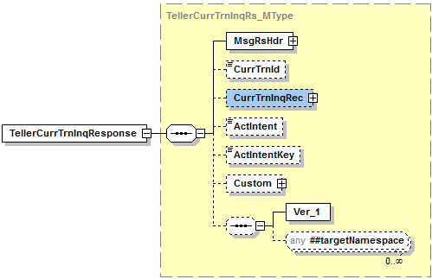

Simple Elements
The following simple elements are contained within this message.
CurrTrnId
- Currency Transaction Identification.
- An identifier provided for each submitted currency transaction.
- VMVALUE – Parameter Value – should be build in the following format. DatePersonNumber. 201704060001546.
Valid Values: blank, 16 digit numeric field. ActIntent
Activity Intent field
Valid Values: ReadOnly; Upd; Dlt; Add

ActIntentKey
Activity Intent Key
Will be used in the TellerCurrTrnInqRq_MType

CurrTrnInqRec_CType
CurrTrnInqRec_CType is a message CType element.
Contains:
- CurrTrnInfo_CType
- TellerTrnRcptArray_AType

CurrTrnInfo_CType
CurrTrnInfo_CType is a message CType element.
Contains:
CurrTrnAcctArray_AType
CurrTrnCustArray_AType

CurrTrnAcctArray_AType
CurrTrnAcctArray_AType is a message AType element.
Contains:
- CurrTrnAcctDetail_CType

CurrTrnAcctDetail_CType
CurrTrnAcctDetail_CType is a message CType element.

Simple Elements
The following simple elements are contained within this message.
AcctId
Account Number
Valid Values: Numeric up to 16 digits
AcctType
Account Type
Valid Values: single character alpha-numeric (i.e.: D-Deposit/Checking; S-Savings; T-Time Deposit; X-Christmas Club; G-GL)
CashIn
Cash In amount
Valid values: .00 to 999999999.99
CashOut
Cash Out amount
Valid values: .00 to 999999999.99
CTRCatType
The category related to the currency transaction.
Valid values: FornCurr, WireXfer, NegInstPur, NegInstCash, CurrExch, DepWthdwl, Oth, AcctAffWthdwl, Pmt, Adv, PrepaidAccess.

CurrTrnCustArray_AType
CurrTrnCustArray_AType is a message AType element.
Contains:
CustName_CType
IdVerifyArray_AType

Simple Elements
The following simple elements are contained within this message.
CTREntityType
Identifies the part of the currency transaction report.
Valid values: Benf, TrnOwner, Curr
CustId
Customer Identification (CIF Number).
Valid values: blank, 20 character alpha numeric field.
NonCustId
Teller Person Number.
Valid values: Numeric Value up to 7 digits.
TaxId
Tax Id Number
Default value = blank, Numeric value up to 9 digits unless person is foreign in which case alpha numeric up to 25 characters.
TINCode
Tax Id Code
Valid Values: blank, A, B, or C (A=US Employer Identification Number, B=Social Sec# or Indiv Taxpayer ID#, C=Foreign TIN (any type(Including entity)).
TrnOwnerExmpRsnType
Reason why the currency transaction does not have a person transactor identified.
Valid values: ArmoredCar, NightDep, ATM, MailDep, MultiTrn, ConductBnf

IdVerifyArray_AType
FreeFormAddrArray_AType is a message AType element.
Contains:
- IdVerifyQueryArray_AType

Simple Elements
The following simple elements are contained within this message.
IdVerifyDesc
The description of the identification code that is used to authenticate the customer.
Valid Values: blank, A – Alien Registration, D – Drivers License/State Id, E – Disabled/Elderly, F – Foreign Entity, G – Government Agency, L – Law Enforcement, M – Amish Customer, O – Other Identification, P – Passport.

IdVerifyCode
The identification code that is used to authenticate the customer.
Valid Values: blank, A – Alien Registration, D – Drivers License/State Id, E – Disabled/Elderly, F – Foreign Entity, G – Government Agency, L – Law Enforcement, M – Amish Customer, O – Other Identification, P – Passport.
IdVerifyVal
The identification value that is used to authenticate the customer.
Valid Values: blank, 22 digit numeric field.
IdVerifyBy
The individual that verified the authenticity of the identification.
Valid Values: N/A
IdIssueBy
The individual that issued the identification value.
Valid Values: blank, 3 character field.

IdVerifyQueryArray_AType
FreeFormAddrArray_AType is a message AType element.
Contains:
- IdVerifyQueryInfo_CType

IdVerifyQueryInfo_CType
IdVerifyQueryInfo_CType is a message CType element.

Simple Elements
The following simple elements are contained within this message.
IdVerifyQuery
A description of the query/question that could be used for customer/account identification purposes.

Valid Values: N/A
IdVerifyQueryVal
A value that corresponds with the description of the query/question that could be used for customer/account identification.
Valid Values: N/A
IdVerifyQueryDataType
This element identifies what type of attributes corresponds with the IDVerifyQueryVal.
Valid Values: N/A

TellerTrnRcptArray_AType
TellerTrnRcptArray_AType is a message AType element.
Contains:
TellerTrnRcptRec_CType
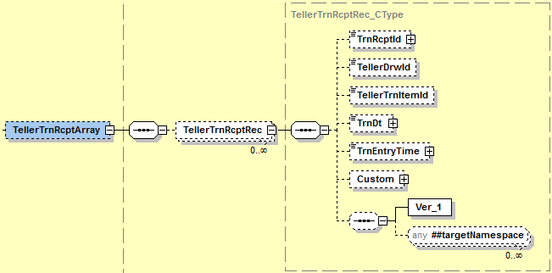

Simple Elements
The following simple elements are contained within this message.
TrnRcptId
Teller Transaction Receipt Id
TrnRcptId should include the following information; bank number, drawer number, transaction number, processing period, and time. It should be listed in the following format; (0079601515000720160718105807) and be broken out like this; TRBKID(00796), TSDWR(01515), TSNBR(0007), TSPD(20160718), TSTIME(105807).
TellerDrwId
Teller drawer number.
Valid values: blank, 5 digit numeric
TellerTrnItemId
Line Item Identifier
Valid Values: Numeric up to 4 digits (should equate to line item sequence number)
TrnDt
Transaction Calendar Date
Valid Values: Calendar date in MM-DD-YYYY format
TrnEntryTime
Transaction time
Valid Values: Time in HH:MM:SS format followed by Coordinated Universal Time (UTC) offset; e.g.: 11:01:08.0000000-06:00

Possible Error Codes:
1 | Error | Record not found.
104 | Error | Invalid drawer number.
114 | Error | Invalid time entered. Must be entered in military format.
230 | Error | Valid values are ‘A’, ‘B’, ‘C’, ‘D’, ‘E’, or ‘F’.
255 | Error | Invalid CTR transaciton ID entered.
1020 | Error | The requested business service did not return any data responses or messages.
1021 | Error | Numeric data is not valid.
1022 | Error | Date is not valid.
1051 | Error | Required field.
9040 | Error | Error opening file.
9999 | Error | Value entered must be greater than zero.
2005 | Error | Value does not match defined list of enumerations.
2008 | Error | No records match selection criteria.
2009 | Error | The maximum number of records must be greater than zero.
2010 | Error | At a minimum, one search value must be populated with a value.
2017 | Error | Invalid value based on data type.
2205 | Error | The unique identifier is required.
2505 | Error | Access was denied.

Teller XXXXXX Service Template
Teller XXXXXXX is a jXchange service designed to allow the consumer to XXXXXXXXXXXXXXXXXXX.

Message Flow
In jXchange, the Teller XXXXXXXX service uses a typical exchange of MType messages to retrieve XXXXXXXXXXXXX from a Service Provider.

Primary Request
The Third Party Consumer forwards the XXXXXXXXXXRq_MType message to the Service Provider. The message contains the required element SrchMsgRqHdr_CType OR MsgRqHdr_CType. The request also contains several optional simple elements designed to filter the response. The optional element Custom_CType can also be included in the request.

Primary Response
The Service Provider returns the XXXXXXXXRs_MType message to the Third Party Consumer. The message contains the required element SrchMsgRsHdr_CType OR MsgRsHdr_CType. The optional element Custom_CType can also be included in the response.

Teller XXXXXXXX Behavior
XXXXX Insert Behavior for selected service as defined in Release_Candidate_ContractDoc.pdf: https://teamsites.jackhenry.com/sites/EAG/Shared Documents/jXchange/Releases/Release Candidates/Release_Candidate_ContractDoc.pdf XXXXXX

Teller XXXXXXXXX Business Case
The consumer is attempting to XXXXXXXXXXXXX in this business case.
The Third Party Consumer sends the XXXXXXXXXRq_MType message with the following values:
Complex Element | Simple Element | Example Value
 | Element 1 | XXXXXXXXXXXX
 | Element 2 | XXXXXXXXXXXX

The Service Provider returns XXXXXXXXXRs_MType with the following values:
Complex Element | Simple Element | Example Value
 | Element 1 | XXXXXXXXXXXX
 | Element 2 | XXXXXXXXXXXX
CType 1 | Element 1 in CType | XXXXXXXXXXXX
 | Element 2 in CType | XXXXXXXXXXXX
Array 1
CType in Array 1 | Element 1 in Array CType | XXXXXXXXXXXX
 | Element 2 in Array CType | XXXXXXXXXXXX

XXXXXXXXXRq_MType
XXXXXXXXXXRq_MType is a message MType element.
Contains:
Custom_CType
SrchMsgRqHdr_CType OR MsgRqHdr_CType
Contains:
XXXXXXXX_CType
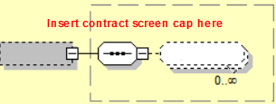

Simple Elements
The following simple elements are contained within this message.
Element 1
Description 1
Valid values:
Element 2
Description 2
Valid values:

XXXXXXXX_CType
XXXXXXXXX_CType is a message CType element.
Contains:
XXXXXXXXX_AType

Simple Elements
The following simple elements are contained within this message.
Element 1
Description 1
Valid values:
Element 2
Description 2
Valid values:

XXXXXXXXX_AType
XXXXXXXXX_AType is a message AType element.
There will be an entry in the array for each line item in the transaction.
Contains:
XXXXXXXX_CType

XXXXXXXXX_CType
XXXXXXXXX_CType is a message CType element.

Simple Elements
The following simple elements are contained within this message.
Element 1
Description 1
Valid values:
Element 2
Description 2
Valid values:

XXXXXXXXRs_MType
XXXXXXXXRs_MType is a message MType element.
Contains:
Custom_CType
SrchMsgRsHdr_CType OR MsgRsHdr_CType
XXXXXXXX_CType

Simple Elements
The following simple elements are contained within this message.
These are an echo back of what was sent in the XXXXXXXRq_MType
Element 1
Description 1
Valid values:
Element 2
Description 2
Valid values:

XXXXXXXX_CType
XXXXXXXXX_CType is a message CType element.
Contains:
XXXXXXXXX_AType

Simple Elements
The following simple elements are contained within this message.
Element 1
Description 1
Valid values:
Element 2
Description 2
Valid values:

XXXXXXXXX_AType
XXXXXXXXX_AType is a message AType element.
There will be an entry in the array for each line item in the transaction.
Contains:
XXXXXXXX_CType

XXXXXXXXX_CType
XXXXXXXXX_CType is a message CType element.

Simple Elements
The following simple elements are contained within this message.
Element 1
Description 1
Valid values:
Element 2
Description 2
Valid values:

Possible Error Codes:
1, 2, 3, 4

